BEYOND RED TEACHER’S GUIDE
Edwin Hubble was an American astronomer that formulated the relationship between the distances of celestial objects and their recessional velocities (the velocity at which objects are moving away from an observer). The recessional velocities of celestial objects were measured using redshift.

Model 1: Graph of Velocity versus Distance
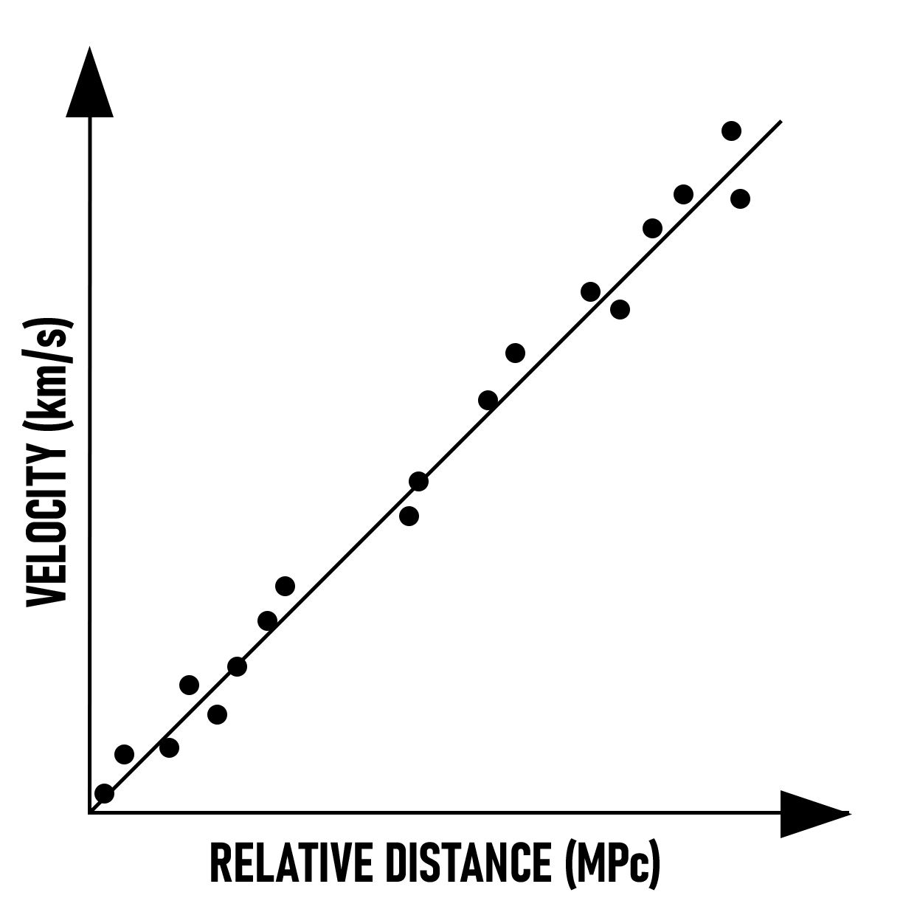
The slope of the graph is known as Hubble’s constant (H₀). The unit of distance used in astronomy is a megaparsec. Another unit of distance used in astronomy is a light year. A light year is the distance light travels in 1 year. One megaparsec (MPc) is equal to 6.26 million light years.
Hubble Equation: v = H₀ · D H₀ = 73 (km/s)/MPc
1 MPc = 3.0x10¹⁹ km 1 year = 3.2x10⁷ seconds
Galaxy Name | Distance (MPc) | Velocity (km/s) | Redshift (Z) (x10⁻³)
NGC 1357 | 24.72 | 2190 | 7.3
NGC 2775 | 17.89 | 1160 | 3.9
NGC 2903 | 6.96 | 450 | 1.5
NGC 3368 | 11.89 | 880 | 2.9
NGC 3516 | 40.00 | 2530 | 8.4
NGC 3627 | 9.57 | 720 | 2.4

Agree or Disagree with the following statements 1-4:

1) The recessional velocities and distances of celestial objects are directly proportional.
Students should agree based on the positive graph slope
2) Objects farther away from the observer have smaller velocities?
Students should disagree based on the positive graph slope
3) A closer object moving away from the observer will have a smaller redshift compared to an object that is farther from the observer.
Students should agree based on the previous activity that showed redshift and velocity are
proportional.
4) The emissions from the farthest objects in the universe would likely be measured in infrared or microwaves.
Students should agree based on prior knowledge that infrared has longer wavelengths and
the farthest objects would have the greatest redshifts.

Complete the following exercises and answer the following questions:

5) Use a triangle of power to create a mathematical formula for the graph in Model 1.
V=H₀D
6) Graph the data in Table 1 with distance on the x-axis and velocity on the y-axis.
Calculate the slope of the best fit line. This slope, constant, is an approximation of Hubble’s
constant. H₀=66 (km/s)/MPc

7) If an object is 1 MPc away from the observer, its velocity is 70 km/s. What is the velocity of an object 2 MPc away from the observer? Since velocity and distance are directly proportional doubling the distance between the objects would double the velocity. V=140 km/s

8) The farthest galaxy from Earth is GN-z11. GN-z11 has a velocity of 295,050 km/s. How far away from Earth is GN-z11 in MPc? 4215 MPc

9) What is the distance of GN-z11 from Earth in light years? 1.37E10 light years

10) The sun is about 150 million km from Earth. It takes about 8.3 minutes for the light emitted from the sun to reach Earth. In a way, when you observe the sun, you are seeing 8.3 minutes into the past. How long would it take light from GN-z11 to reach Earth? 1.37E10 light years

11) Isolate Hubble’s constant on the left side of your equation from step 5. Invert both sides of the equation. Distance divided by velocity equals time. Replace the right side (D/V) with time.
H₀=V/D; 1/H₀=D/V; 1/H₀=Time
12) Use your equation from question 9, and the acceptable value of Hubble’s constant, 73 (km/s)/MPc, to calculate the age of the universe in years. (Hint: Calculate time or the inverse of Hubble’s constant)
Time=1/H₀=1/73=0.0137(s·MPc)/km; Convert by multiplying by 3E19 km and dividing by 3.1E7 s/yr; 13.8E9 years or 13.8 billion years old.

