Edwin Hubble was an American astronomer that formulated the relationship between the distances of celestial objects and their recessional velocities (the velocity at which objects are moving away from an observer). The recessional velocities of celestial objects were measured using redshift.

Model 1: Graph of Velocity versus Distance
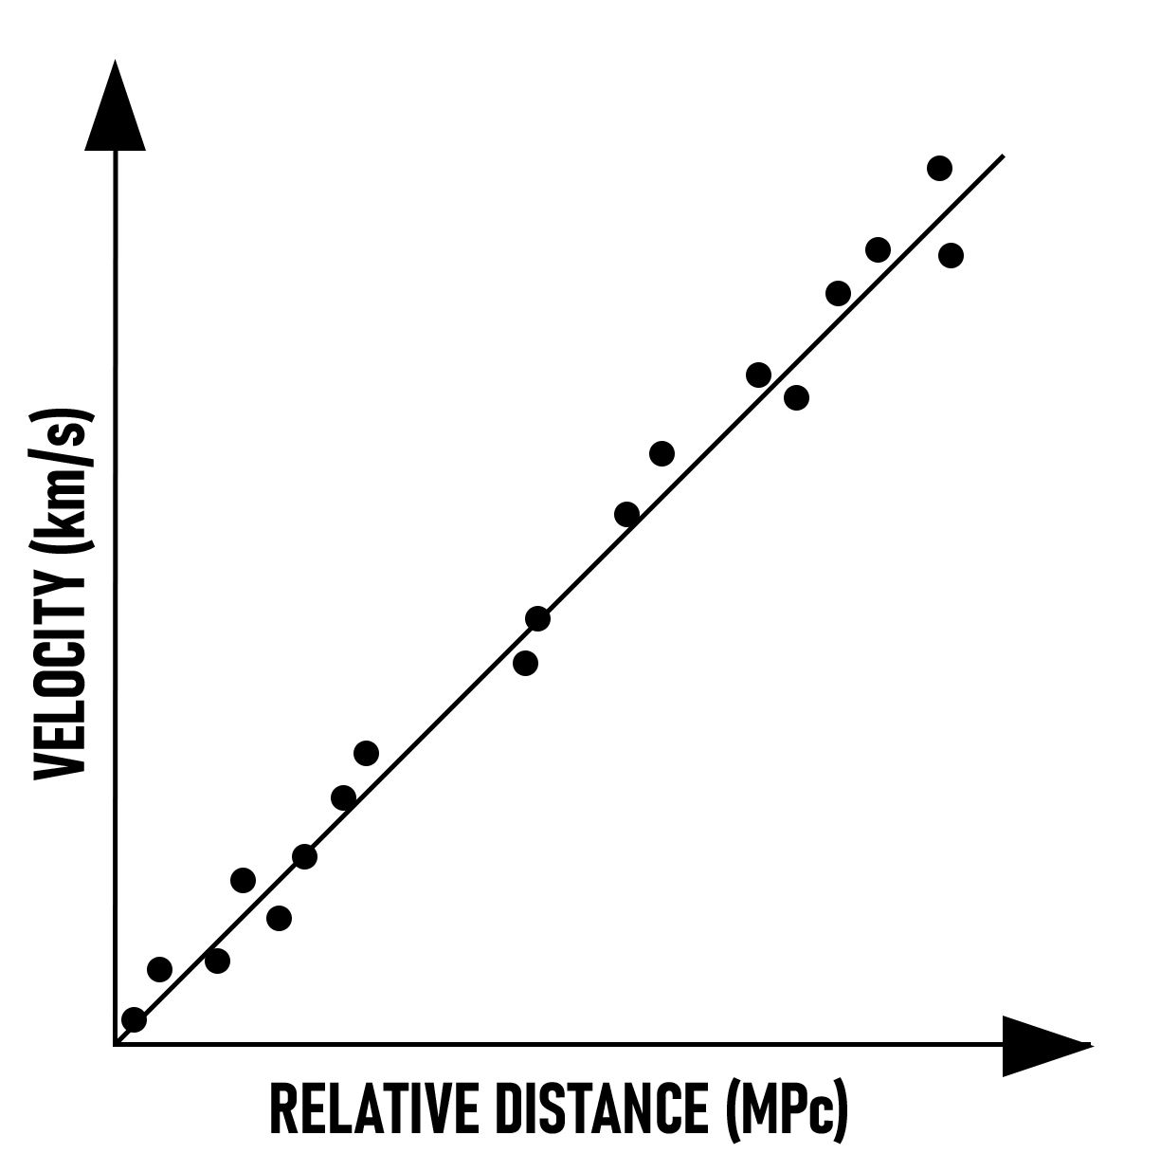
The slope of the graph is known as Hubble’s constant (H₀). The unit of distance used in astronomy is a megaparsec. Another unit of distance used in astronomy is a light year. A light year is the distance light travels in one year. One megaparsec (MPc) is equal to 6.26 million light years.

Hubble Equation: v = H₀ · D H₀ = 70 (km/s)/MPc
1 MPc = 3.0x10¹⁹ km 1 year = 3.2x10⁷ seconds

Galaxy Name | Distance (MPc) | Velocity (km/s) | Redshift (Z) (x10⁻³)
NGC 1357 | 24.72 | 2190 | 7.3
NGC 2775 | 17.89 | 1160 | 3.9
NGC 2903 | 6.96 | 450 | 1.5
NGC 3368 | 11.89 | 880 | 2.9
NGC 3516 | 40.00 | 2530 | 8.4
NGC 3627 | 9.57 | 720 | 2.4

Agree or Disagree with the following statements 1-4:

1) The recessional velocities and distances of celestial objects are directly proportional.

2) Objects farther away from the observer have larger velocities.

3) A closer object moving away from the observer will have a smaller redshift compared to an object that is farther from the observer.

4) The emissions from the farthest objects in the universe would likely be measured in infrared or microwaves.

Complete the following exercises and answer the following questions:

5) Use a triangle of power to create a mathematical formula for the graph in Model 1.

6) Graph the data in Table 1 with distance on the x-axis and velocity on the y-axis.
Calculate the slope of the best fit line. This slope, constant, is an approximation of Hubble’s
constant.

7) If an object is 1 MPc away from the observer, its velocity is 70 km/s. What is the velocity of an object 2 MPc away from the observer?

8) The farthest galaxy from Earth is GN-z11. GN-z11 has a velocity of 295,050 km/s. How far away from Earth is GN-z11 in MPc?

9) What is the distance of GN-z11 from Earth in light years?

10) The sun is about 150 million km from Earth. It takes about 8.3 minutes for the light emitted from the sun to reach Earth. In a way, when you observe the sun, you are seeing 8.3 minutes into the past. How long would it take light from GN-z11 to reach Earth?

11) Isolate Hubble’s constant on the left side of your equation from step 5. Invert both sides of the equation. Distance divided by velocity equals time. Replace the right side (D/V) with time.

12) Use your equation from question 9, and the acceptable value of Hubble’s constant, 73 (km/s)/MPc, to calculate the age of the universe in years. (Hint: Calculate time or the inverse of Hubble’s constant)

