You are going to watch a video that will provide you with some information about how a radar gun works.
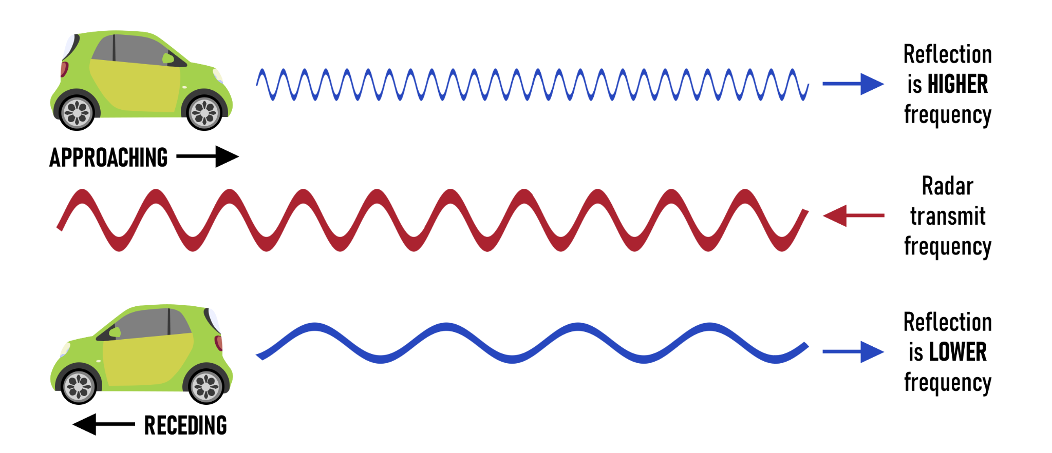

Before you watch the video, answer these questions. If you don't have the answer now, try and get it from the video later.
1) What is the Doppler Effect? An increase or decrease in the frequency of waves as the wave source and the observer move towards or away from one another.
2) Radars make radio waves. Are radio waves sound? If not, what are they? Radio waves are electromagnetic waves which are not the same as sound waves.
3) The speed of sound is 343 m/s. Radio waves move at the speed of light. What is the speed of light in meters per second? c=300,000,000 m/s or 3x10⁸ m/s
4) The radio waves emitted by radars hit objects and return to the radar. How might a wave change when it reflects off an object? Students may predict the frequency of the radar waves will increase or decrease in frequency.
5) Compared to a stationary object, would it take more or less time for a wave to return if it reflected off an object moving away from it? Students may guess it will take a longer time or shorter time.
6) Compared to a stationary object, would it take more or less time for a wave to return if it reflected off an object moving towards it? Students may guess it will take a longer time or shorter time.
Answer these questions during the video.
7) What does a radar gun measure? The frequency of radio waves
8) What is the frequency of the radar gun in the video? 34.7 Gigahertz (GHz)
9) For a stationary object, how does the reflected frequency compare to the original frequency? They would be the same
10) For an object moving towards the radar, how does the reflected frequency compare to the original frequency? The frequency increases and the wavelength decreases.
11) For an object moving away from the radar, how does the reflected frequency compare to the original frequency? The frequency decreases and the wavelength increases.
12) Write the equation for calculating speed. (Note: add a 2 to the denominator)
V = (Δf/2f_{o})c
13) Calculate the speed of a car, in miles per hour, given Δf=4213 Hz.
(1 mile =1609 m; 1 hour = 3600 s)
V = (4213/(2 x 34.7E9)x3e8=18.1m/s=41 mph

