RADAR VIDEO QUESTIONS
You are going to watch a video that will provide you with some information about how a radar gun works.
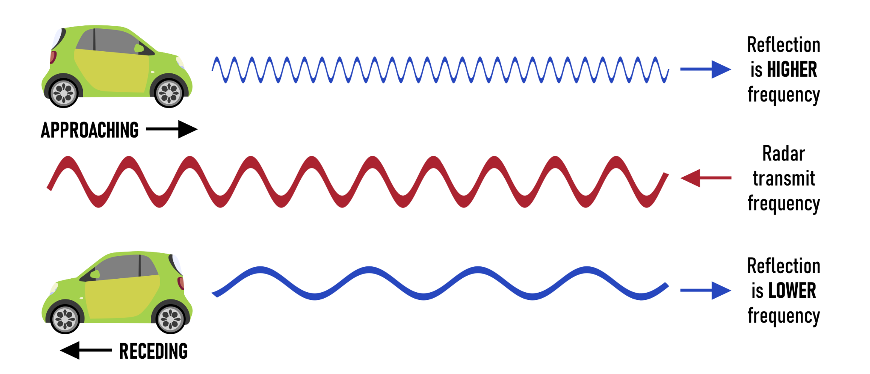

Before you watch the video, answer these questions. If you don't have the answer now, try and get it from the video later.
1) What is the Doppler Effect?

2) Radars make radio waves. Are radio waves sound? If not, what are they?

3) The speed of sound is 343 m/s. Radio waves move at the speed of light. What is the speed of light in meters per second?

4) The radio waves emitted by radars hit objects and return to the radar. How might a wave change when it reflects off an object?

5) Compared to a stationary object, would it take more or less time for a wave to return if it reflected off an object moving away from it?

6) Compared to a stationary object, would it take more or less time for a wave to return if it reflected off an object moving towards it?

Answer these questions during the video.
7) What does a radar gun measure?

8) What is the frequency of the radar gun in the video?

9) For a stationary object, how does the reflected frequency compare to the original frequency?

10) For an object moving towards the radar, how does the reflected frequency compare to the original frequency?

11) For an object moving away from the radar, how does the reflected frequency compare to the original frequency?

12) Write the equation for calculating speed. (Note: add a 2 to the denominator of equation in video)

13) Calculate the speed of a car given Δf=4213 Hz.
(1 mile =1609 m; 1 hour = 3600 s)

