In the previous learning activity, you learned that light emitted from far away objects like stars can change colors as it moves through space. The light emitted from objects moving away from the observer lengthen as it travels through space. This effect is known as redshift because the color of the light moves towards the red end of the spectrum. When distance objects are moving towards the observer, the wavelength of light shortens. This effect is known as blueshift because the color of the light moves toward the blue end of the spectrum.

Model 1:
Absorption spectra for various celestial objects. Image shows spectral lines emitted by hydrogen (410, 434, 486 and 656), calcium (393 and 397), magnesium (518) and sodium (589) in other galaxies. The lines are measured in nanometers (nm).
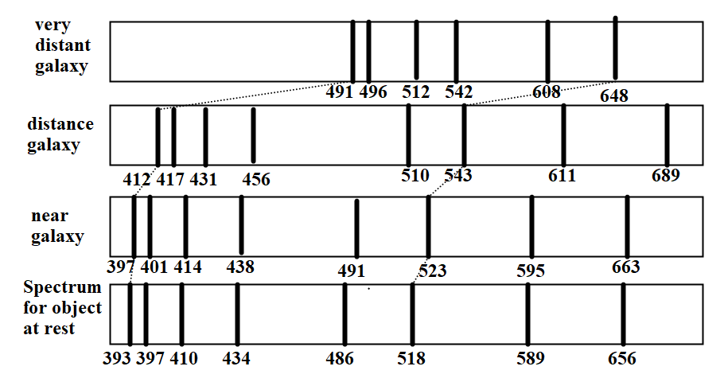

Model 2:
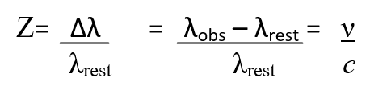
Z : Redshift
∆λ = λ_{obs}-λ_{rest}
λ_{rest} : wavelength for object at rest
λ_{obs} : wavelength for a moving object
ν : velocity of object
c : speed of light, 3x10⁸ m/s

Questions:
1) What happens to the wavelength of light as objects are moving away from an observer on Earth? The wavelength of the light increases and shifts towards red
2) What happens to the wavelength of light as objects are moving toward the observer?
The wavelength of light shortens and shifts towards blue
3) What is redshift? When light is stretched and the wavelength increases making the light shift towards the red end of the visible spectrum
4) What is blueshift? When light is compressed and the wavelength decreases making the light shift towards the blue end of the visible spectrum
5) According to Model 1, how are all of the objects moving relative to the observer? The objects are moving away from the observer as demonstrated by the redshift.
6) According to Model 2, how are the redshift, z, and the velocity, v, related mathematically? (Hint: Are they directly or inversely proportional?) Directly proportional
7) Based on your answer to question 6, which object is moving away from the observer at the largest velocity? Justify your answer. The very distant galaxy has the greatest redshift and would have the largest velocity since redshift and velocity are directly proportional.
8) Pick one wavelength from Model 1 and calculate the redshift for each object. You only need one of the wavelengths from each spectra to calculate the redshift. You can use any wavelength you wish. Using the 393nm line: Near galaxy: 397-393=4; Distant galaxy: 412-393=19; Very Distant galaxy: 491-393=98
9) Calculate the velocity, in m/s, for each object in Model 1. (v=Z·c)
Near galaxy: 4c=1.2E9m/s; Distant galaxy: 19c=5.7E9 ; Very Distant galaxy: 98c=2.9E10

10) Do you agree or disagree with the following statement? If you disagree, write the statement so that it is correct.

Objects outside of our galaxy are moving towards us at velocities that can be predicted using a redshift measurement.

Disagree: Objects outside of our galaxy are moving away from us at velocities that can be predicted using a redshift measurement.

