In the previous learning activity, you learned that light emitted from far away objects like stars can change colors as it moves through space. The light emitted from objects moving away from the observer lengthen as it travels through space. This effect is known as redshift because as the wavelength increases, the color of the light moves to the red end of the spectrum. When distance objects are moving towards the observer, the wavelength of light shortens. This effect is known as blueshift because the color of the light moves toward the blue end of the spectrum.

Model 1: Absorption spectra for various celestial objects
Image shows spectral lines emitted by hydrogen (410, 434, 486 and 656), calcium (393 and 397), magnesium (518) and sodium (589) in other galaxies. The lines are measured in nanometers (nm).
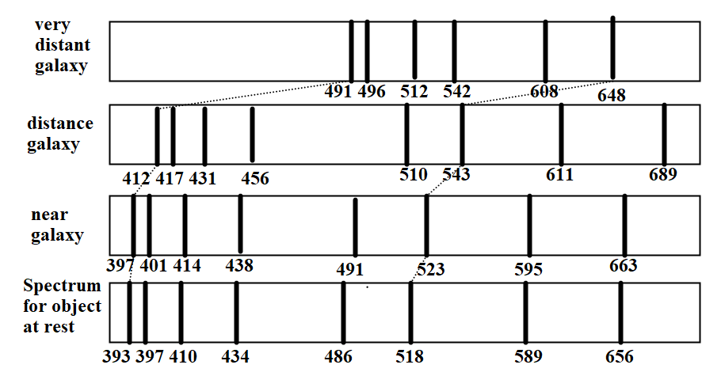

Model 2:
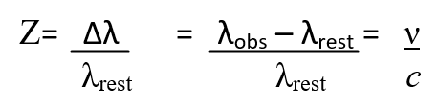
Z : Redshift
∆λ = λ_{obs}-λ_{rest}
λ_{rest} : wavelength for object at rest
λ_{obs} : wavelength for a moving object
ν : velocity of object
c : speed of light, 3x10⁸ m/s

Pick a partner for each of the four appointments labeled on the clock. Write your partner's name down in the corresponding box.
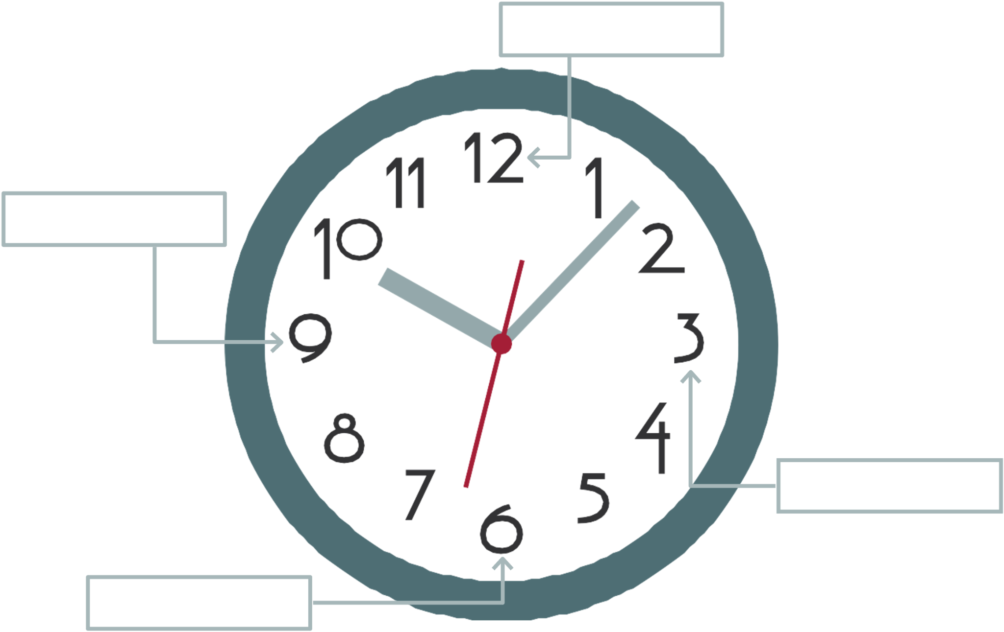

12 o’clock Appointment:
1) What happens to the wavelength of light as objects are moving away from an observer on Earth?
2) What happens to the wavelength of light as objects are moving toward the observer?

3 o’clock Appointment:
3) What is redshift?
4) What is blueshift?

6 o’clock Appointment:
5) According to Model 1, how are all the objects moving relative to the observer?
6) According to Model 2, how are the redshift, z, and the velocity, v, related mathematically?
7) Based on your answer to question 6, which object is moving away from the observed at the largest velocity? Justify your answer.

9 o’clock Appointment:
8) Calculate the redshift for each object in Model 1. You only need one of the wavelengths from each spectra to calculate the redshift. You can use any wavelength you wish.
9) Calculate the velocity for each object in Model 1. (v=Z·c)
10) Do you agree or disagree with the following statement? If you disagree, write the statement so that it is correct.

Objects outside of our galaxy are moving towards us at velocities that can be predicted using a redshift measurement.

