Model 1: The Doppler effect
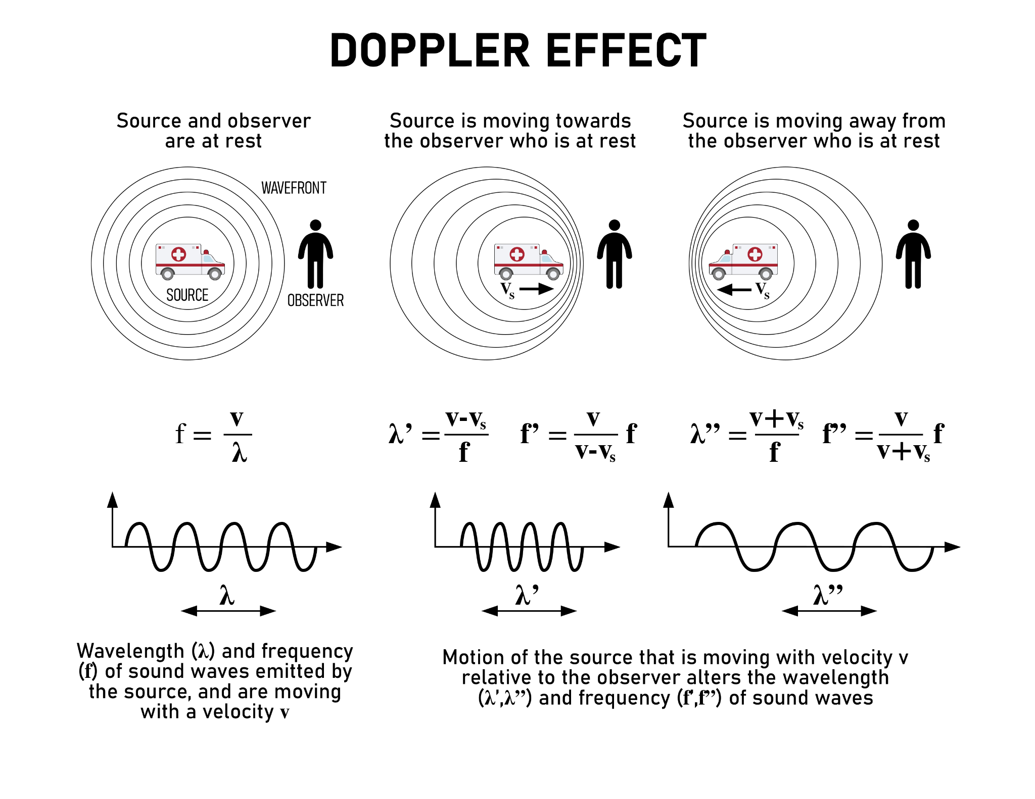

Table 1:
The wavelengths for light emitted by hydrogen atoms at rest (left) and as the hydrogen atoms emitting light are moving away from the observer (right).
Spectral Line | Wavelength/Color  (at rest) |  | Spectral Line | Wavelength/Color  (moving away)
A | 656 nm/ Red |  | A | 729 nm/ Red
B | 486 nm/ Blue green |  | B | 524 nm/ Blue green
C | 434 nm/ blue violet |  | C | 481 nm/ blue violet
D | 410 nm/ Violet |  | D | 452 nm/ Violet

Table 2:
The wavelengths for light emitted by hydrogen atoms at rest (left) as the hydrogen atoms emitting light are moving toward the observer (right).
Spectral Line | Wavelength/Color  (at rest) |  | Spectral Line | Wavelength/Color  (moving towards)
A | 656 nm/ Red |  | A | 632 nm/ Red
B | 486 nm/ Blue green |  | B | 441 nm/ Blue green
C | 434 nm/ blue violet |  | C | 409 nm/ blue violet
D | 410 nm/ Violet |  | D | 387 nm/ Violet

Questions:
1) According to the Doppler effect, when a sound source is moving away from you, what happens to its frequency? The frequency decreases.
2) Recall from the waves unit the equation for the wavelength of light, v =𝝀·f.
Based on your answer to question 1, what happens to the wavelength of the sound source as it moves away? The wavelength increases.
3) According to the Doppler effect, when a sound source is moving towards you, what happens to its frequency? The frequency increases
4) Based on your answer to question 3, what happens to the wavelength of the sound source as it moves toward you? The wavelength decreases.
5) What color of light in the visible spectrum has the longest wavelength? Red
6) If light waves are affected in a similar way as sound waves for objects moving away from the observer, would the light become more reddish or more blueish? Reddish because reds have longer wavelengths.
7) If light waves are affected in a similar way as sound shifts for objects moving toward the observer, would the light become more reddish or more blueish? Blueish because blues have shorter wavelengths.
8) Based on the data in table 1, do the wavelengths of the light become longer or shorter? Longer. Do the wavelengths ‘shift’ towards the red or blue end of the color spectrum? Red What causes this ‘shift’? The lengthening of the wavelengths.
9) Based on the data in table 2, do the wavelengths of the light become longer or shorter? Shorter Do the wavelengths ‘shift’ towards the red or blue end of the color spectrum? Blue What causes this shift? The shorter wavelengths
10) How is light affected by the movement of the light source as it moves towards or away from an observer at rest? If the light source is moving away from the observer, the wavelength will increase and will shift towards the red end of the spectrum. If the light source is moving towards the observer, the wavelength will decrease and will shift towards the blue end of the spectrum.

