STUDENT RECORD SHEET
Picture 1: Butterfly

Perimeter: _________________________ Area: _________________________

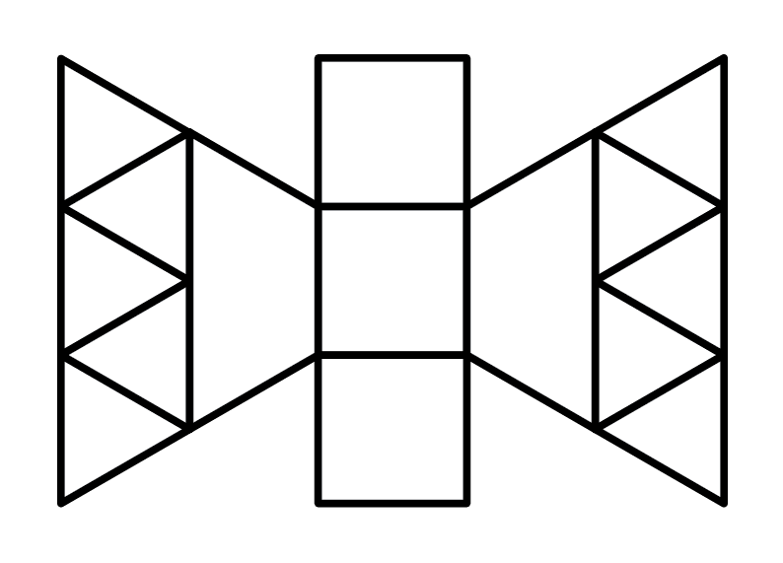
STUDENT RECORD SHEET
Picture 2: Lollipop

Perimeter: _________________________ Area: _________________________

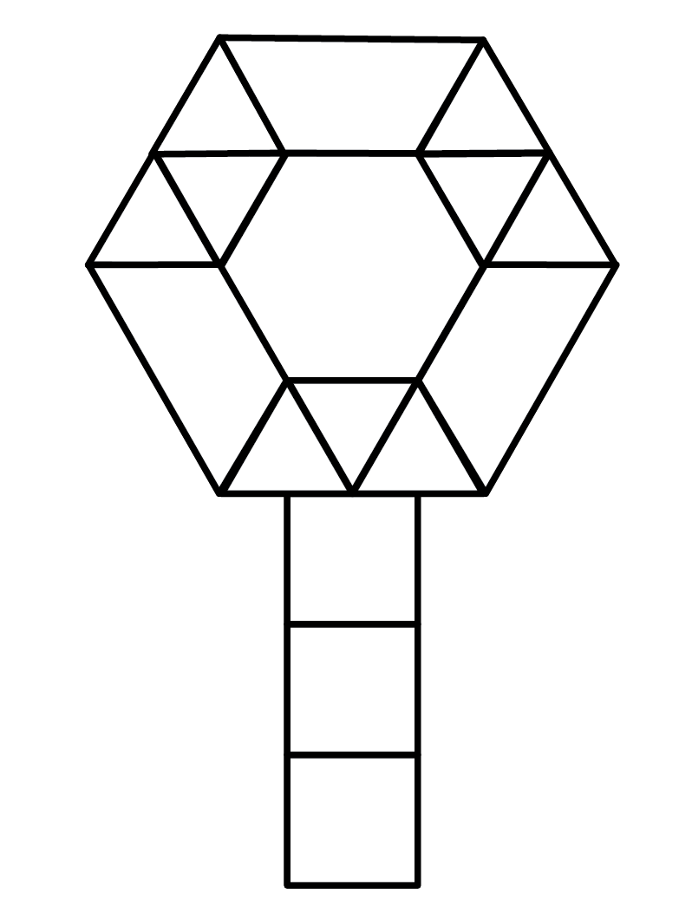
STUDENT RECORD SHEET
Picture 3: Fish

Perimeter: _________________________ Area: _________________________

