**Picture 1: Butterfly**

Perimeter_____________________ Area_____________________

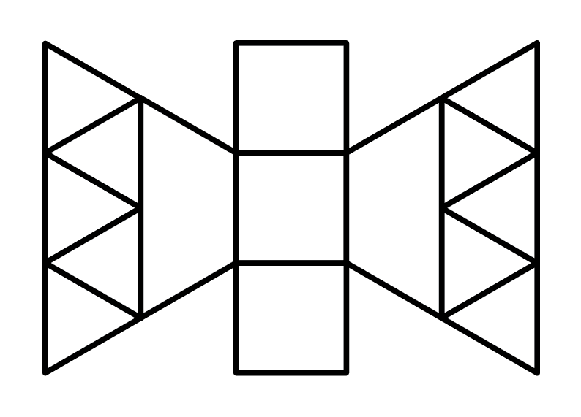

**Picture 2: Lollipop**

Perimeter_____________________ Area_____________________

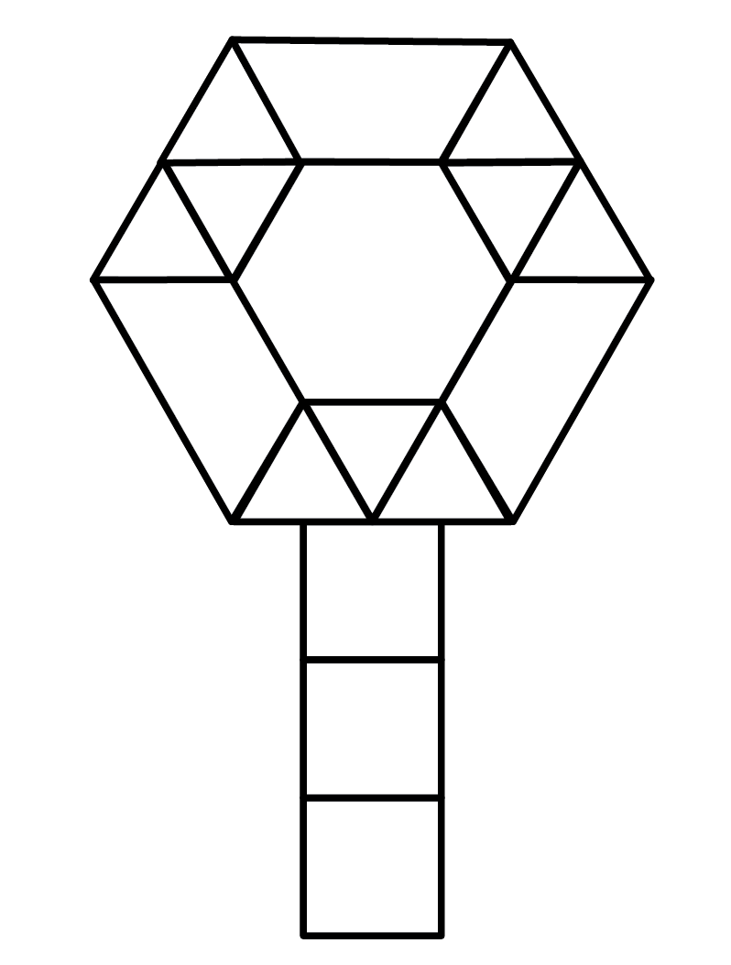

**Picture 3: Fish**

Perimeter_____________________ Area_____________________

