finding the gravitational constant teacher guide
1) Use the “I Notice / I Wonder” table to reflect on the two videos about how Henry Cavendish applied Newton’s Law of Gravitation to measure the gravitational constant using a torsional balance in 1798. | 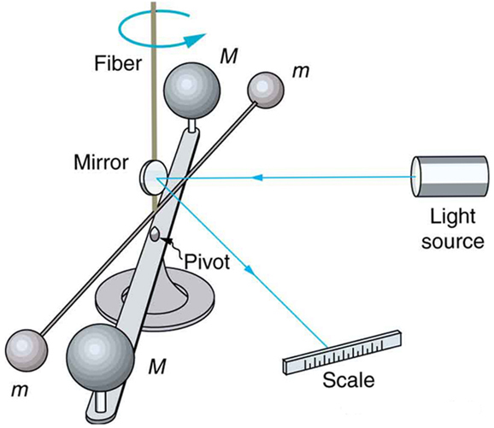
Video 1: https://www.youtube.com/watch?v=4wt0135G8kM&t=38s

Video 2: https://www.fourmilab.ch/gravitation/foobar/videos/foobar1.webm

I Notice | I Wonder
Answers will vary. | Answers will vary.

2) Use the data table and Newton’s Universal Law of Gravity to decide what should be graphed on the x and y axis to make a linear graph and show how the slope of that graph can be used to help you calculate the Gravitational constant, G. | $F_{g}$= $\frac{Gm_{1}m_{2}}{r^{2}}$

M_{Person} (kg) | 50 | 50 | 50 | 50 | 50
M_{Earth} (kg) | 5.97 x 10²⁴ | 5.97 x 10²⁴ | 5.97 x 10²⁴ | 5.97 x 10²⁴ | 5.97 x 10²⁴
r_{Person to Earth} (m) | 6.38 x 10⁶ | 1.29 x 10⁷ | 1.92 x 10⁷ | 2.50 x 10⁷ | 3.21 x 10⁷
F_{g Person} (N) | 489 | 124 | 52.3 | 32.1 | 19.4
x: $\frac{1}{r^{2}}$($\frac{1}{m^{2}}$) | 2.457 x 10⁻¹⁴ | 6.01 x 10⁻¹⁵ | 2.713 x 10⁻¹⁵ | 1.60 x 10⁻¹⁵ | 9.705 x 10⁻¹⁶
y: F_{g Person} (N) | 489 | 124 | 52.3 | 32.1 | 19.4

Answers will vary.
$F_{g}$= $\frac{Gm_{1}m_{2}}{r^{2}}$ $→$ G = $\frac{{F_{g}∙r}^{2}}{m_{1}m_{2}}$
Decide to graph F_{g} vs $\frac{1}{r^{2}}$ to create a linear graph.
Calculate these variables in the table. Want F_{g} on the y axis and $\frac{1}{r^{2}}$ on the x axis.
Graph F_{g} vs $\frac{1}{r^{2}}$, and solve for the slope of graph (slope = $\frac{F_{g}}{\frac{1}{r^{2}}}$).
Relate Newton’s Law of Gravitation back to slope. G = $\frac{{F_{g}∙r}^{2}}{m_{1}m_{2}}$ = $\frac{slope}{m_{1}m_{2}}$
3) Notes from pairing up with another person to discuss the combined answer to the same question.
Answers will vary and build on answer to question 2.

4) Notes from class discussion over the same question.
Answers will vary and build on answer to question 3.

5) With a partner, follow the steps described above to create a graph and use its slope to calculate the gravitational constant.
a) Complete the table above with what will be on the x and y axis.
See table above.
b) Clearly label the variable and unit for each axis on the graph.
See graph below.
c) Include a clearly marked scale for each axis and clearly mark the plotted points.
See graph below.
d) Draw a best fit line for the graph.
See graph below.
e) Show the work to calculate the slope of the graph.
slope = $\frac{rise}{rnn}$ = =

f) Using the slope show the steps to find the gravitational constant.
g) Find the percent error of the calculated value of gravitational constant, if the actual
value of the gravitational constant, G, is 6.67 x 10⁻¹¹ Nm² / kg².
Percent Error = $\frac{⌈Actual-Predicted⌉}{Actual}$ x 100

