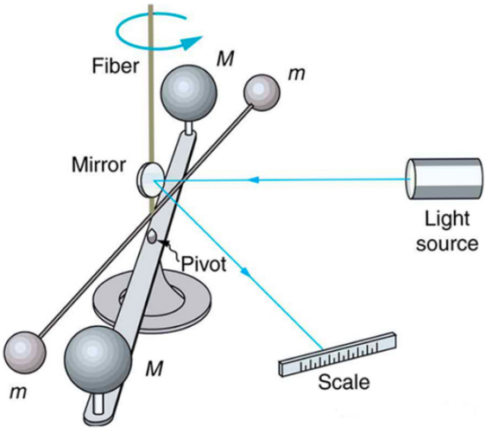
Finding the gravitational constant
1) Use the “I Notice / I Wonder” table as you watch the two videos to reflect on how Henry Cavendish applied Newton’s Law of Gravitation to measure the gravitational constant using a torsional balance in 1798.

Video 1: https://www.youtube.com/watch?v=4wt0135G8kM&t=38s
Video 2: https://www.fourmilab.ch/gravitation/foobar/videos/foobar1.webm
I Notice | I Wonder

2) Use the data table and Newton’s Universal Law of Gravity to decide what should be graphed on the x and y axis to make a linear graph and show how the slope of that graph can be used to help you calculate the Gravitational constant, G. | $F_{g}$= $\frac{Gm_{1}m_{2}}{r^{2}}$

M_{Person} (kg) | 50 | 50 | 50 | 50 | 50
M_{Earth} (kg) | 5.97 x 10²⁴ | 5.97 x 10²⁴ | 5.97 x 10²⁴ | 5.97 x 10²⁴ | 5.97 x 10²⁴
r_{Person to Earth} (m) | 6.38 x 10⁶ | 1.29 x 10⁷ | 1.92 x 10⁷ | 2.50 x 10⁷ | 3.21 x 10⁷
F_{g Person} (N) | 489 | 124 | 52.3 | 32.1 | 19.4
x: __________
y: __________

3) Notes from pairing up with another person to discuss the combined answer to the same question.

4) Notes from class discussion over the same question.

5) With a partner, follow the steps described above to create a graph and use its slope to calculate the gravitational constant.
a) Complete the table above with what will be on the x and y axis.
b) Clearly label the variable and unit for each axis on the graph.
c) Include a clearly marked scale for each axis and clearly mark the plotted points.
d) Draw a best fit line for the graph.
e) Show the work to calculate the slope of the graph.
f) Using the slope show the steps to find the gravitational constant.
g) Find the percent error of the calculated value of gravitational constant, if the actual
value of the gravitational constant, G, is 6.67 x 10⁻¹¹ Nm² / kg².
Percent Error = $\frac{⌈Actual-Predicted⌉}{Actual}$ x 100
