gravity simulation handout
Pull up the Phet simulation on the force of gravity: https://phet.colorado.edu/en/simulations/gravity-force-lab

The simulation displays the force of gravity between object 1 and object 2. Play around with the simulation and answer the following questions.

1) What variables can be changed in the simulation to affect the value of the force of gravity?

2) What is the relationship between the F₁₂ and the F₂₁?

3) Write down whether an increase in each of the variables mentioned above causes the force of gravity to increase or decrease.

4) On each graph below, graph the $F_{g}$vs one of the variables from the simulation that affect the force of gravity. Use at least four points for each graph, and it is recommended to change the value in the simulator by a consistent amount for each variable. There may be extra graphs.
a) In the margin, write out a table with the values from the simulator that you will plot.
b) Clearly label the variable and unit for each axis on each graph.
c) Include a clearly marked scale for each axis and clearly mark the plotted points.
d) Draw a best fit line or curve for each graph.

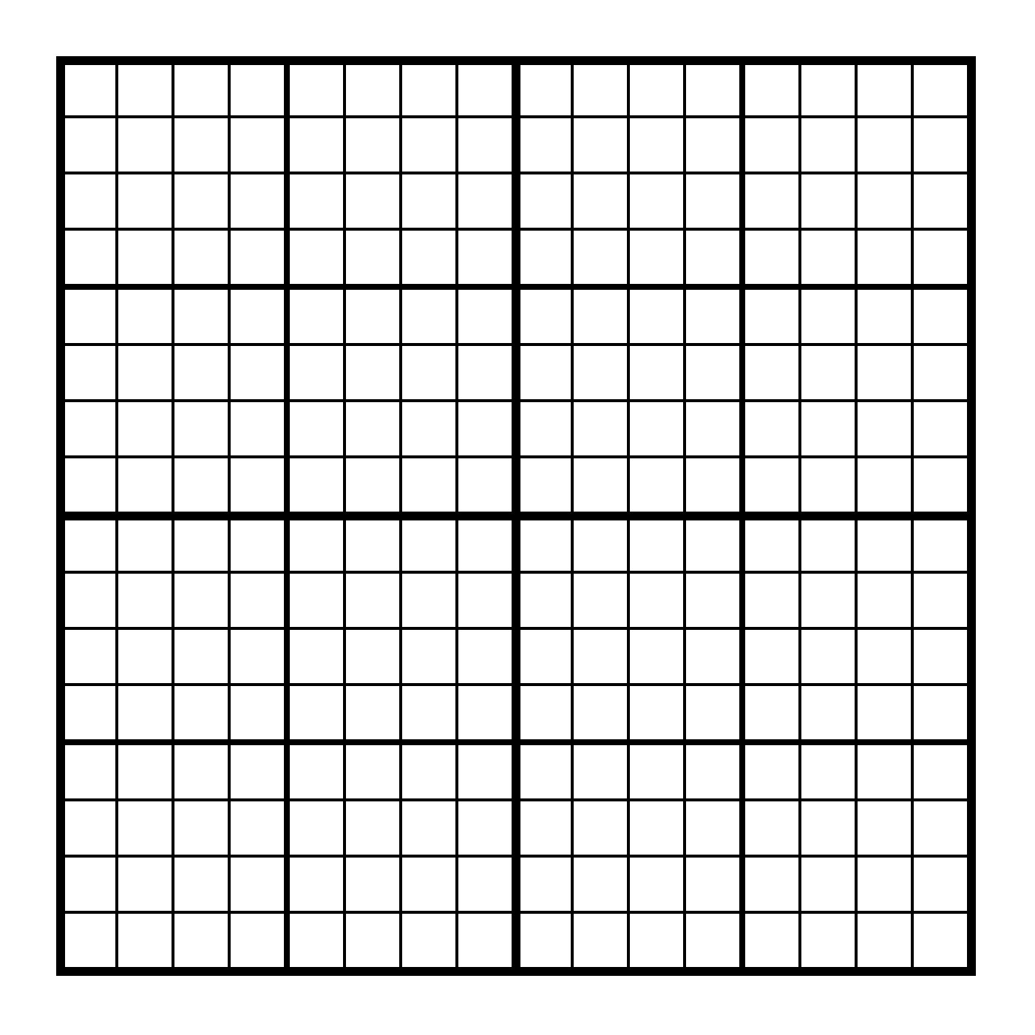

More graphs on the next page.
5) For the variable that was not linear above, use the additional graphs below to find the linear relationship between the $F_{g}$ and the variable.
a) In the margin, write out a table with the values from which you will plot.
b) Clearly label the variable and unit for each axis on each graph.
c) Include a clearly marked scale for each axis and clearly mark the plotted points.
d) Draw a best fit line or curve for each graph.

6) Based on your graphs in the questions above, make statements of how to make each of the variables directly related to the force of gravity. If the variable is indirectly related, then relate it to the reciprocal relationship of the variable.

7) Write out a relationship of the Force of Gravity related to all of the variables at once and multiply all of the variables by the constant G, which will stand for the gravitational constant between all masses. This is Newton’s Universal Law of Gravity.

