newton’s law of gravitation teacher guide
In Newton’s Law of Gravitation, the G stands for the gravitational attractive constant between masses, and it has a value of 6.67 x 10⁻¹¹Nm²/kg². | 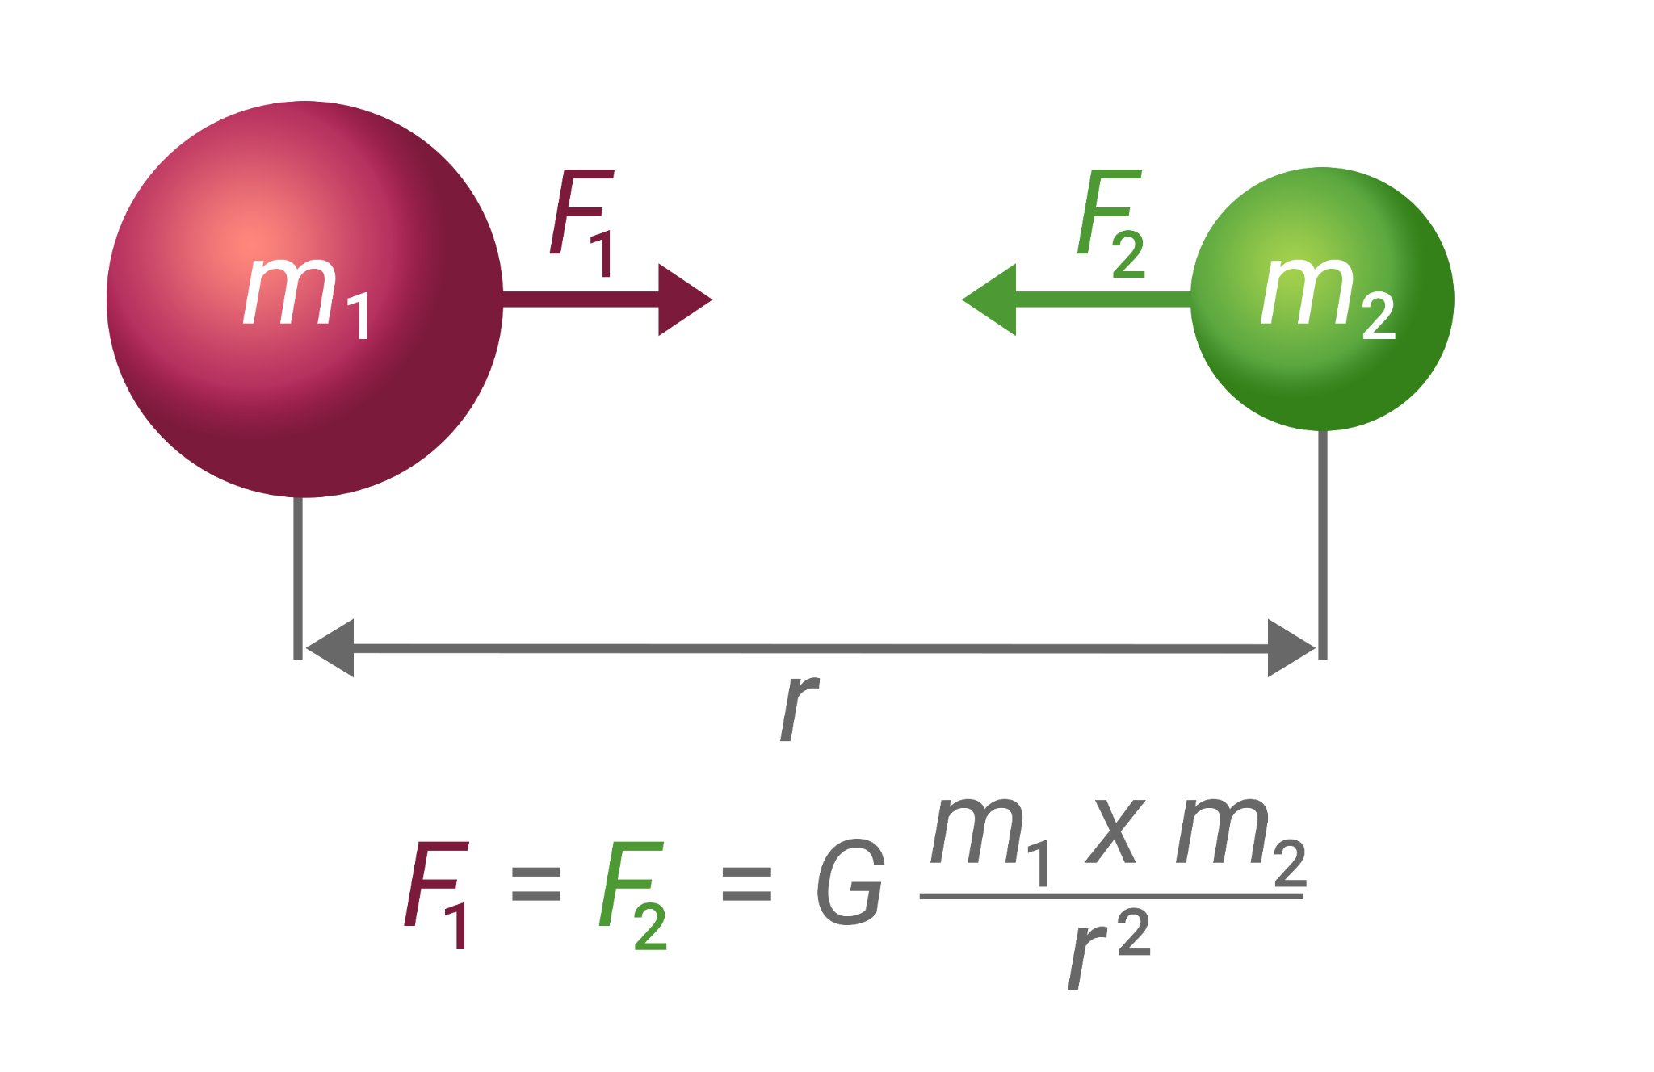

1) Why is the force in the simulation so small, or in other words, why is the force of gravity from the earth acting on you so much bigger than the forces in the simulation?

The mass of the earth is so much bigger than the maximum mass allowed in the simulation, and so the maximum force displayed is much less than the force of the earth attracting an object. The gravitational constant is very small (G = 6.67 x 10⁻¹¹Nm²/kg²), and so you need a huge amount of mass or a very small distance to create a significant force.

2) A 5kg and 10kg sphere are .3m apart (center to center distance). Find the force of attraction between them.

$F_{g}$= $\frac{Gm_{1}m_{2}}{r^{2}}$ = $\left(\frac{(6.67 x {{10}^{-11} )(5kg)(10kg)}^{}}{(.3m)^{2}}\right)$ = 3.71 x 10 ⁻ ⁸N

3) Explain how the force of gravity from the earth on another object could be even smaller than the force values in the simulation.

The earth could be pulling on an object with a very small mass, like an electron (mass = 9.11 x 10⁻³¹kg) or the other object could be a much larger distance away from the center of the earth than the objects in the simulation.
4) Astrologers claim that your personality traits are determined by the positions of the planets in relation to you at birth. Scientists argue that these gravitational effects are so small that they are totally insignificant. Calculate the force of gravity of Mars on the baby. r is the average distance between the Earth and Mars. The distance varies as the planets orbit the sun.
$${(M}_{Mars} = 6.42 x {10}^{23}kg,r_{Earth to Mars} =7.83 x {10}^{10}m, m_{baby} = 3kg)$$

$F_{g}$= $\frac{Gm_{Mars}m_{baby}}{r_{Mars to baby}^{2}}$ = $\left(\frac{(6.67 x {{10}^{-11} Nm^{2}/kg^{2})(6.42 x {10= }^{23}kg)(3kg)}^{}}{(7.83 x {10}^{10}m)^{2}}\right)$
$F_{g}$= 2.1 x 10 ⁻ ⁸N
5) The force of gravity on a 60kg woman is 588N. The woman also exerts a gravitational force on the Earth. How large a force is this?
This is a 3rd law action reaction force. If the force of the earth on the woman is 588N, then the force of the woman on the earth is an equal 588N in the opposite direction.
6) Astrologers claim that your personality traits are determined by the positions of the planets in relation to you at birth. Scientists argue that these gravitational effects are so small that they are totally insignificant. Calculate the force of gravity of the doctor on the baby.
$${(M}_{doctor} = 70kg,r_{doctor to baby} =.5m, m_{baby} = 3kg)$$

$F_{g}$= $\frac{Gm_{doctor}m_{baby}}{r_{doctor to baby}^{2}}$ = $\left(\frac{(6.67 x {{10}^{-11} Nm^{2}/kg^{2})(70kg)(3kg)}^{}}{(.5m)^{2}}\right)$ =
$F_{g}$= 5.6 x 10 ⁻ ⁸N
7) After the answers are presented, compare the gravitational attraction between the baby and Mars in question 4 to the gravitational attraction between the baby and the 70kg doctor in question 6 at the moment of birth.
Both are insignificant, but the force of gravity of the doctor on the baby is larger than the force of gravity of Mars on the baby since the doctor is so much closer and that factor is squared.

