newton’s law of gravitation
In Newton’s Law of Gravitation, the G stands for the gravitational attractive constant between masses, and it has a value of 6.67 x 10⁻¹¹Nm²/kg². | 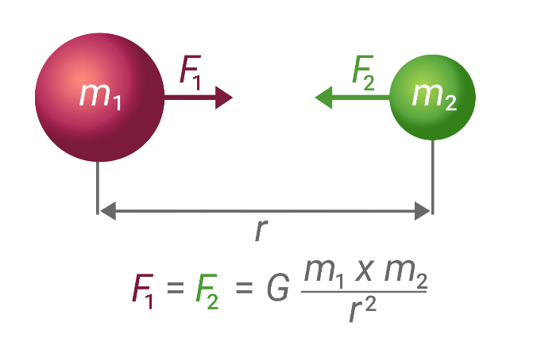

1) Why is the force in the simulation so small, or in other words, why is the force of gravity from the earth acting on you so much bigger than the forces in the simulation?

2) A 5kg and 10kg sphere are .3m apart (center to center distance). Find the force of attraction between them.

3) Explain how the force of gravity from the earth on another object could be even smaller than the force values in the simulation.

4) Astrologers claim that your personality traits are determined by the positions of the planets in relation to you at birth. Scientists argue that these gravitational effects are so small that they are totally insignificant. Calculate the force of gravity of Mars on the baby. r is the average distance between the Earth and Mars. The distance varies as the planets orbit the sun.

5) The force of gravity on a 60kg woman is 588N. The woman also exerts a gravitational force on the Earth. How large a force is this?

6) Astrologers claim that your personality traits are determined by the positions of the planets in relation to you at birth. Scientists argue that these gravitational effects are so small that they are totally insignificant. Calculate the force of gravity of the doctor on the baby.

7) After the answers are presented, compare the gravitational attraction between the baby and Mars in question 4 to the gravitational attraction between the baby and the 70kg doctor in question 6 at the moment of birth.

