behavior of light as a wave
Imagine a wavefront passing through a barrier with small gaps in the barrier. The parts of the wave that pass through the different gaps spread out as they move forward, and if the gaps are close enough and the waves move forward undisturbed, then the waves will eventually overlap and interfere with one another. This interference of the waves creates a new combined wave that has alternating regions where the combined wave amplitude is larger than the individual wave amplitude and regions where the combined wave amplitude is smaller than the individual wave amplitude. | 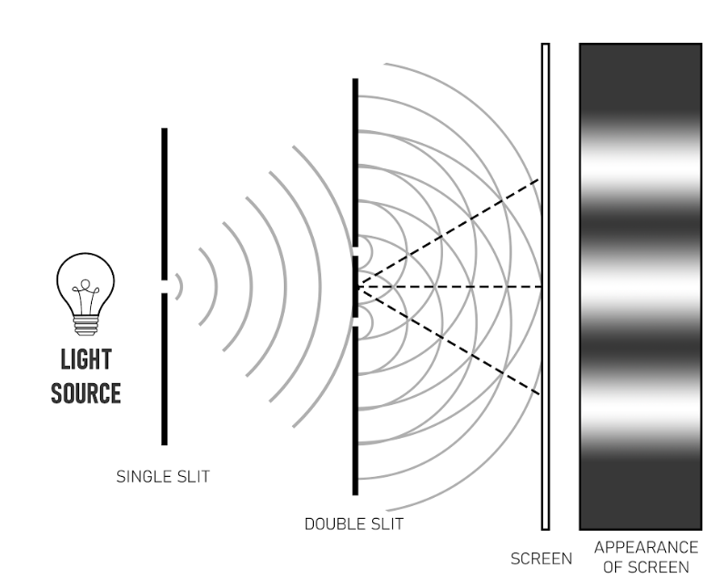
This alternating pattern is known as an interference pattern. In the early 19th century scientists understood that an interference pattern could be created in water and sound because water and sound moved as a wave. In 1801, Thomas Young produced an alternating pattern of bright and dark spots using light in his double slit experiment.
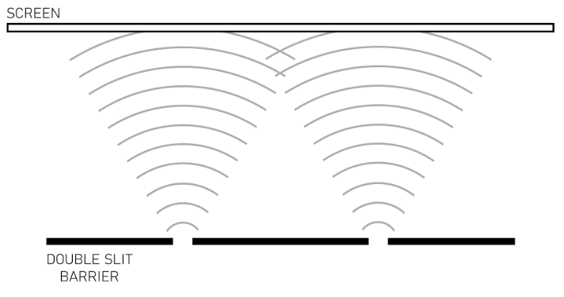 | If the double slit is too close to the screen there is no interference pattern because the waves did not diffract enough for the waves to overlap and interfere with one another.

To understand how wave interference causes the bright and dark spots on the screen we need to go back to the concept of wave addition, which is called superposition. Superposition states that the sum of two waves creates a new wave that is the sum of the amplitude of the two individual waves at every point along the new wave. The superposition of waves produces a bright spot from constructive interference when the waves are completely in phase causing the amplitudes at every point to add together and double in value, and the superposition of the waves produces a dark spot from destructive  interference when the waves are 180º out of phase with each other causing the amplitudes at every point to subtract and cancel each other out. An interference pattern fades between bright and dark spots because the angle that the waves are out of phase changes so that the wave is not completely in phase or out of phase. The center of each bright spot is constructive interference, and the center of each dark spot is destructive interference. | 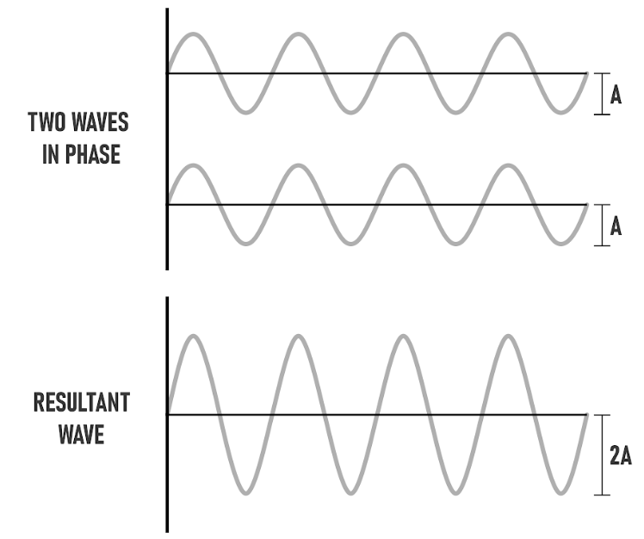  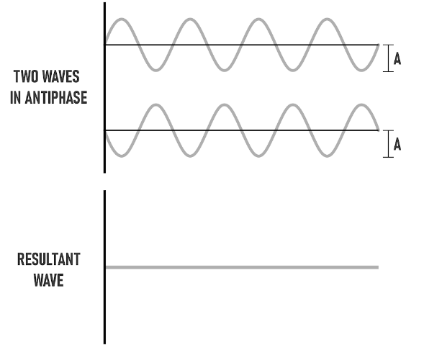

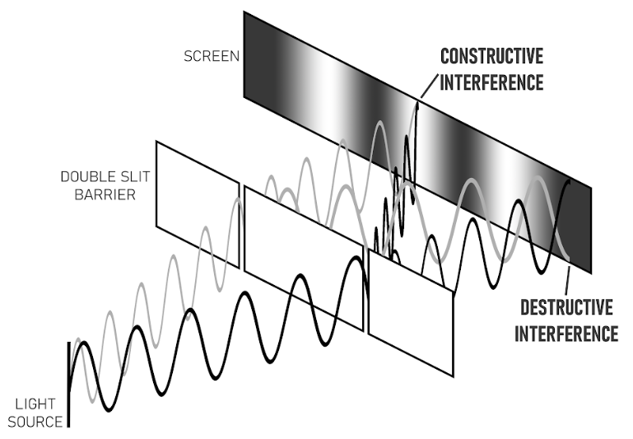 | Each wave travels the same distance to the middle of the screen, and so the waves are still in phase to give constructive interference at the center. However, the waves travel different distances to different parts of the screen, which causes them to arrive out of phase. The waves are still arriving at the screen at the dark spots, but they are 180º out of phase, which cancels the disturbance of each wave to create no net disturbance. Locations between the middle of the bright and dark spots are not completely in or out of phase.
This means that there will be a smaller amount of constructive or destructive interference to produce a different level of disturbance at the screen.
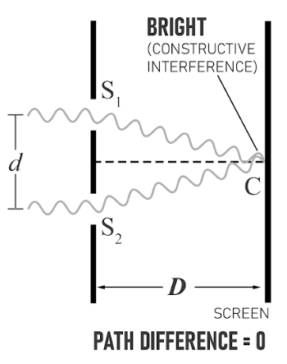 | 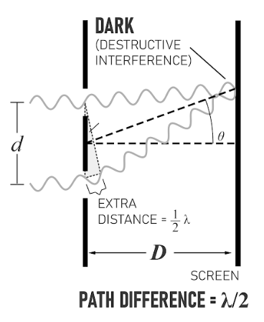 | 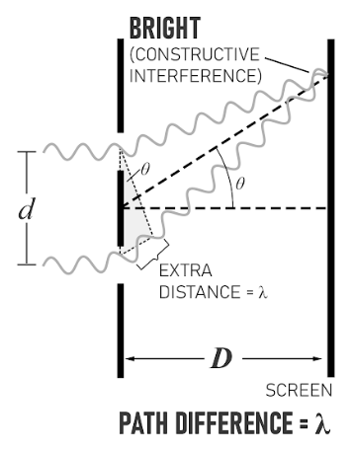

Fringes Of Constructive Interference:  y = $\frac{λD}{d}$ m (where m = 0, $-+ 1$, $-+ 2$, . . . ) | Fringes Of Destructive Interference:  y = $\frac{\frac{1}{2} λD}{d}$ m (where m = $-+ 1$, $-+ 2$, . . . )

These equations assume that the width of the slits is insignificant, and that the distance to the screen (D) is much larger than the distance between the slits (d) in order to simplify the equations.

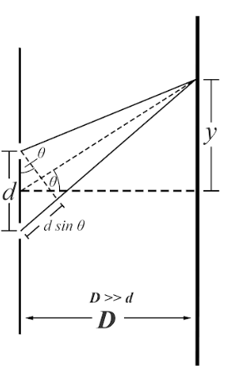 | dsin$θ$ in the diagram is the difference in distance that the light needs to travel from each slit to a specific position on the screen. When dsin$θ$ equals $mλ$, then the waves are completely in phase creating constructive interference of the wavelength. When dsin$θ$ equals $(\frac{1}{2})mλ$, then the waves are completely out of phase creating destructive interference, where the amplitude of the two waves cancel.  y is the distance from the center of the screen to where the observation is being made.  D is the horizontal distance from the double slit to the screen.  d is the distance between the slits

Questions:
1a) Use the equation, y = $\frac{λD}{d}$ m, to mathematically justify how increasing the distance to the screen, D, changes the distance between the bright fringes, y.
Increasing D in the numerator on the right, increases y in the numerator on the left. They are directly proportional to each other.

1b) Create an argument to help intuitively explain why changing D would have this effect.
The larger distance to the screen allows the wavefronts to expand as they move away from the slits. The location of each fringe is at a certain angle relative to the horizontal, and so the further back that the screen is, the larger y becomes.

2a) Use the equation, y = $\frac{λD}{d}$ m, to mathematically justify how increasing the wavelength, $λ$, changes the distance between the bright fringes, y.
Increasing in the numerator on the right, increases y in the numerator on the left. They are directly proportional to each other.

2b) Create an argument to help intuitively explain why changing $λ$ would have this effect.
Making $λ$ bigger means that there is a bigger distance between fringes because there is a bigger distance between constructive interference fringes which equals the difference between the two paths (dsin$⊖$ = $λ$) to get to the screen from the slits.
3a) Use the equation, y = $\frac{λD}{d}$ m, to mathematically justify how increasing the distance between the slits, d, changes the distance between the bright fringes, y.
Increasing d in the denominator on the right, decreases y in the numerator on the left. They are indirectly proportional to each other.

3b) Create an argument to help intuitively explain why changing d would have this effect.
In the extreme case when the distance between the slits is infinitely small the opening would act like one slit with one bright spot across from it. The distance to the next bright spot would be an infinite distance away. This shows that when d decreases, y would increase.

Making d bigger means that the distance between fringes decreases. When the difference in distance between the two paths is a multiple of the wavelength there is constructive interference at the screen. When the overall distance traveled to the screen is bigger because the distance between the slits is bigger, changing the path by the wavelength of light is less significant to the overall path distance, then when the distance traveled by the light is smaller when the distance between the slits is small.

