classical wave theory teacher guide
The photoelectric effect became an exciting experiment in the late 19th century. It was discovered that when light was absorbed by a piece of metal, the metal could absorb enough energy from the light to eject electrons with their own kinetic energy. Scientists wanted to use the Classical Wave Theory to explain what was happening.

Classical Wave Theory said that light was an electromagnetic wave that could be described by its brightness and color. The brightness of light is its intensity, which is proportional to the square of the amplitude of the wave. Remember that the amplitude is the distance between the crest of the wave and its equilibrium position. The color of light is related to its frequency, which represents how many cycles per second that it completes. Classic Wave Theory said that the energy of the wave was related to the brightness of the wave, not the color of the wave.

1) What does Classical Wave Theory predict happens to the kinetic energy of the ejected electrons when the brightness (intensity) of the light is increased?
Hint: Think of a wavefront launching a boat across the water. Which wavefront will move the boat more quickly?
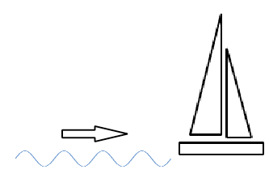 | 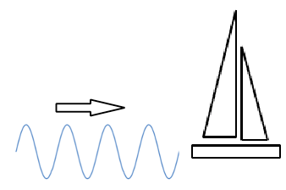
same frequency, smaller amplitude | same frequency, larger amplitude
Classical Wave Theory predicts that a brighter light (wave with more amplitude) will give the ejected electrons more kinetic energy (will move the boat faster). Larger intensity has more energy which transfers more energy to the ejected electrons.

2) What does Classical Wave Theory predict happens to the kinetic energy of the ejected electrons when the color (frequency) of the light is increased?
Hint: Think of waves launching a boat across the water. Which wavefront will move the boat more quickly?
 | 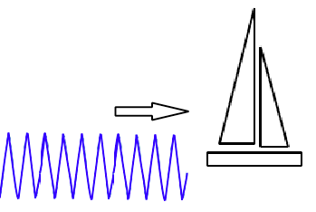
same amplitude, smaller frequency | same amplitude, larger frequency
Classical Wave Theory predicts that a different color light (higher frequency) does not change the ejected electrons' kinetic energy (does not change the boat's speed). The wavefront is still moving the same speed regardless of how quickly it oscillates.

3) What does Classical Wave Theory predict happens to the rate at which electrons eject from the surface of the metal when the color (frequency) of the light is increased?
Classical Wave Theory predicts that increasing the color (frequency) of the light will increase the rate at which electrons eject from the surface of the metal because energy is transferred to the electrons with the arrival of every wavefront. Increasing the frequency increases the energy to eject a larger number of electrons by having more rounds of ejection in the same amount of time.

4) What does Classical Wave Theory predict about the time it takes to eject an electron from different types of metal. The bonds in some materials are stronger, and it takes more energy to enable the electron to break free from the surface.
Classical Wave Theory predicts that the incoming wave will give more and more energy to the metal surface over time. This energy will be spread out between the different atoms, and as more wavefronts hit, eventually an electron will be ejected. With materials that require more energy to break the electrons free it will take more time to absorb enough energy to eject the electrons.

Final Slide:
There are three results from the Photoelectric Effect that contradict the Classical Wave Theory.

1) Brightness (Intensity) of light is found to have no effect on the kinetic energy of the ejected electrons. The color (frequency) of light is found to have a direct effect on the kinetic energy of the ejected electrons.

2) Regardless of the energy required to eject the electron from different metal surfaces, there is almost no delay to build up the energy to eject the electrons.

3) There is a threshold frequency required to eject electrons from a specific surface. Regardless of how bright (intense) the light, the electron will not be ejected if the frequency of the light is less than the minimum value.

