Diffraction and double slit experiment teacher guide

Part 1 : Diffraction
PhET Wave Simulation: https://phet.colorado.edu/en/simulation/wave-interference
1.) Set up instructions for simulation:
Click the play button  on the simulation. | 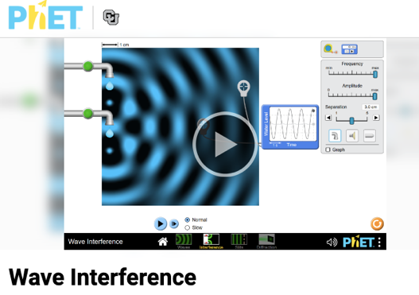

Click on the  “Diffraction” option. | 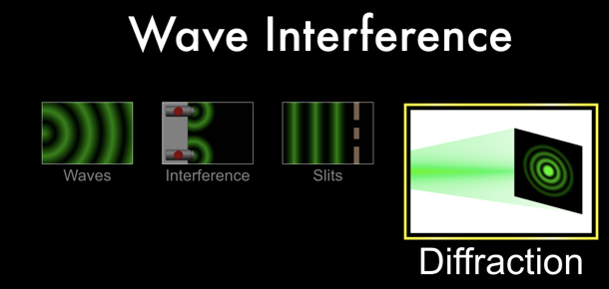
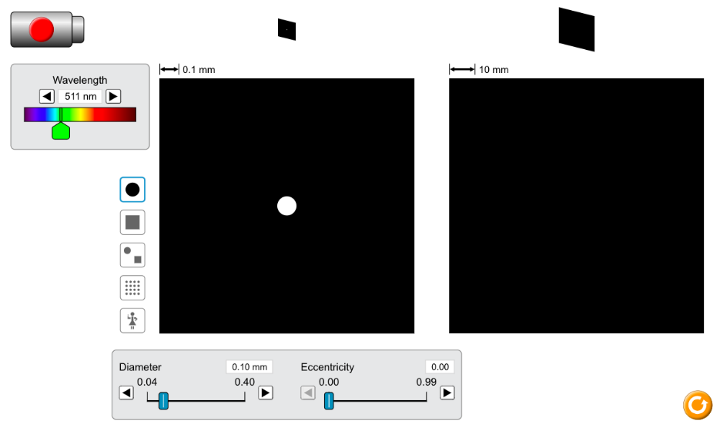
Hit the red button on the laser to shine it through the hole and hit the screen.
Diffraction is the spreading out of light as it passes through a small opening or around an object, which is why the circle of light on the screen is larger than the hole that it passed through.

1) Use constructive and destructive interference to explain the dark and light circles centered around the central light spot.
The diffraction (spreading out of light) causes the light to go to the light and dark spots. The light parts are created from light coming from two parts of the hole coming together at the screen in phase with each other so that two crests coming together create constructive interference. The dark parts are created from light coming from two parts of the hole coming together at the screen out of phase with each other so that a crest comes together with a trough where they cancel amplitude, which is destructive interference. The light spreads out more and more from the center as it moves farther from the hole. So, far away from the center there are no more bright circles because the light does not reach out that far yet.

2) Adjust the diameter of the hole and write down the relationship between the size of the hole and the amount of diffraction (how big the circle of light on the screen gets).
The smaller the hole gets the more diffraction (the circle of light becomes bigger) there is.

3) Adjust the wavelength of the light and write down the relationship between the wavelength and the amount of diffraction.
The smaller the wavelength the less diffraction (the circle of light becomes smaller) there is.

Hit the red button on the laser to turn it off and hit the square button to change the aperture (opening) to a square shape.

4a) Write down a prediction of what will happen if you minimize the width and maximize the height.
Answers will vary.

4b) Minimize the width and maximize the height and write down the result when the laser is turned back on.
The vertical slit creates a horizontal dashed line with a thicker brighter spot in the middle. There is a lot of horizontal diffraction because of the narrow horizontal aperture, and there is little vertical diffraction because of the wide vertical aperture.

5a) Write down a prediction of what will change if you maximize the width and minimize the height.
Answers will vary.

5b) Maximize the width and minimize the height and write down the result.
The horizontal slit creates a horizontal dashed line with a thicker brighter spot in the middle. There is a lot of vertical diffraction because of the narrow vertical aperture, and there is little horizontal diffraction because of the wide horizontal aperture.

6a) Write down a prediction of what will change if you minimize the width and minimize the height.
Answers will vary.

6b) Minimize the width and minimize the height and write down the result.
The aperture is small vertically and horizontally creating a lot of diffraction vertically and horizontally, which creates a cross of large dots with the biggest and brightest in the middle.

7a) Write down a prediction of what will change if you maximize the width and maximize the height.
Answers will vary.

7b) Minimize the width and minimize the height and write down the result.
The aperture is large vertically and horizontally creating little diffraction vertically and horizontally, which creates a cross of small dots with the biggest and brightest in the middle.

Part 2: Double Slit Interference
PhET Wave Simulation: https://phet.colorado.edu/en/simulation/wave-interference
Set up instructions for simulation:
-Click the play button
on the simulation.

-Click on the  “Slits” option. | 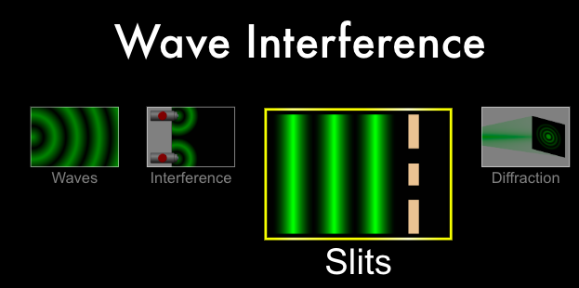

Click on the light icon in the toolbar on the right. | 

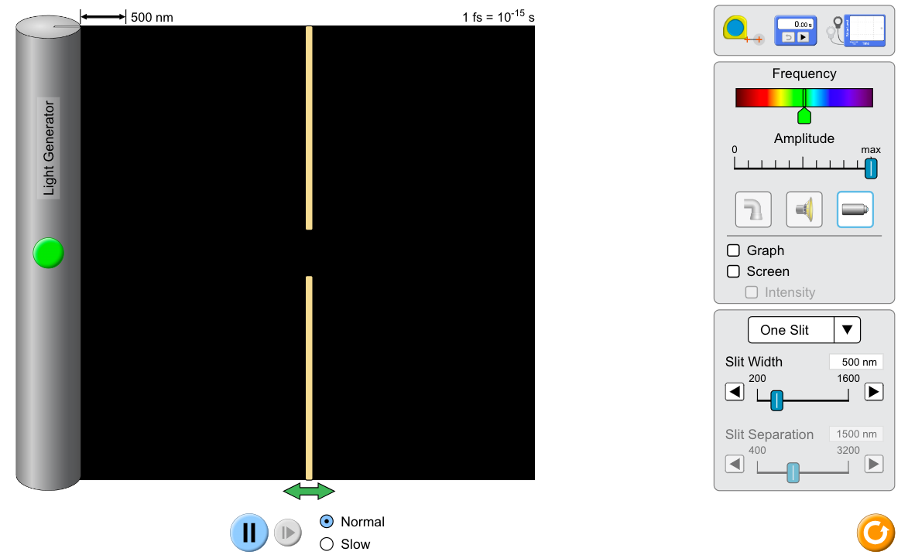
Drag the green arrow at the bottom under the slit all of the way to the right.
Drag the slit separation bar all the way to the right (3,200nm).
Change the drop-down menu in the tool bar from “One Slit” to “Two Slits.”
Click next to the screen in the toolbar so that a checkmark appears.
Click next to intensity in the toolbar so that a checkmark appears.
Click the green button to turn the light generator on.
1) Wait a few seconds for the light to reach the screen. Adjust the intensity graph so that the peaks do not leave the graph.
a) Draw the pattern on the screen and the intensity graph.
b) Explain why this pattern appears.
The wavefronts reached the double slit barrier. All of the wavefront was blocked except for the parts in front of the openings. The unblocked portions went through the barrier and hit the screen directly across from the openings creating two bright spots. | 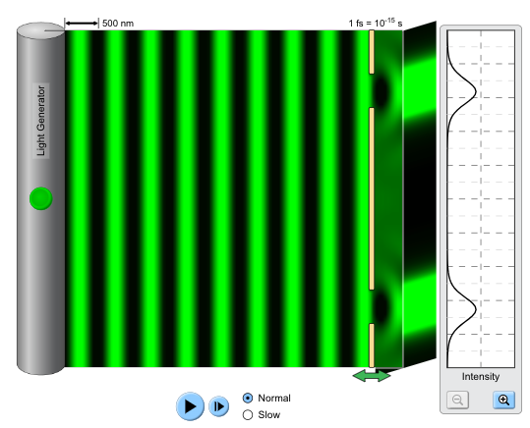

Drag the green arrow at the bottom under the slit all of the way to the right.
2) Wait a few seconds for the light to reach the screen. Adjust the intensity graph so that the peaks do not leave the graph.
a) Draw the pattern on the screen and the intensity graph.
b) This is called an interference pattern. Use constructive and destructive interference
to explain why the pattern is different from the pattern in question 1.
The fact that there are more bright spots than holes in the barrier means that light is not simply passing through the barrier and striking the screen across from the opening. Diffraction could explain the widening of the bright spots, which is how the light bright spots are across the screen, but diffraction does not explain why there are dark spots within the pattern. This is an interference pattern. When the crests of two waves meet at the screen it creates constructive interference and a bright spot, but when a crest meets a trough at the screen the amplitudes of the waves cancel creating destructive interference and a dark spot. | 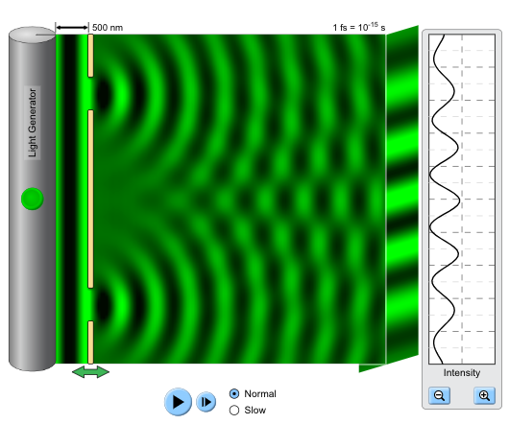
3) Change the wavelength of light to determine how it changes the separation of the bright and dark fringes. Use the “Wavelength” slide bar on the left.
Increasing wavelength increases the space between the dark and bright fringes.

4) Change the distance between the slits (see diagram to left) and record how it changes the separation of the bright and dark fringes. Use the “Slit Width” slide bar on the right toolbar. Be aware that if d is too big the interference pattern will disappear when the waves no longer overlap.
Increasing the distance between the slits decreases the space between the dark and bright fringes.

5) Change the distance between the double slit barrier and the screen (L) and record how it changes the separation of the bright and dark fringes. Use the “Barrier Location” slide bar on the right toolbar. Be aware that if L is too small the interference pattern will disappear when the waves no longer overlap.
Increasing the distance between the slits and the screen increases the space between the dark and bright fringes.

What Did I Learn Today? Reflection Questions Sample Responses

1a) Why can you hear your friend yelling from around the corner even though you cannot see him? Both light and sound are waves that diffract, and so why is there a difference? (Hint: Refer to question 3.)
Low frequency waves with large wavelengths, like sound, diffract much more than high frequency waves with short wavelengths, like light. Higher frequency waves are more directional than low frequency waves.

1b) A flute is higher pitched than a drum, but explain why it is hard to hear the difference between when the sound from each instrument would come to you around the corner as the marching band came down the hallway while it is not hard at all to tell that you hear the instruments before you see the marching band?
Visible light is in hundreds of nanometers, while both a drum and a flute have wavelengths of a few feet or multiple inches. This means that the sound waves are millions or billions of times longer than the light waves, which means that they diffract much more than the light to make it around the corner.

2.) State the effect of increasing each of the variables on the distance from the central bright spot to the next bright spot (y) in the interference pattern. The variables are the distance from the double slit to the screen (D), the wavelength of the light used (λ), and the distance between the slits (d).
Increasing D, increases y.
Increasing, increases y.
Increasing d, decreases y.

Wave interference‬ - phet interactive simulations. (n.d.-q). https://phet.colorado.edu/sims/html/wave-interference/latest/wave-interference_en.html

