exit ticket teacher guide

Materials
Red Laser pointer  Green Laser pointer  Blue Laser pointer | Double Slit  Diffraction Grating with smaller number of slits  Diffraction Grating with larger number of slits
Safety:
5mW lasers can cause eye damage, but that is the standard threshold for lasers in the classroom because it is possible to blink or jerk your head away from a beam before damage is done. Lasers should be used with caution. It is good practice to have everyone behind the laser, have the laser below significantly below eye level, and in advance check to see where stray beams of the laser are deflected during the experiment.

Procedure:
For each of the following pairs of demonstrations have the students write down their explanation of how and why the interference pattern is changing when the following variables change: distance between the slits and the screen (D), wavelength of the light (λ), and distance between the slits (d).

You can mount the laser and the slide on ring stands, or just hold the laser pointer and double slit in your hand. The pattern will show up better with the lights off, and the blue light especially shows up better shining onto a piece of paper rather than the whiteboard.

Questions:
1) Shine the red laser through the double slit from a close distance to the screen, and a large distance from the screen. First picture D is small, and the second picture D is big. The top line in each picture is 500 lines/mm, and the bottom line is 1,000 lines/mm, but for this comparison the number of slits/mm is the same, so you are comparing top line to top line or bottom line to bottom line between the two pictures.
When the double slit is farther from the screen, the distance between the constructive interference bands is farther apart. The larger distance to the screen allows the wavefronts to expand as they move away from the slits. The location of each fringe is at a certain angle relative to the horizontal, and so the further back that the screen is, the larger y becomes.
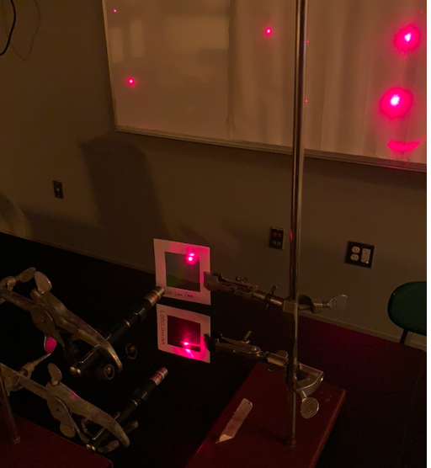

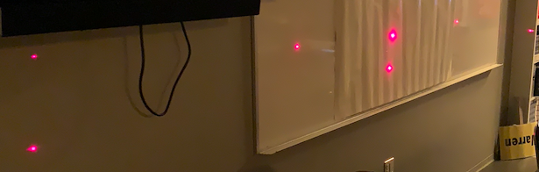

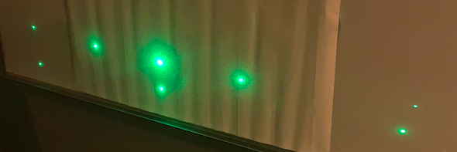
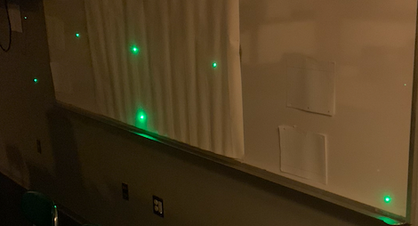
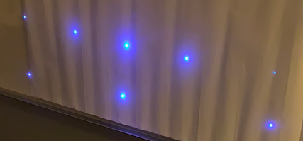

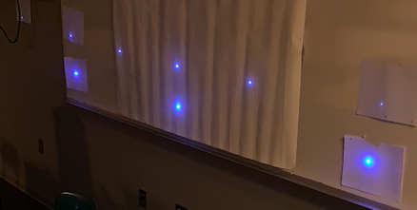
2) Shine the red laser (λ= 650nm), the green laser (λ= 510nm), and the blue laser (λ= 475nm) through the same double slit at the same distance from the screen.
When the wavelength of the light increases, the distance between the constructive interference bands is farther apart. Making bigger means that there is a bigger distance between fringes because there is a bigger distance between constructive interference fringes which equals the difference between the two paths (dsinθ =λ) to get to the screen from the slits.
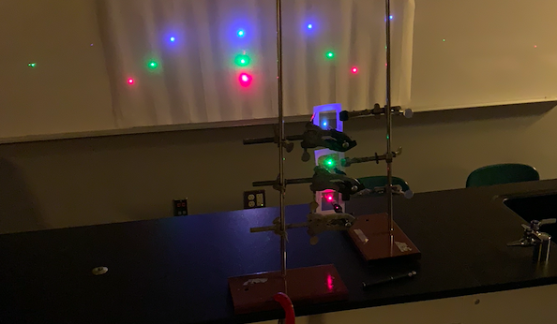

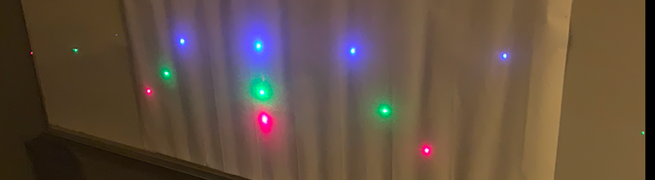
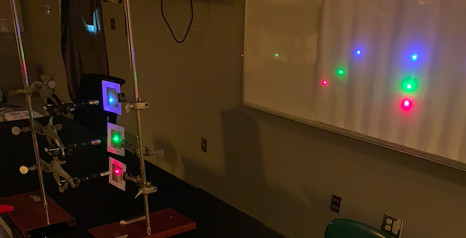

3) Shine the red laser through the diffraction grating with slits that are close together and with slits that are farther apart at the same distance from the screen. The top line is 500 lines/mm, and the bottom line is 1,000 lines/mm.
When the distance between the slits increases, the distance between the constructive interference is closer together. In the extreme case when the distance between the slits is infinitely small the opening would act like one slit with one bright spot across from it. The distance to the next bright spot would be an infinite distance away. This shows that when d decreases, y would increase.

Making d bigger means that the distance between fringes decreases. When the difference in distance between the two paths is a multiple of the wavelength there is constructive interference at the screen. When the overall distance traveled to the screen is bigger because the distance between the slits is bigger, changing the path by the wavelength of light is less significant to the overall path distance, then when the distance traveled by the light is smaller when the distance between the slits is small.
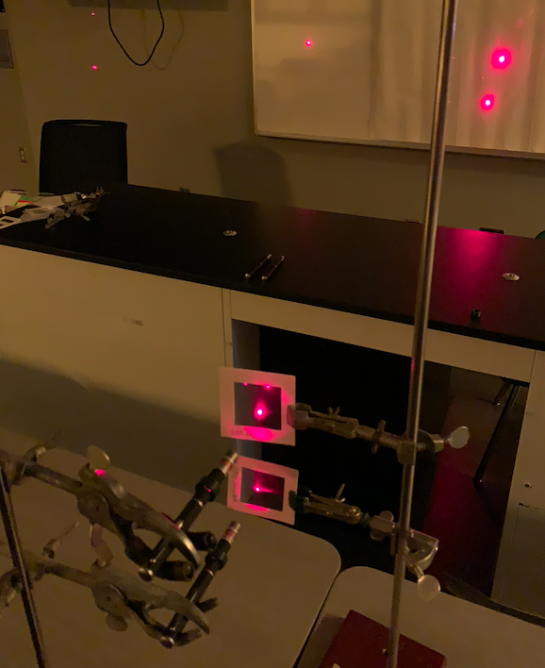

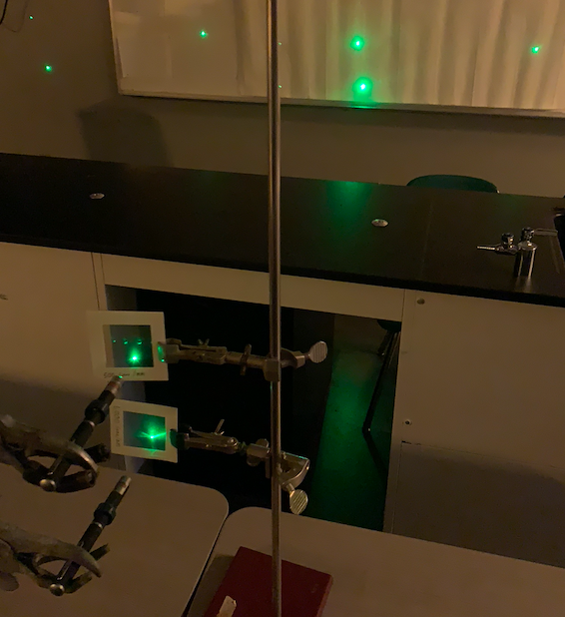

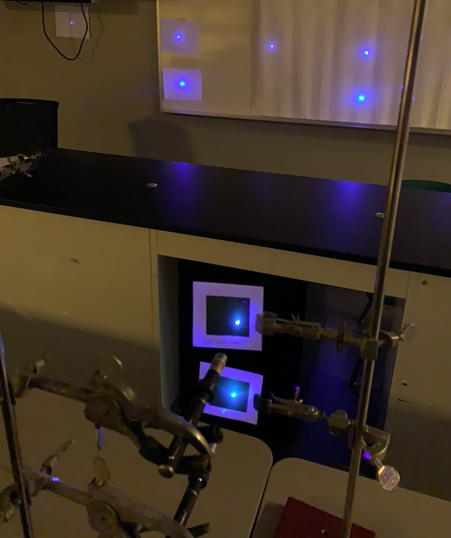

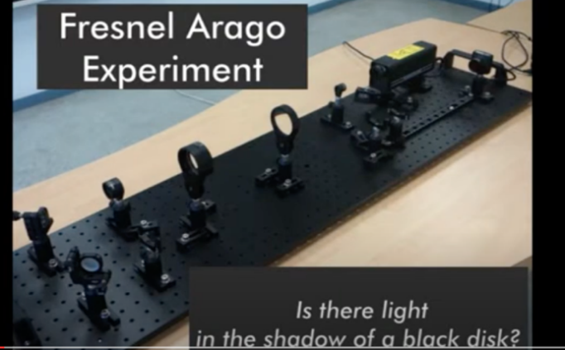  https://www.youtube.com/watch?v=xHHhbR5evq0 | 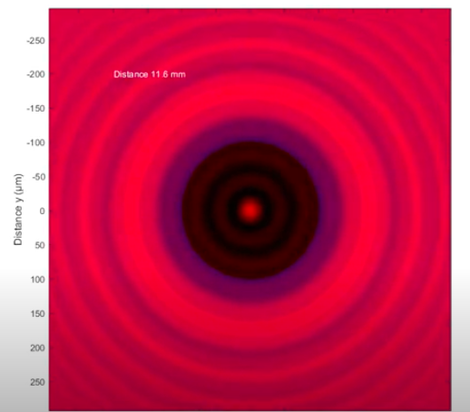  https://www.youtube.com/watch?v=fgJnPE-dm4M

4a) Watch the video on the Arago spot and explain how there is a bright spot in the shadow of an opaque object.
Diffraction causes the light to spread out behind the object once it passes the object, and constructive interference creates a bright spot where the crests of combining waves meet.

4b) Explain why there is a bright spot in the very middle of the shadow specifically.
In the very middle all of the light from the different spots on the edge have an equal distance to travel, which means that all of the waves arise in phase leading to constructive interference creating the bright spot.

