Exit ticket teacher guide
- Imagine that electrons are being shot through a double slit as shown in the left image, and the result is shown on the screen. Explain why this result is counterintuitive to what was expected and how it forced scientists to view the situation more like the image on the right.
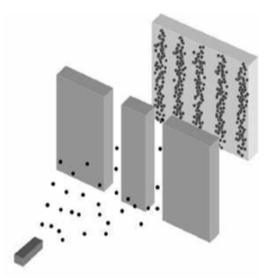 | 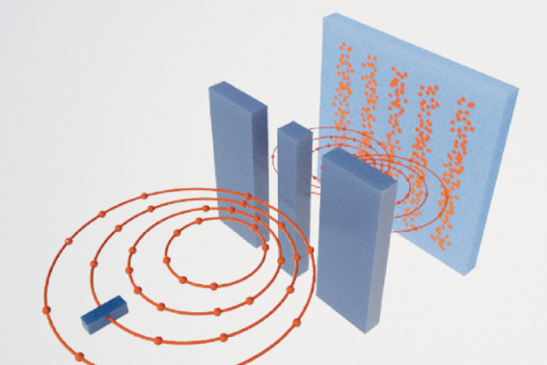
Shooting particles through a double slit should result in two spots of intensity right in front of each of the openings. This is what you see when the slit is large enough and the particles are big enough. However, once the slit is small enough, the particles passing through the slits create an interference patten. Even if the particles are shot through one at a time, the interference pattern still appears, and if a detector is added, the interference pattern disappears. The individual particles are acting like waves, passing through both slits and interfering with themselves. Scientists conclude that in some experiments, the particles will act like waves, in some experiments the particles act like particles, and in some experiments, they could act like either.
- According to De Broglie Wavelength (𝜆 = $\frac{h}{p}$), we do not see the wave nature of objects like a person because of the concept described below:
The wavelength of any object that has a mass of a couple of kilograms has a wavelength that is too small to measure. For example, a person with a mass of around 70kg jogging down the road at 3m/s has a wavelength of 3.155 x 10⁻³⁶ m (𝜆 = $\frac{h}{mv}=$ $\frac{6.626 x 10^{-34} J∙s}{(70kg)(\frac{3m}{s})}$ = 3.155 x 10⁻³⁶ m).
The smallest measurements of length ever done were at the Large Hadron Collider (LHC), and those measurements were only 10⁻¹⁸m. We are not able to measure the wavelength of a person. We need to look at objects with very small masses to measure their wavelengths.
- The Heisenberg’s Uncertainty Principle is $Δ$x $Δ$p $≥$ $\frac{h}{4π}$.
  - Explain what each variable on the left side of the equation means.
  - Why do we not notice the effect of the Heisenberg Uncertainty on objects like a soccer ball?

$a) Δ$ represents the uncertainty of each measurement. x is for position, and p is for momentum. The left side of the equation must be greater than $\frac{h}{4π}$. If the uncertainty in position is within a very small range, like making the slit very small, this means that there is a large range in the momenta. Like in the Veritasium video, there will be a larger range of angles so that the light scatters out wider on the screen, which can also just be viewed as diffraction if it is thought of like a wave.
b) $\frac{h}{4π}$ is very small, and so unless you are measuring extremely precisely, you will never observe that there is a minimum constant that it must exceed. The stairstep instrument in the quantization is very small.
- One way of observing a small particle is to shoot a high energy photon at it, which will give the particle a big kick. Watch the Science ABC video clip from 1:15-2:15. Is the act of measuring a particle’s position or momentum altering the particle’s position or momentum the reason for the uncertainty in Heisenberg’s Uncertainty Principle?
No, the observation is not the fundamental thing about the Heisenberg Uncertainty Principle. At a small enough scale objects have properties of waves and particles, and it does not make any sense to talk about a precise value of position or momentum because the object does not necessarily have one specific value. By measuring it, it behaves like a particle, but without the measurement it is capable of making an interference pattern made of multiple positions. So, it is not the measurement that creates the uncertainty.
- How does adding all the waves on the left to create the wave pulse on the right fit with Heisenberg’s Uncertainty Principle.
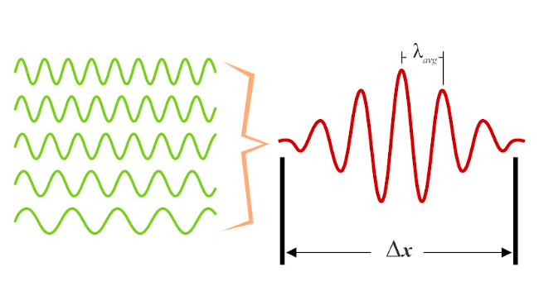
It shows the fundamental nature of the Heisenberg Uncertainty Principle. It is not just a measurement error or the observer effect during the measurement. To get a narrow range in position, you need to add multiple momenta waves, which create an interference pattern that begins to localize the position wave pulse. You could also add multiple position waves to create an interference pattern to begin to localize the momentum wave pulse. To get a more precise result in one, you need to add more possibilities in the other to physically localize the first.

Science ABC. (2020, November 25). What is the Heisenberg uncertainty principle: Explained in simple words. Video. YouTube. https://www.youtube.com/watch?v=m7gXgHgQGhw

