Fourier Making Waves PhET Simulation teacher guide
Fourier Making Waves PhET Simulation:
https://phet.colorado.edu/en/simulations/fourier-making-waves/about
Set up instructions for simulation: | 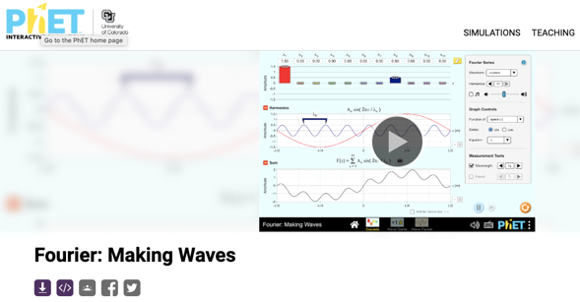

Click on “Discrete.” | 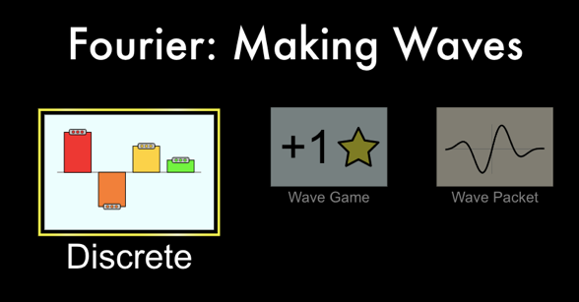

Website: | 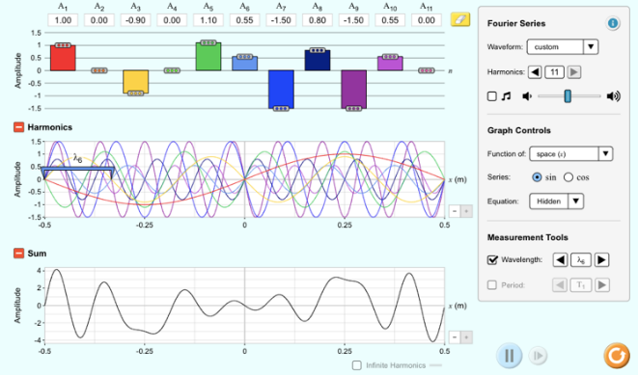

- Drag the different amplitude bars in the top third of the simulation up or down. Each amplitude bar that you move away from 0 amplitude adds another individual wave in the middle section of the simulation. The bottom third of the simulation shows the superposition of all of the waves together.

Go to the wave game.
Hit “Wave Game” at  the bottom of the screen. | 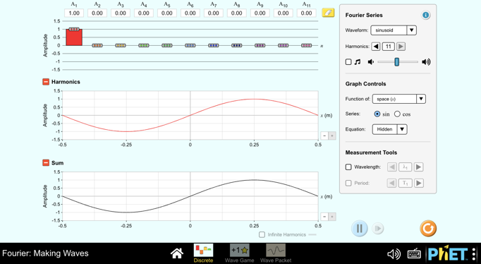

Choose level 1 to start with and increase the difficulty as you succeed in matching each wave. | 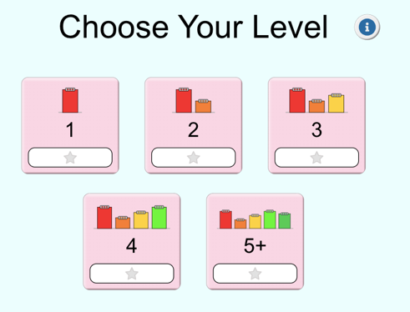

- Spend 10 minutes leveling up on the game trying to match the waves by changing the individual amplitudes of additional waves.
Go back to the first simulation by hitting “Discrete” at the bottom of the screen. | 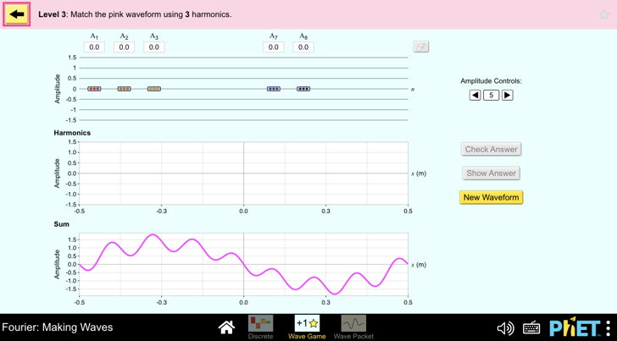
- Click through the Waveform options (sinusoidal, triangle, square, sawtooth, and wave packet) at the top of the toolbar on the right side. Notice how adding the waves can approximate any shape. If you click below “Harmonics” below the Wave Form button to decrease the number of harmonic waves to be added, the approximation becomes worse, and if you increase the number of harmonics, the approximation becomes better. If the simulation could add more than 11 waves, the approximation would be an even better approximation of whatever shape that you wanted.

- Go to the “Wave Packet” wave form option button. As you decrease the number of “Harmonics,” what happens to the width of the wave packet?
The width of the wave packet broadens as the number of harmonic waves decreases.

- What is the width of the wave packet when there is only one harmonic?
One harmonic produces a single sinewave that exists throughout space.

- If you could add more and more harmonics to the simulation, what would the width of the wave front approach becoming?
As the number of harmonics approaches infinity, the width of the wavefront would approach becoming infinitely small to be precisely measured at one point.

- How does the Fourier Transformation explain how the Heisenberg Uncertainty Principle is a necessary part of understanding what can be known about the position and momentum of a particle?

The tighter you want to make the wave packet, the more waves with different frequencies you need to add. The sharper you want the change to occur, the higher frequency waves you need to add to make the change happen more quickly. A spike at one point in time requires an infinite number of individual infinite frequency waves to be added together. Perfectly known frequency would be a simple sine wave that extends infinitely in time. So, the time of its existence is undefined.

Light has no mass, but the real equation for momentum is not mass times velocity (p
mv). When traveling near the speed of light, you need to use E_{Total}² = (m_{o}c²)² + (pc)². Since the rest mass of the photon equals zero, this equation simplifies to E_{Total} = pc.
The energy of a photon is Planck's Constant times the frequency of the photon (E = hf).
Plugging into E_{Total} = pc creates hf = pc. h and c are both constants and so f is proportional to p. This shows that you can talk about adding momenta rather than adding frequencies, and so it directly relates to Heisenberg Uncertainty Principle (∆x∆p≥ h/(4$π$).

Therefore, the Fourier simulation shows that having a large number of frequencies (proportional to a greater uncertainty in momenta (∆p)) enables the width of the peak (uncertainty in position ((∆x)) to decrease and still remain greater than or equal to the constant in the Heisenberg Uncertainty Principle.

University of Colorado-Boulder. (n.d.). Fourier: Making waves. PhET similations. https://phet.colorado.edu/en/simulations/fourier-making-waves/about

