quantum wave interference simulation teacher guide
Recreating strange results from Dr. Quantum Video in the double slit experiment.
PhET Quantum Wave Interference Simulations
Set up instructions for simulation:
Click the play button on the simulation. | 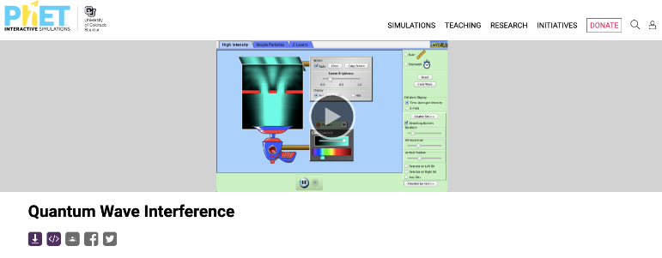

Click RUN CHEERPJ  BROWSER-COMPATIBLE  VERSION option. | 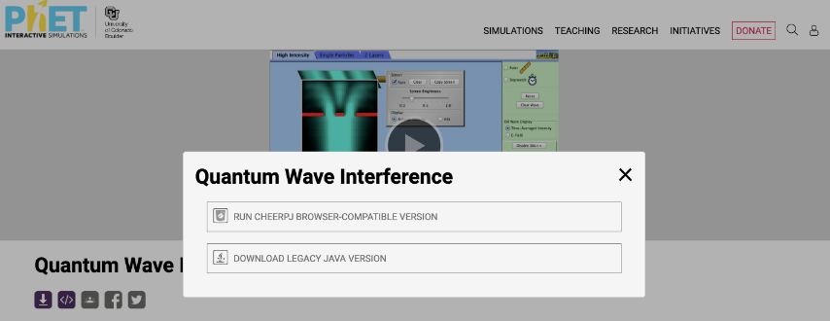
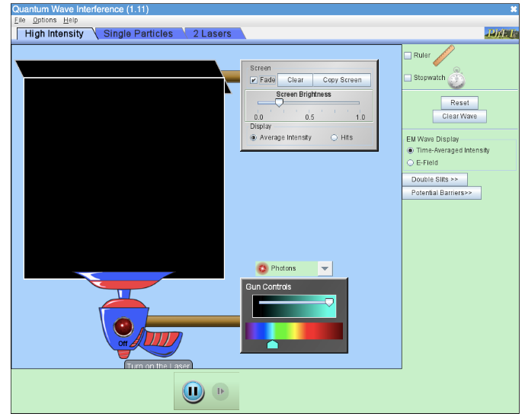
- Recreate the claim that shooting particles at the double slit can create an interference pattern. Time stamp (2:13-2:45) in Dr. Quantum video.
- Click on the “High Intensity” tab at the top left of the simulation.  - Click on “Double Slits” on the right toolbar.  - Select “Electrons” in the drop-down menu for the particle that will be fired.  - Click on the red button on the gun to turn it on.  - Adjust the “Screen Brightness,” “Slit Width,” “Slit Separation,” and “Vertical Position” bars to create an interference pattern with the electrons.  - Record a description of what you did to the controls and a sketch of the interference pattern. | 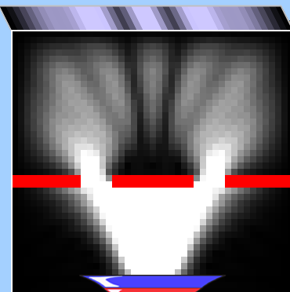
As long as the waves leaving the slits overlap, there should be an interference pattern on the screen. You can change the “Screen Brightness,” move the “Vertical Position” to the right and decrease the “Slit Width” to help the waves overlap and create an interference pattern.
- Recreate the claim that shooting particles at the double slit one particle at a time can still create an interference pattern. Time stamp (2:45-3:42) in Dr. Quantum video.
- Click on the “Single Particles” tab at the top left of the simulation.  - Click on “Double Slits” on the right toolbar.  - Select “Electrons” in the drop-down menu for the particle that will be fired.  - Check the box for “Auto-repeat” firing in “Gun Controls.”  - Adjust the “Screen Brightness,” “Slit Width,” “Slit Separation,” and “Vertical Position” bars to create an interference pattern with the electrons.  - Click on the red button on the gun to turn it on and wait for 2-3 minutes to see if you have created an interference pattern. If there is not an interference pattern, adjust the controls and try it again. Look at the wave path to help predict whether an interference pattern will be created.  - Record a description of what you did to the controls and a sketch of the interference pattern.  Scientists hypothesized that the interference pattern from particles only occurred from electrons interacting with each other. By firing the electrons one at a time, it was thought that the interference pattern would disappear.  A hazy plume goes up through both slits, but only one single dot | 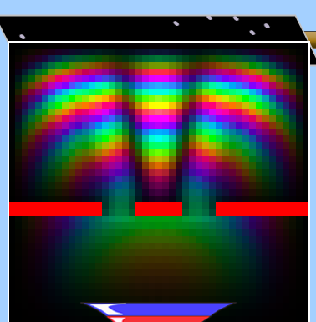  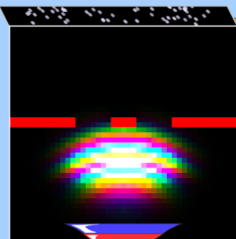  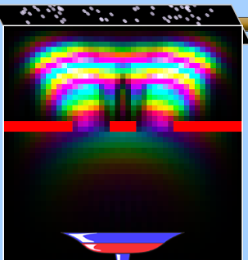
appears somewhere randomly on the screen.
A new dot shows up on the screen at different random locations each time a photon is fired. The dots appear random at first, but as the dots build up on the screen, they still show an interference pattern with regions where few to no hits are made on the screen. The interference pattern that contains regions without hits is surprising because there were no other electrons to interfere with since only one electron was fired at a time. Since there were no other photons to interfere with after passing through the slit, the result of sending through many photons one at a time should have been two bright spots directly across from the slits.
Firing photons through one at a time resulted with a really weird outcome, which did not match the classical view of the world. Scientists wanted more information, and so they decided to put detectors at the slits so that they could know which slit each photon was passing through on its way to the screen.
- Recreate the claim that shooting particles at the double slit one particle at a time can still create an interference pattern, but that adding a detector in front of the slit will make the interference pattern disappear. The detector stops wave behavior, and it reverts to particle behavior. Time stamp (3:42-4:36) in Dr. Quantum video.
- Click on the “High Intensity” tab at the top left of the simulation.
- Click on “Double Slits” on the right toolbar.
- Select “Electrons” in the drop-down menu for the particle that will be fired.
- Click on the red button on the gun to turn it on.
- Adjust the “Screen Brightness,” “Slit Width,” “Slit Separation,” and “Vertical Position” bars to create an interference pattern with the electrons.
- Add a detector, and the interference pattern should disappear. You may need to lower the screen brightness, but once you have it set up right adding a detector removes the interference pattern, and removing the detector brings the interference pattern back.
- Record a description of what you did to the controls and a sketch of the interference pattern.
With Detectors On | With Detectors Off
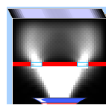 | 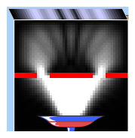

Scientists added the detectors to gather additional support for the theory that individual electrons had a distinct path that went through one single slit and hit the screen at one specific location on the screen.
However, with the detectors on the slits, the alternating bright and dark spot interference pattern disappears. You can change the “Screen Brightness,” move the “Vertical Position” to the right, and increase the “Slit Separation” to reduce the result to two bands in front of the two slits. However, even if there is just a bright spot across the whole image, it still shows that there is no constructive and destructive interference like a wave because the dark spots have disappeared.
When the detectors are removed from the slits, the alternating bright and dark spot interference pattern reappears. With the detector, the electrons act like particles. Without the detector, the electrons act like waves. The act of making the observation and knowing the information changed the result.
What Did I Learn Today?
Take five minutes to write out some of the key ideas covered in class and include a list of when an interference pattern will and will not form when using a double slit.
Answers will vary, but in this simulation, students observed that an interference pattern was created when waves or particles were sent through the double slit. Even when the photons or electrons were sent through one at a time, they still created an interference pattern. However, putting a detector in front of at least one of the slits to determine which slit was used caused the interference pattern to disappear.

Sources
University of Colorado-Boulder. (n.d.). Quantum wave Interference. PhET Interactive Simulations. https://phet.colorado.edu/en/simulations/quantum-wave-interference
University of Colorado at Boulder. (n.d.). Quantum wave interference simulation. PHET Interactive Simulations. https://phet.colorado.edu/sims/cheerpj/quantum-wave-interference/latest/quantum-wave-interference.html?simulation=quantum-wave-interference

