PERSUASION GRAPHIC ORGANIZER

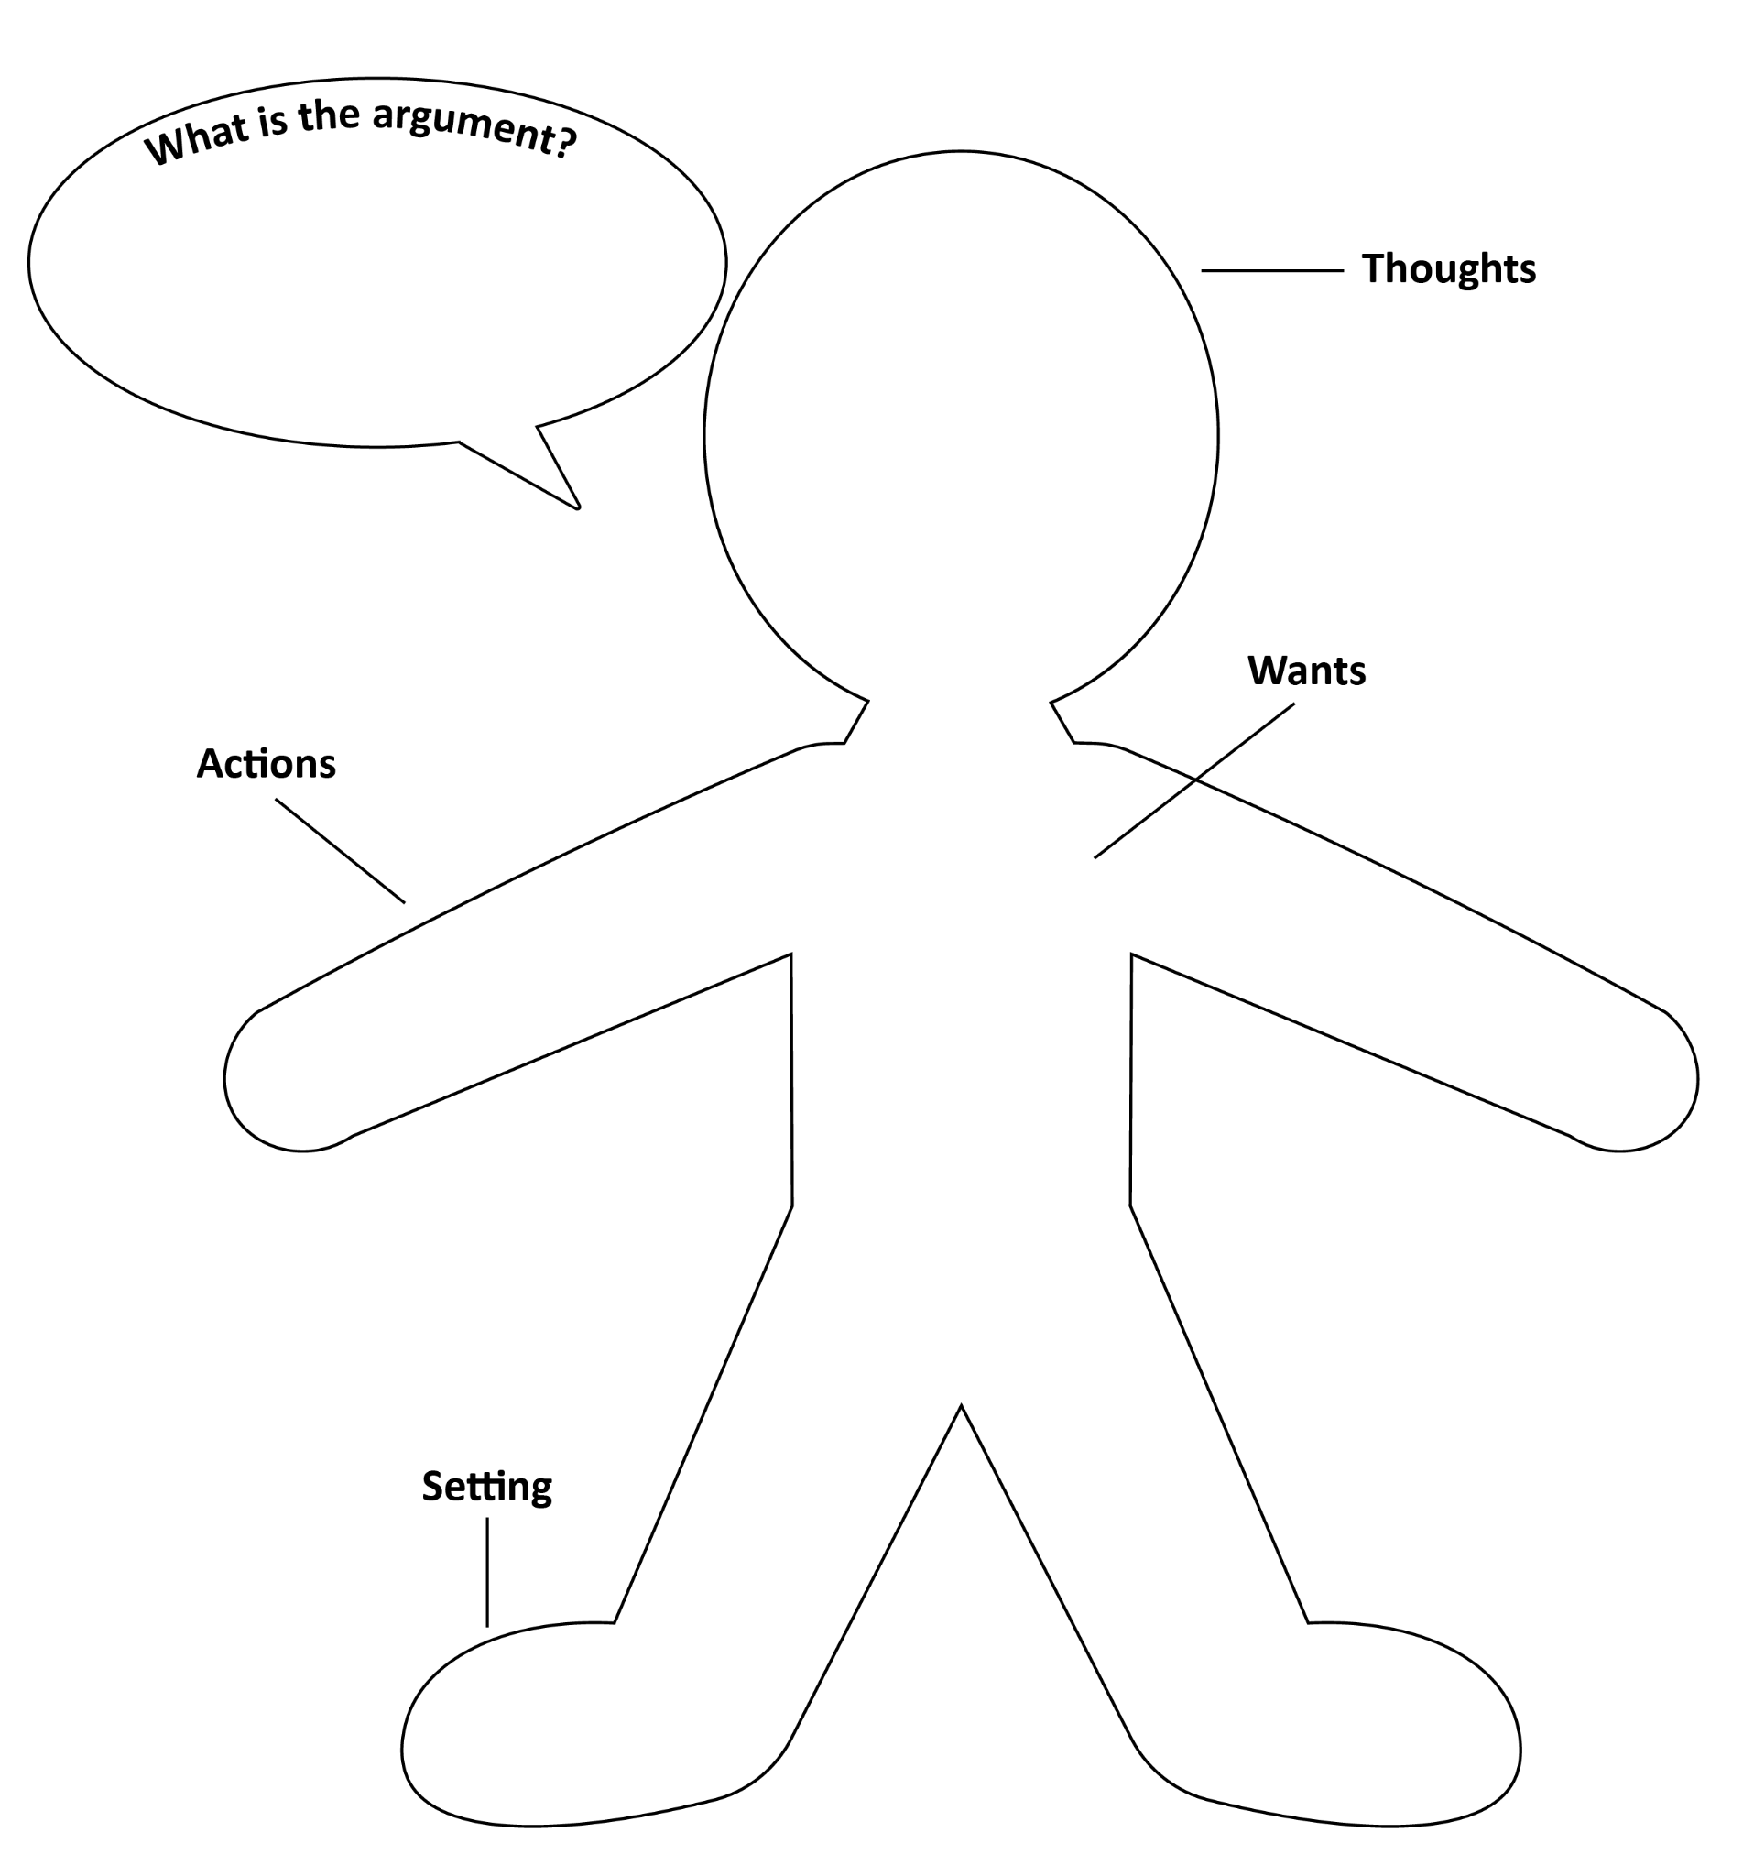
Part 1: Who Are You Arguing To? To craft a focused argument, you must first understand who the argument is for. Use the graphic organizer below to help you learn more about this person and why they’re arguing the way they are. Be creative!

DEAL WITH THE DEVIL

