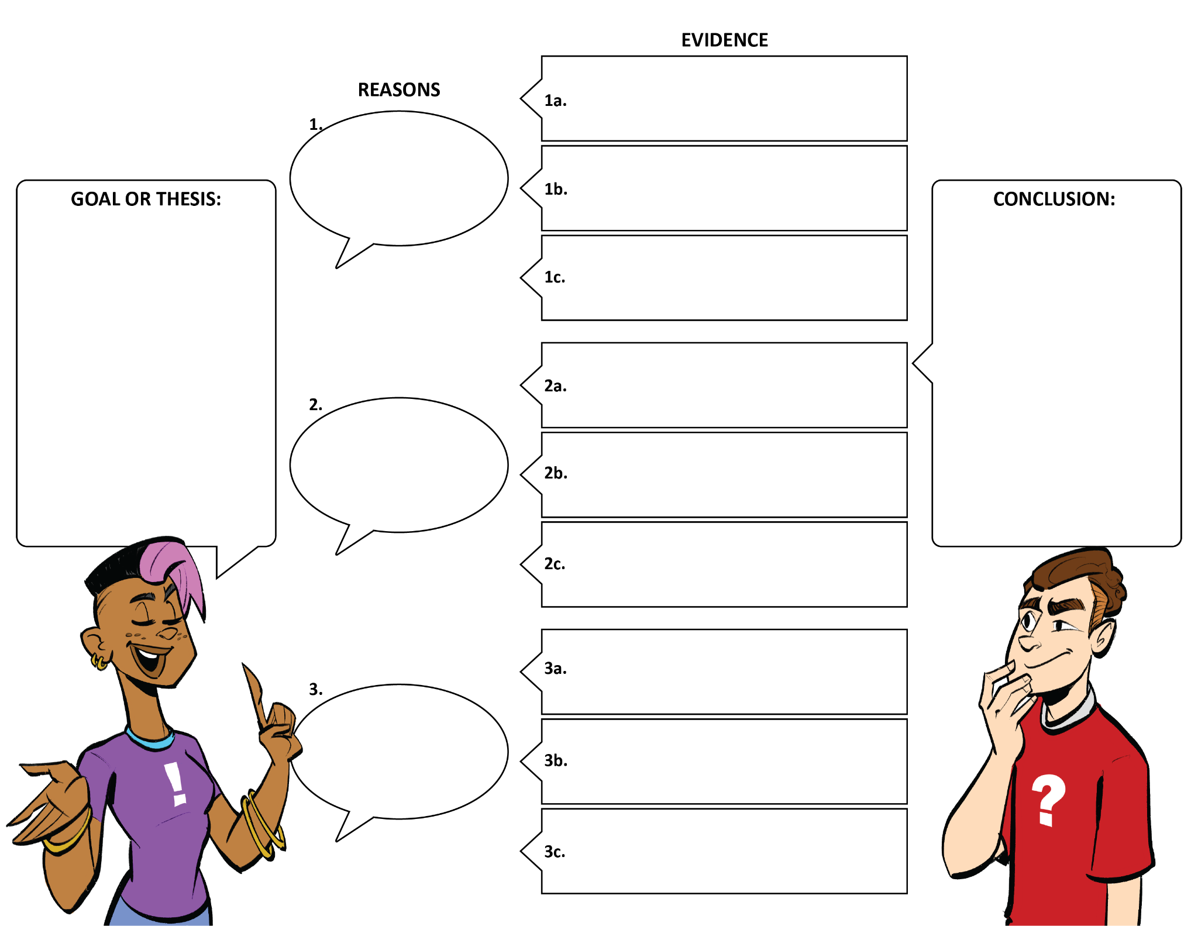

**Part 2: Craft your Argument.**