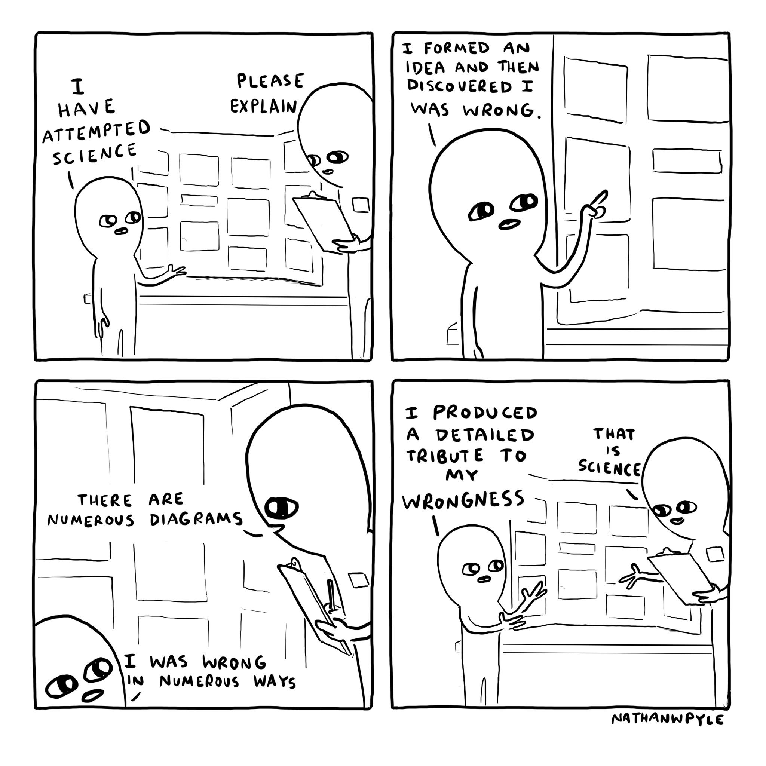
CHAT STATIONS
https://twitter.com/nathanwpyle/status/1176860147223867393
https://twitter.com/caitvw/status/953841172530843648

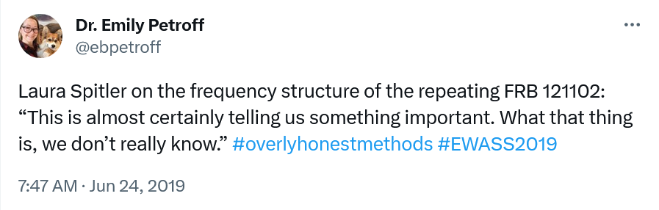
https://twitter.com/cathrynlewis/status/1189215668786401290
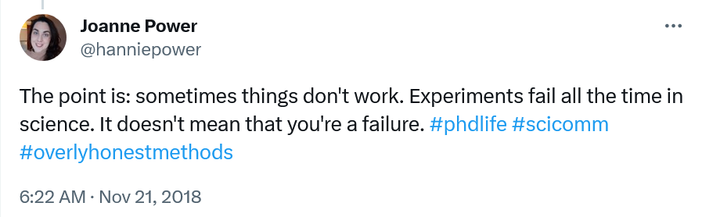
https://twitter.com/ebpetroff/status/1143138612030136320
https://twitter.com/hanniepower/status/1065218823140331520

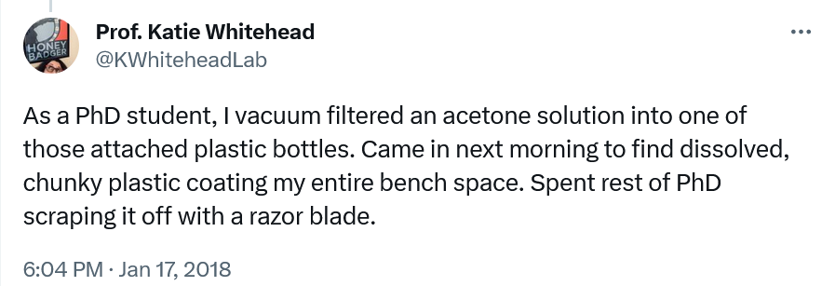
https://twitter.com/smely8mely/status/953847582278680576
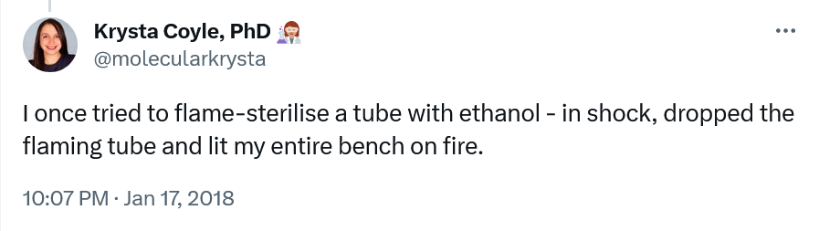
https://twitter.com/KWhiteheadLab/status/953780156858093568
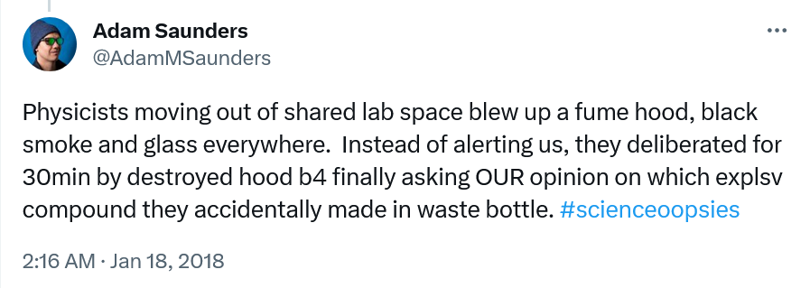
https://twitter.com/molecularkrysta/status/953841300947816448
https://twitter.com/AdamMSaunders/status/95390378911057510
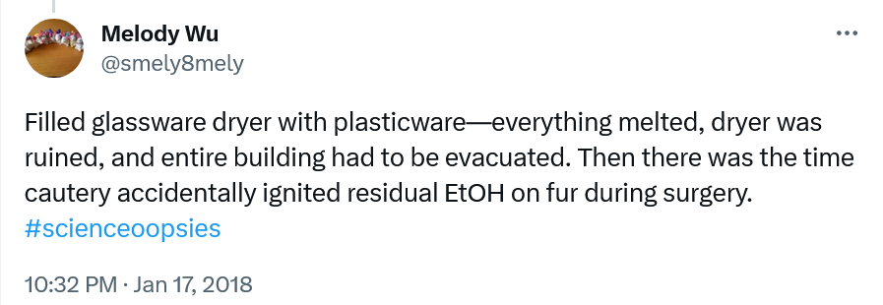
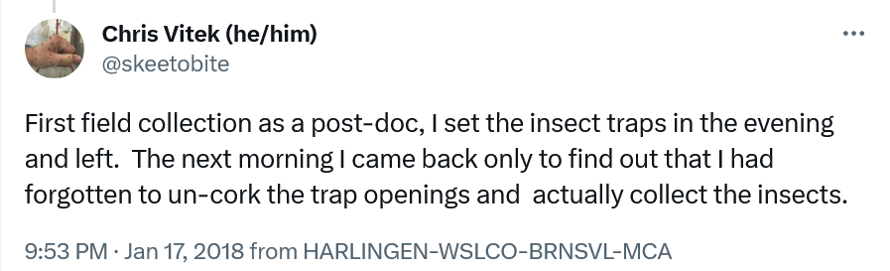
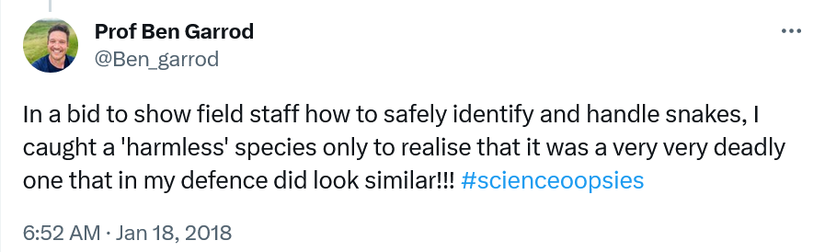
https://twitter.com/Ben_garrod/status/953973493573603328
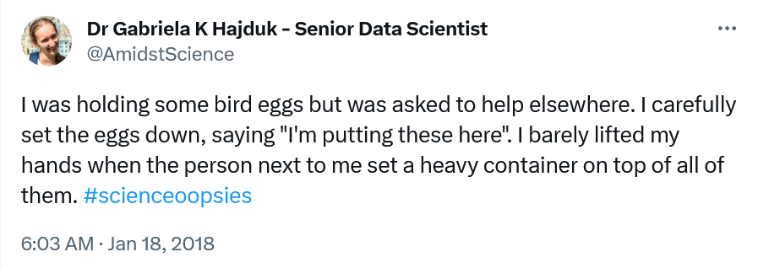
https://twitter.com/skeetobite/status/953837645934792704
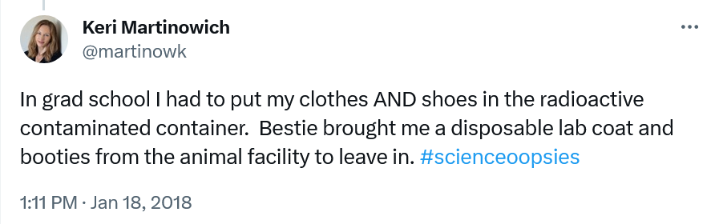
https://twitter.com/AmidstScience/status/953961123832913920
https://twitter.com/martinowk/status/954068820049780736

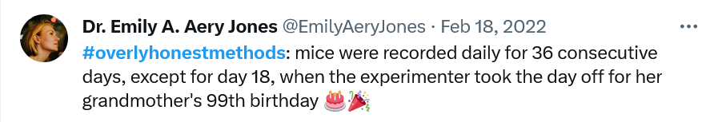
https://twitter.com/MrSteveKnutson/status/1046024211284848640
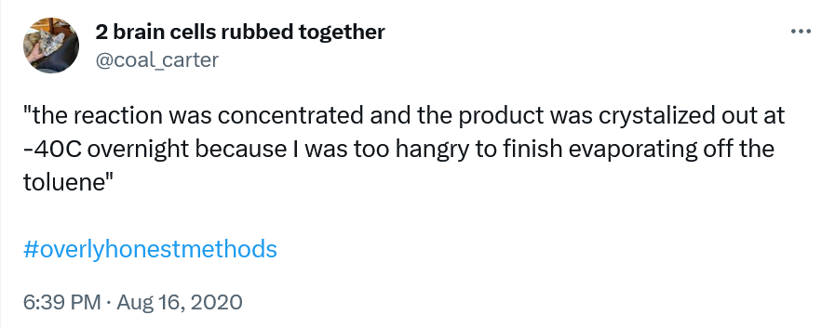
https://twitter.com/EmilyAeryJones/status/1494853967028768772
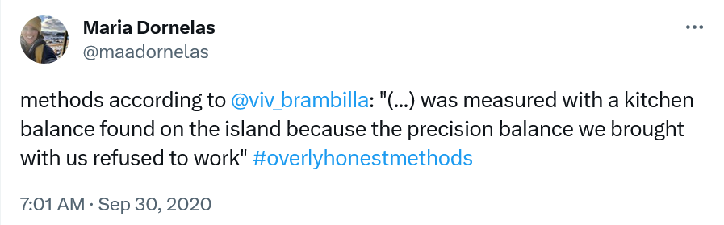
https://twitter.com/coal_carter/status/1295143050998677506
https://twitter.com/maadornelas/status/1311274906752081920

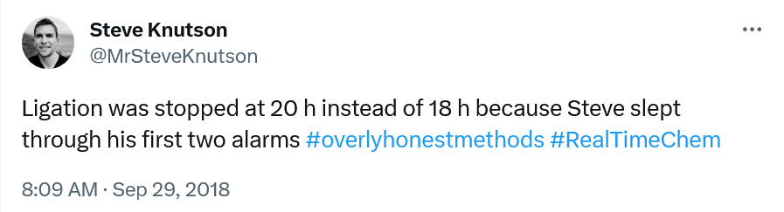
https://twitter.com/marissascavuzzo/status/1397677314922532866
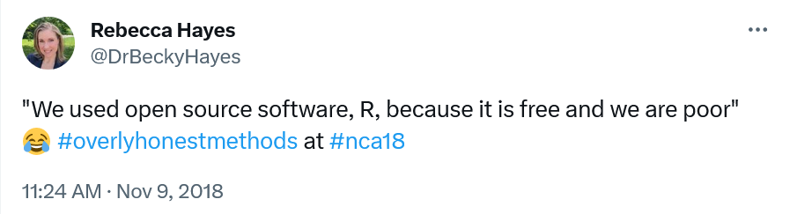
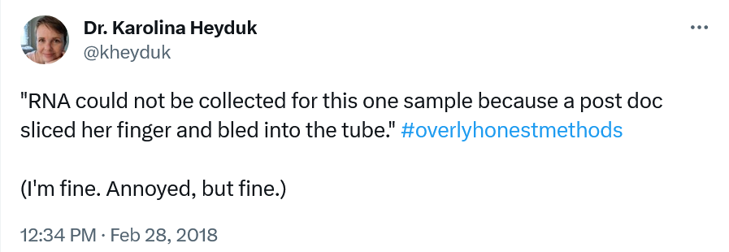
https://twitter.com/kheyduk/status/968917420676087809
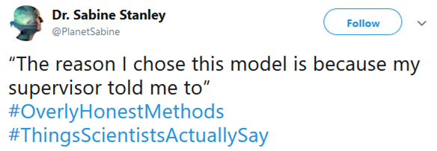
https://twitter.com/DrBeckyHayes/status/1060946308536528897
https://twitter.com/PlanetSabine/status/1047157233132482561

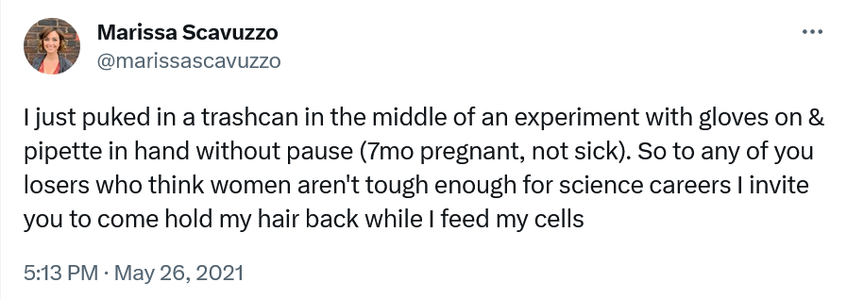

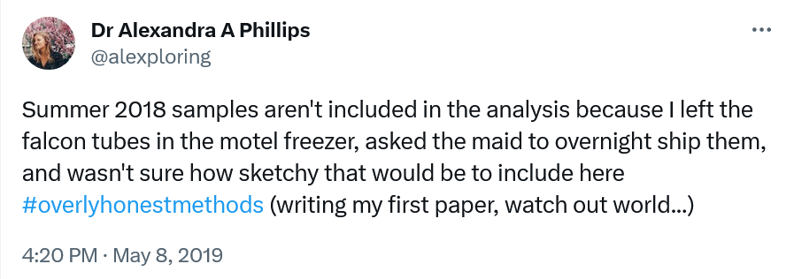
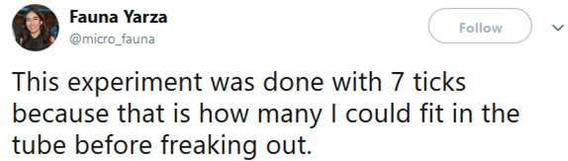
https://twitter.com/micro_fauna/status/1022217773886332929
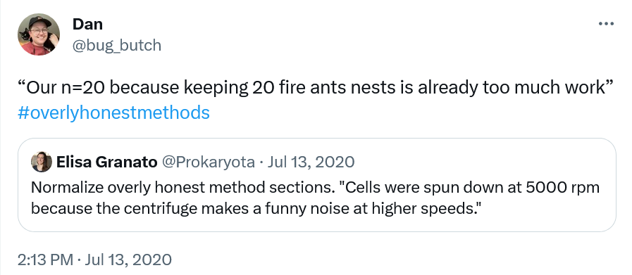
https://twitter.com/alexploring/status/1126235462518038528
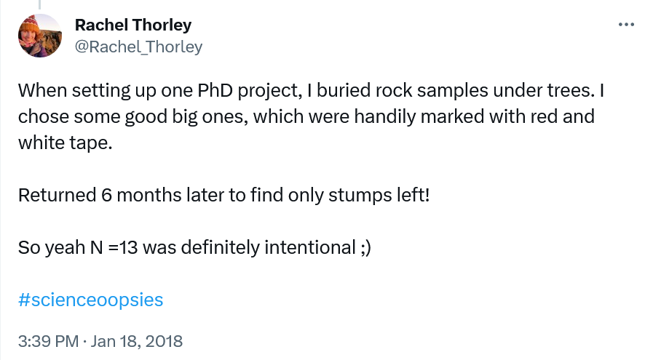
https://twitter.com/bug_butch/status/1282755019675062272
https://twitter.com/Rachel_Thorley/status/954106064676577280

