THE TORTOISE AND THE HARE Aesop

The Hare was once boasting of his speed before the other animals. “I have never yet been beaten,” said he, “when I put forth my full speed. I challenge anyone here to race with me.”

The Tortoise said quietly, “I accept your challenge.”

“That is a good joke,” said the Hare; “I could dance round you all the way.”

Keep your boasting till you’ve won, “ answered the Tortoise.” Shall we race?”

So a course was fixed and a start was made. The Hare darted almost out of sight at once, but soon stopped and, to show his contempt for the Tortoise, lay down to have a nap. The Tortoise plodded on and plodded on, and when the Hare awoke from he nap, he saw the Tortoise just near the winning post and could not run up in time to save the race.

The Tortoise said: “Slow and steady progress wins the race.”

EXPLORE
Scene A
For each description let f(x) be the function for the fare and g(x) the function for the tortoise. The unit for f(x) and g(x) is km and the unit for (x) is hour. For your scene make a T-chart and graph each function. Both graphs must be on the same graph so be careful with the scaling of your axes. Determine when and where the hare and the tortoise meet or pass each other.

f(x) = 5x²
g(x) = 0.3x + 5

Scene B
For each description let f(x) be the function for the fare and g(x) the function for the tortoise. The unit for f(x) and g(x) is km and the unit for (x) is hour. For your scene make a T-chart and graph each function. Both graphs must be on the same graph so be careful with the scaling of your axes. Determine when and where the hare and the tortoise meet or pass each other.

f(x) = 10x² - 8
g(x) = 0.6x + 2

Scene C
For each description let f(x) be the function for the fare and g(x) the function for the tortoise. The unit for f(x) and g(x) is km and the unit for (x) is hour. For your scene make a T-chart and graph each function. Both graphs must be on the same graph so be careful with the scaling of your axes. Determine when and where the hare and the tortoise meet or pass each other.

f(x) = 30x² – 0.5
g(x) = 0.6x + 2

Scene D
For each description let f(x) be the function for the fare and g(x) the function for the tortoise. The unit for f(x) and g(x) is km and the unit for (x) is hour. For your scene make a T-chart and graph each function. Both graphs must be on the same graph so be careful with the scaling of your axes. Determine when and where the hare and the tortoise meet or pass each other.

f(x) = 2x + x² - 1
g(x) = 0.7x + 3

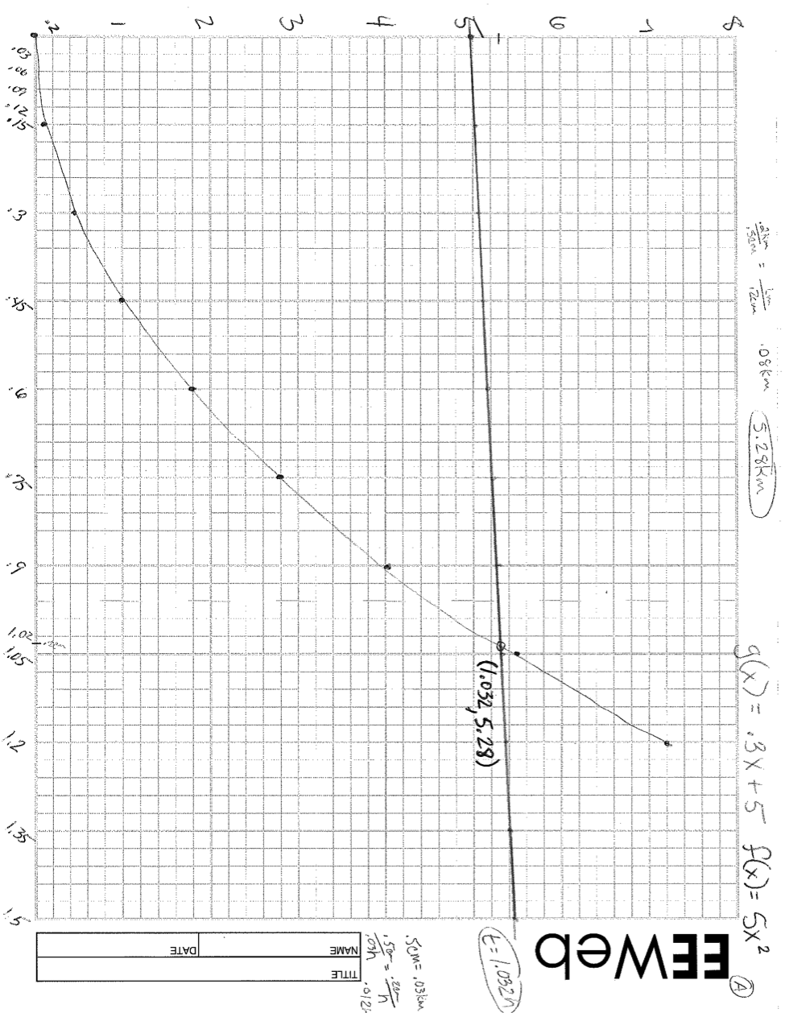
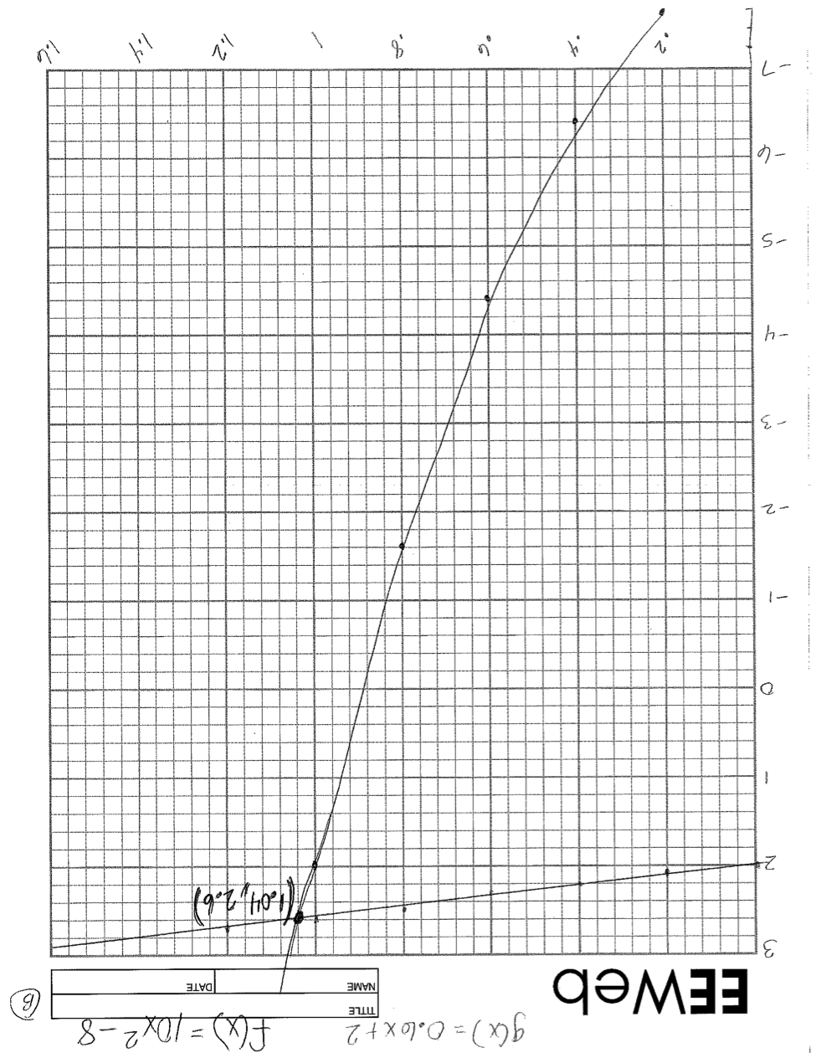

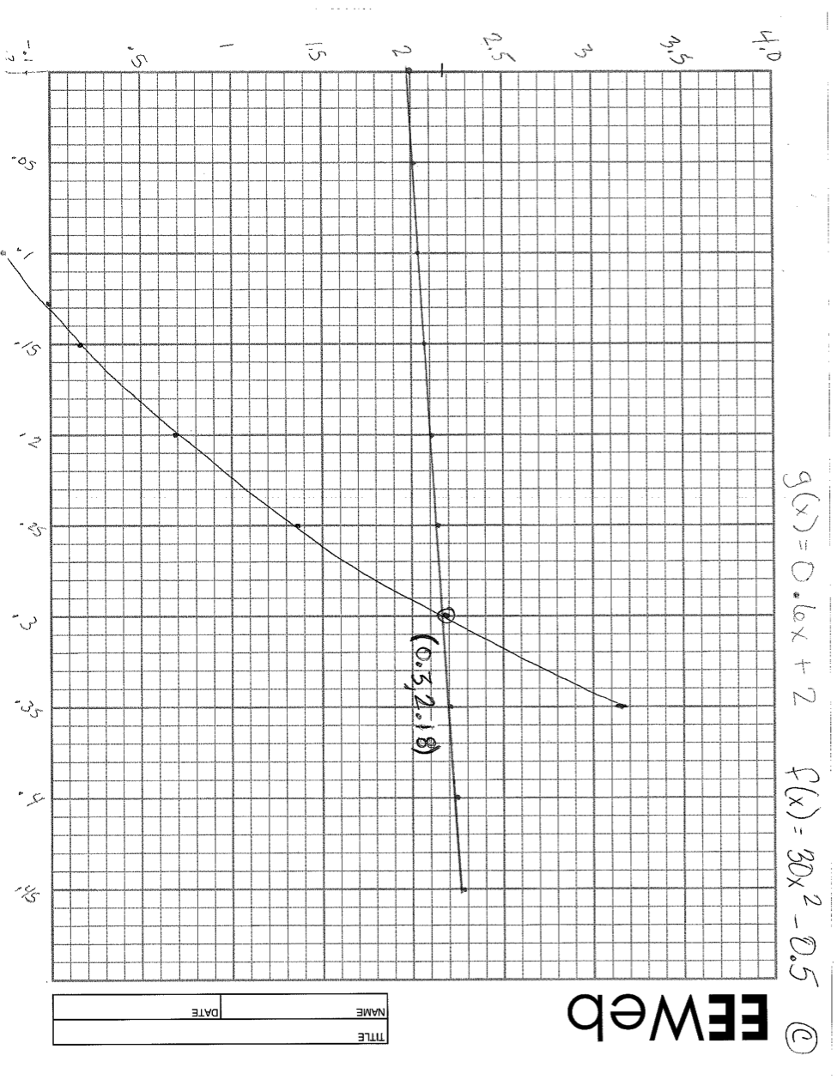

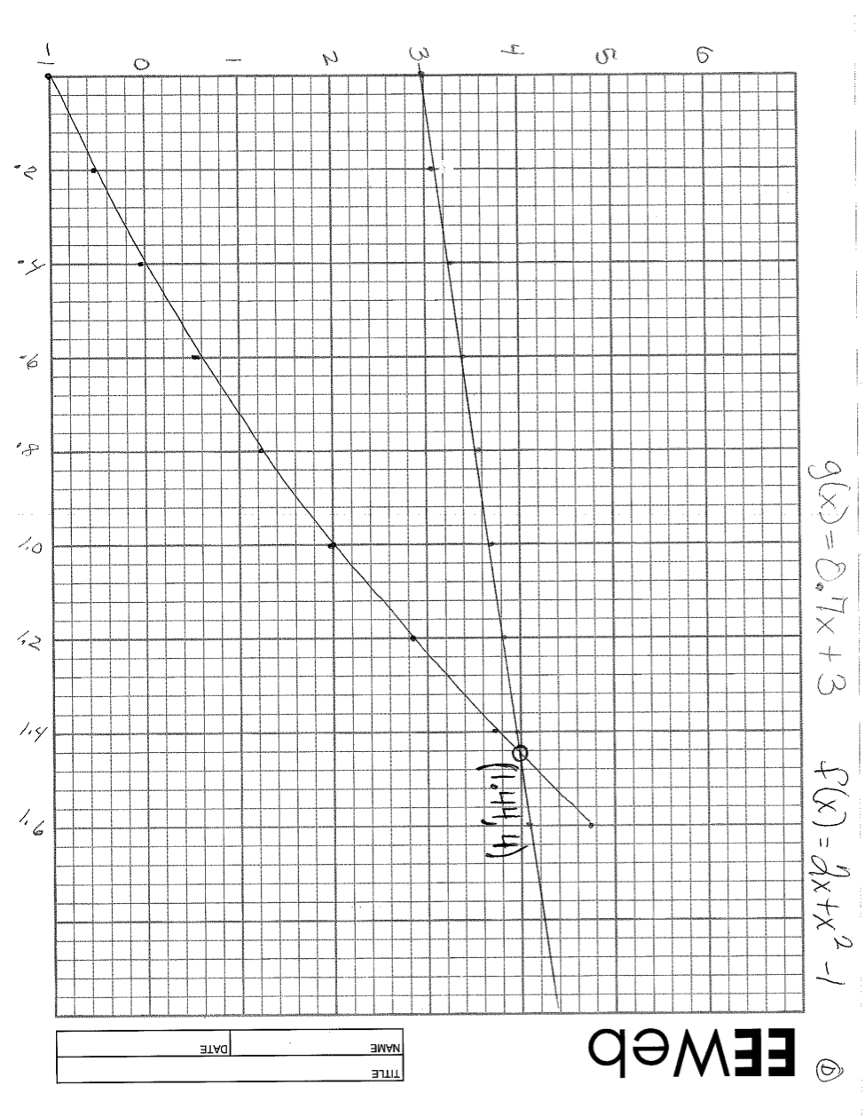

“Police and the car” chase graph with equations:

