HYDROGEN EMISSION LINES
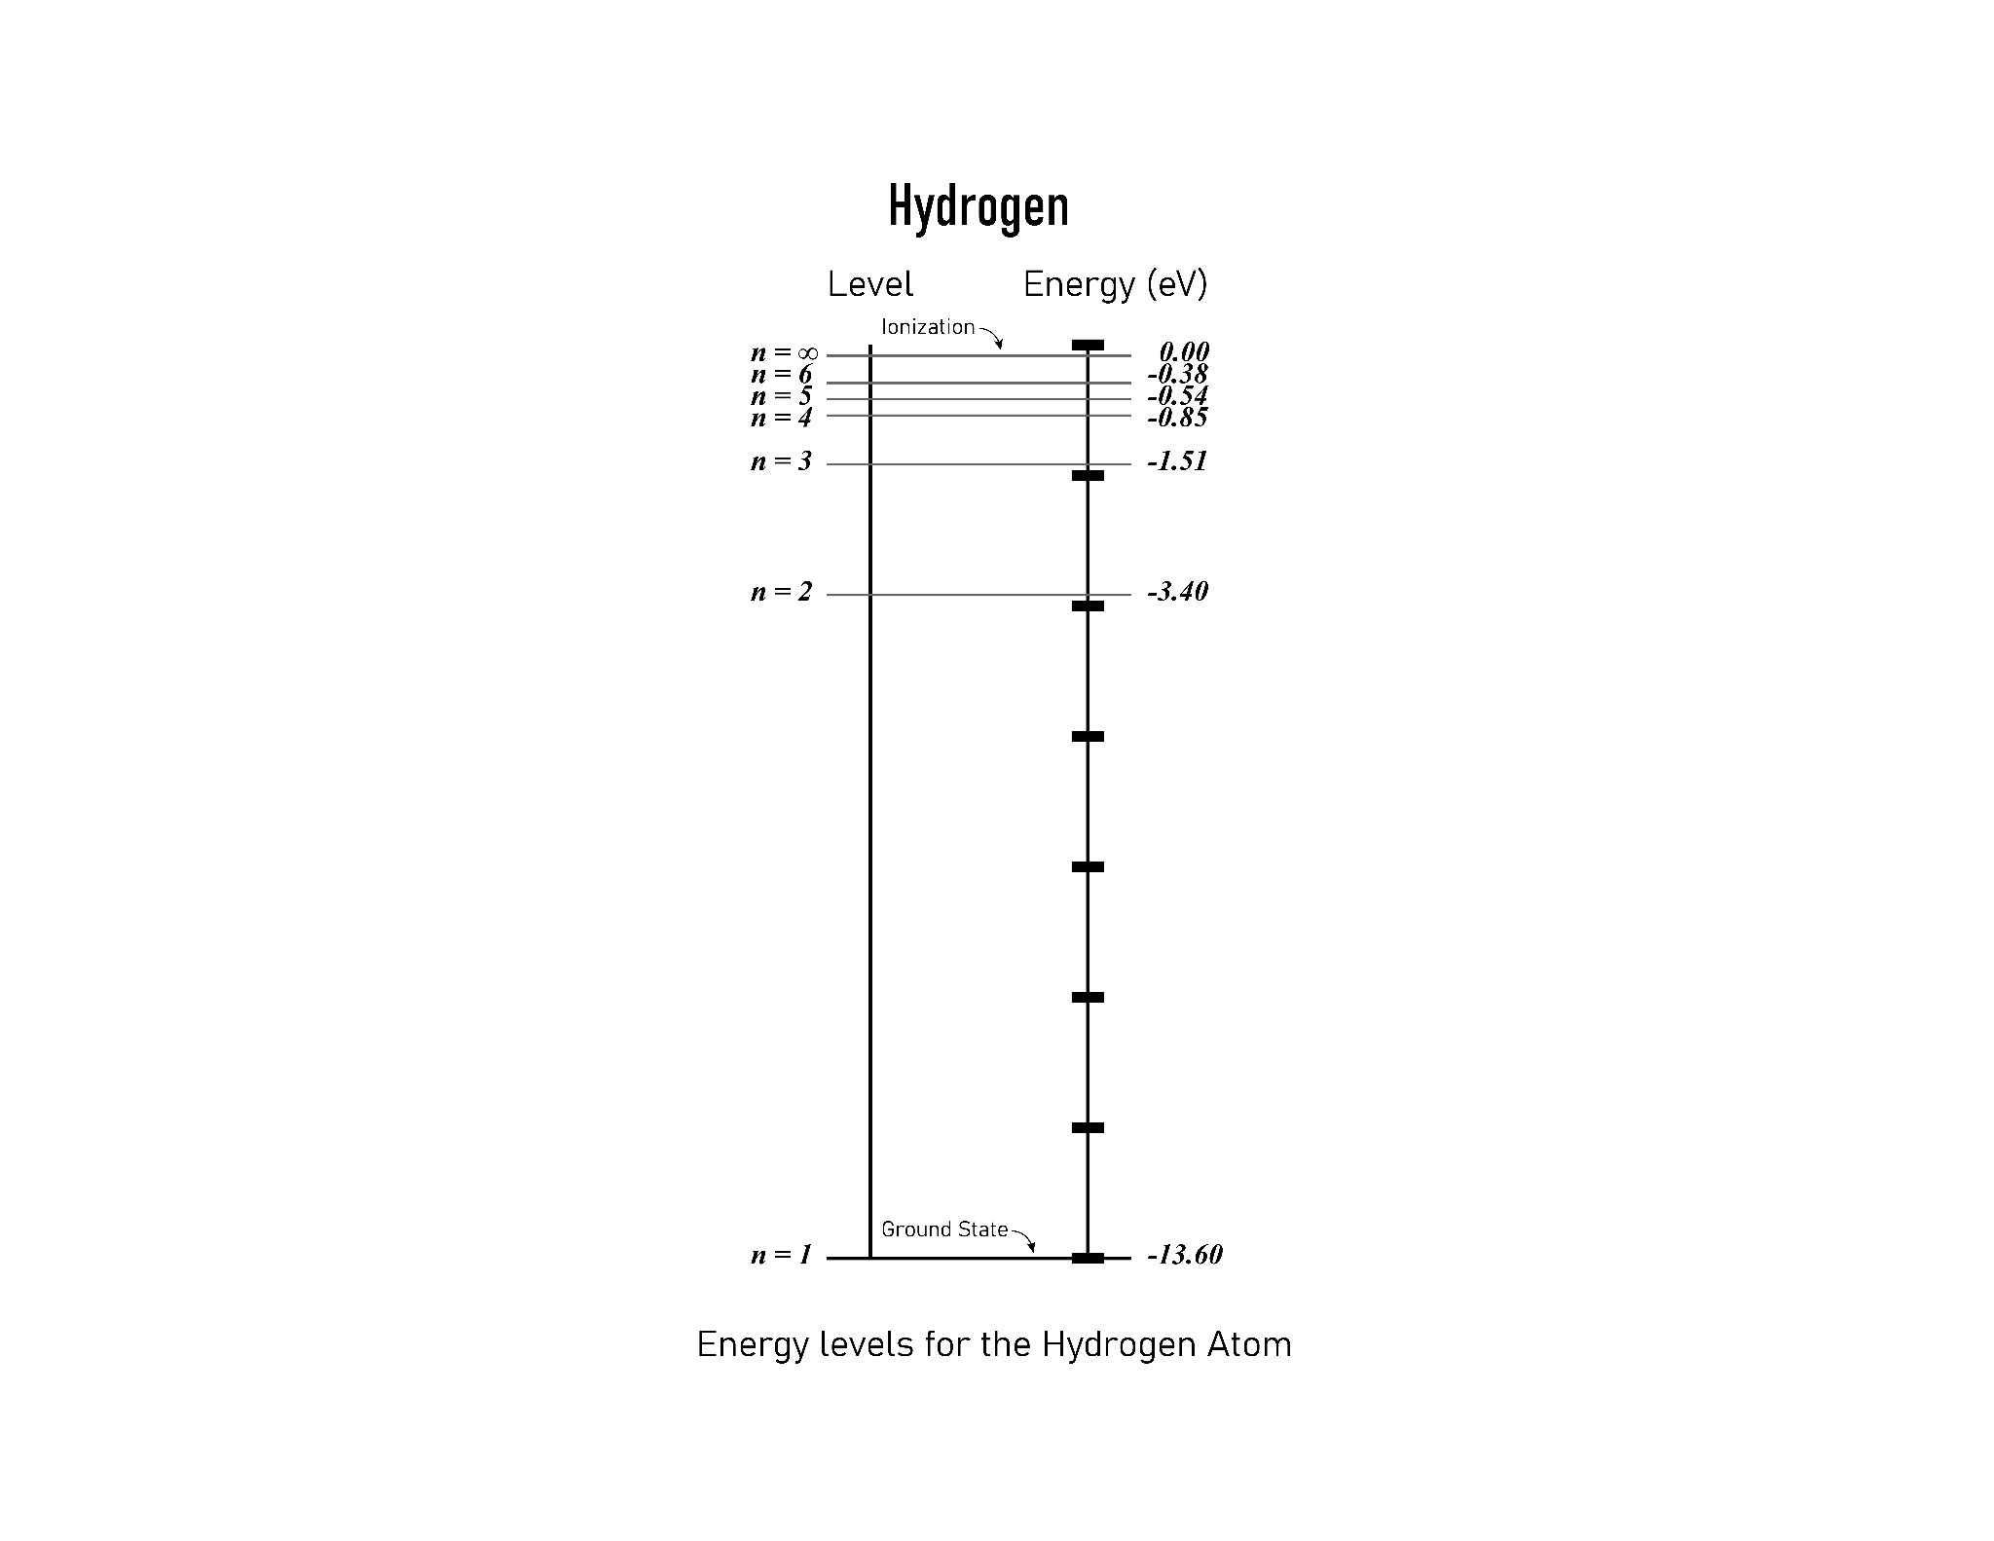

Figure 1: The left side of the chart shows the principal quantum number which represents the shell or energy of an electron in a given shell. The right side represents the energy associated with each value of the principal quantum number in electron volts. The energies have a negative value due to the negative charge of the electron. The maximum energy value for a shell is 0 eV.
After observing the line spectra of hydrogen, the scientist Niels Bohr proposed that the electron in a hydrogen atom can have different energies and that the energies are quantized. Bohr used the principal quantum number, n, to describe the energy of the electron in a hydrogen atom. The principal quantum number has positive integer values (n=1,2,3,...∞) as shown in Figure 1.
The potential value on the right side is obtained by using the formula: E= (-13.6 eV)/n²
If an electron is moving towards the nucleus, its electric potential energy is decreasing. The electron moves towards the nucleus because opposite charges attract. Negative electrons are attracted to the positive nucleus.

The ground state describes the lowest energy state of the electron and the ionization potential, or work function, is the energy required to separate the electron from the nucleus.

Concept Questions:

- What is the lowest potential energy value an electron can possess in a hydrogen atom?
- What is the highest potential energy value an electron can possess in a hydrogen atom?
- When an electron is in a state higher than its ground state, it is described as being in an excited state. What principal numbers in Figure 1 represent excited states in a hydrogen atom?
- If an electron in the ground state gained sufficient energy, what could happen to the electron?
- If an electron in an excited state returned to the ground state, what would happen to the lost energy?
- Where would the lost energy go and how would that energy be transported? Think about what you learned in the Photoelectric Effect activity.
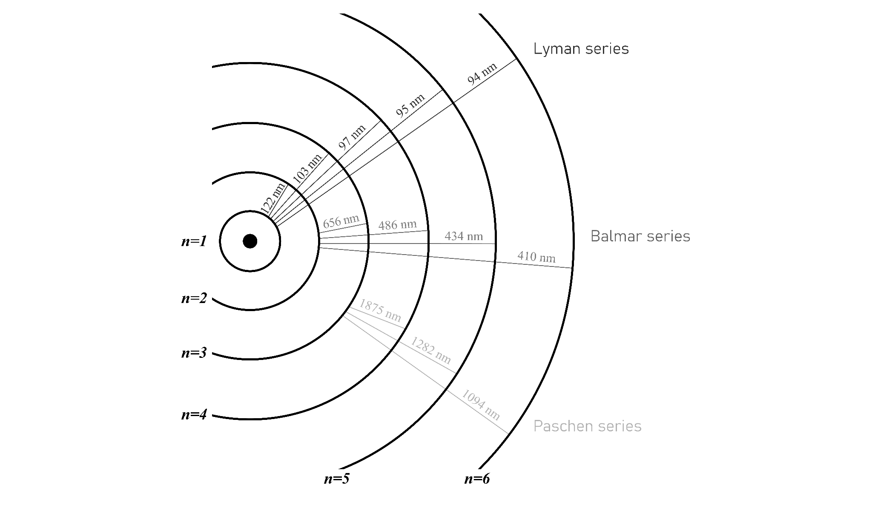Figure 2: This image shows the wavelengths of photons emitted by electrons as they transition between various excited states and lower energy shells.

Table 1: Wavelength range for select types of electromagnetic radiation.

Type of Radiation | UV | Visible | Infrared
Wavelength Range (nm) | 100-400 | 400-700 | 700-1800

Table 2: The wavelengths in nanometers of photons in the visible spectrum.
Violet | Blue | Green | Yellow | Orange | Red
380-450 | 450-495 | 495-570 | 570-590 | 590-620 | 620-750

The Lyman series in Figure 2 shows the wavelength of photons emitted from electrons in hydrogen atoms as they lose energy transitioning between excited states (n- 2, 3, 4, 5, 6) and the ground state (n=1).
The Balmer series in Figure 2 shows the wavelengths of photons emitted from electrons in hydrogen atoms as they lose energy transitioning between excited states (n=3, 4, 5, 6) and the second energy level (n=2).
The Paschen series in Figure 2 shows the wavelength of photons emitted from electrons in hydrogen atoms as they lose energy transition g between excited states (n=4, 5, 6) and the third energy level (n=3).
Wavelength is related to the difference in electron energy by equation 1: λ=hc/∆E
(h is Planck’s Constant, c is the speed of light constant and ΔE is the difference in energy between two different shells)

Concept Questions:
- Based on equation 1, write a statement that describes the relationship between the wavelength of photons and their energy.
- According to Table 1, which type of radiation is made up of photons possessing the largest energies?
- In Figure 2, which energy transition is the most energetic?
- In Figure 2, which energy transition is the least energetic?
- If you were looking at electrons transitioning from n=3 to n=2, what would you observe? (Refer to Figure 2 and Table 2)
- Can you observe the Lyman series with your eyes? Explain. (Refer to Figure 2 and Table 1)
- Does the hydrogen lamp emit photons from the Paschen series? (Hint: Is the light bulb hot?) If so, would you be able to see these photons?
- When you observed the line spectra, why did you see a line of violet color? (Refer to Figure 2 and Table 2)
- Why don’t you see a yellow line in hydrogen’s spectrum?
- Based on Figure 2, explain the spectral lines you observed when you looked at the hydrogen lamp.
- Explain how your observations in this activity support the idea that electron energies are quantized.

