PARTICLE IN A BOX

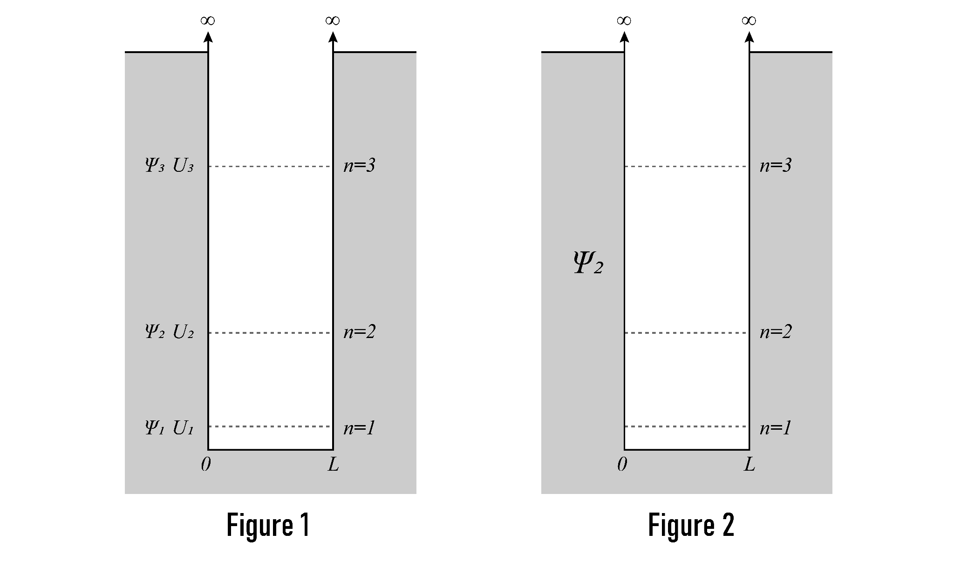
Figure 1: One-dimensional box that contains an electron. Electrons and other small particles have wave properties. The sides of the box are separated by the distance L. The depth of the box is defined by the potential energy of the electron which has a range of zero to infinity. The electron cannot escape the box. The potential energies, U₁, U₂, and U_{3,} are shown on three different axes that are separated vertically for clarity. The separations are not shown to scale. This box will show the wave functions of the electron. The principal quantum number, n, represents the energy of the electron, which increases with increasing n value.

Figure 2: Electrons are waves and their exact position at any given time is unknown. However, the likelihood of an electron position can be shown by a probability density. The probability density is produced by the square of the wave function. The figure will show the probability densities of the electron (square of the wave functions) with three different energies.

Simulation:
- Open the PhET simulations Quantum Bound States: http://k20.ou.edu/quantum
- Click on “Configure Potential” and set the width to 0.5 nm.
- Click on the “Wave Function” button. Click the “Play” button.
- In Figure 1 on the dashed line, Ψ₁ U₁, above, sketch the simplest wave function for an electron that shows the wave contained in the box. This is the wave function you see in the orange line at the bottom.
- Record the energy of this state: _________ eV. What is the wavelength in terms of L (the width of the box)?
- Based on previous lessons, write a statement that describes the relationship between the energy and the wavelength of a wave.

Schrodinger’s Equation Variation: 𝛹_{n}(x)=√(2/L)sin((nπx)/L)
Where L is the length of the box, x is position, n is a positive integer value known as the principal quantum number.
From this equation, you can predict the increasing values of n will produce more waves in the box.

Energy of electron: E_{n}=n²h²/(8mL²)
From this equation you can predict that increasing values of n will lead to increases in electron energy.
- Click on the lower green line above the red line on the top graph. On the dashed line, Ψ₂ U₂, sketch the next wave function that shows the wave contained in the box. Record the energy of this state _____eV.
- Write an expression for the wavelength of this wave in terms of L: _______________
- Compare the wavelengths and the energies of the first two wave functions for the electron. Which has a greater wavelength? Which has a greater energy?

- Click on the green line above the red line. On the dashed line, Ψ₃ U₃, sketch the next wave function that shows the wave contained in the box. Record the energy of this state _____eV.
- Write and expression for the wavelength of this wave in terms of L: _______________
- Compare the wavelengths and energies of the electron with this energy to the electron with the second energy described. Which has the greater wavelength Which has the greater energy?

- Predict three different wavelengths, in terms of L, that will show the wave contained in the box.
_________________ ___________________ __________________
- Click on the lowest green line. Click on the “Probability Density” button. On Figure 2, sketch the square of the wave functions on the line labeled n=1 (above right).
- The square of the first wave function is shown below:
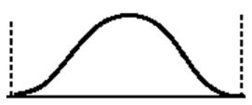
Use your pencil to shade the area representing the probability density of the electron.
Label the following:
- The most probable location for the electron. (The antinode)
- The place(s) where the electron cannot be found. (The nodes and edges of the box)

- Click on the first green line above the red line. On Figure 2, sketch the square of the wave functions on the line labeled n=2.

The square of the second wave function is shown below:
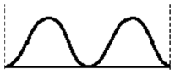
Use your pencil to shade the area representing the probability/probabilities density of the electron.
Label the following:
- The most probable locations (there are two for the electron.
- The place(s) where the electrons cannot be found.

- Click on the first green line above the red line. On Figure 2, sketch the square wave functions on the line labeled n=3.
The square of the third wave function is shown below.
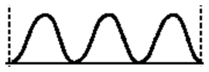
Use your pencil to shade the area representing the probability/probabilities density of the electron.
Label the following:
- The most probable location(s) for the electron.
- The place(s) where the electrons cannot be found.

- In the box below, sketch a wave that cannot fit in the box. A wave must have nodes at the sides of the box to fit in the box.
19. Estimate the principal quantum number for the wave you sketched.

20. Do you agree with the following statement? Explain.

An electron in a 1-D box can have any amount of energy.

21. How does the particle in a box support the idea of quantized energy?

