TEACHER’S GUIDE: PARTICLE IN A BOX
- Open the PhET simulations Quantum Bound States: http://k20.ou.edu/quantum
- Click on “Configure Potential” and set the width to 0.5 nm.
- Click on the “Wave Function” button. Click the “Play” button.
- On the dashed line, U₁, sketch the simplest wave function for an electron that shows the wave contained in the box.
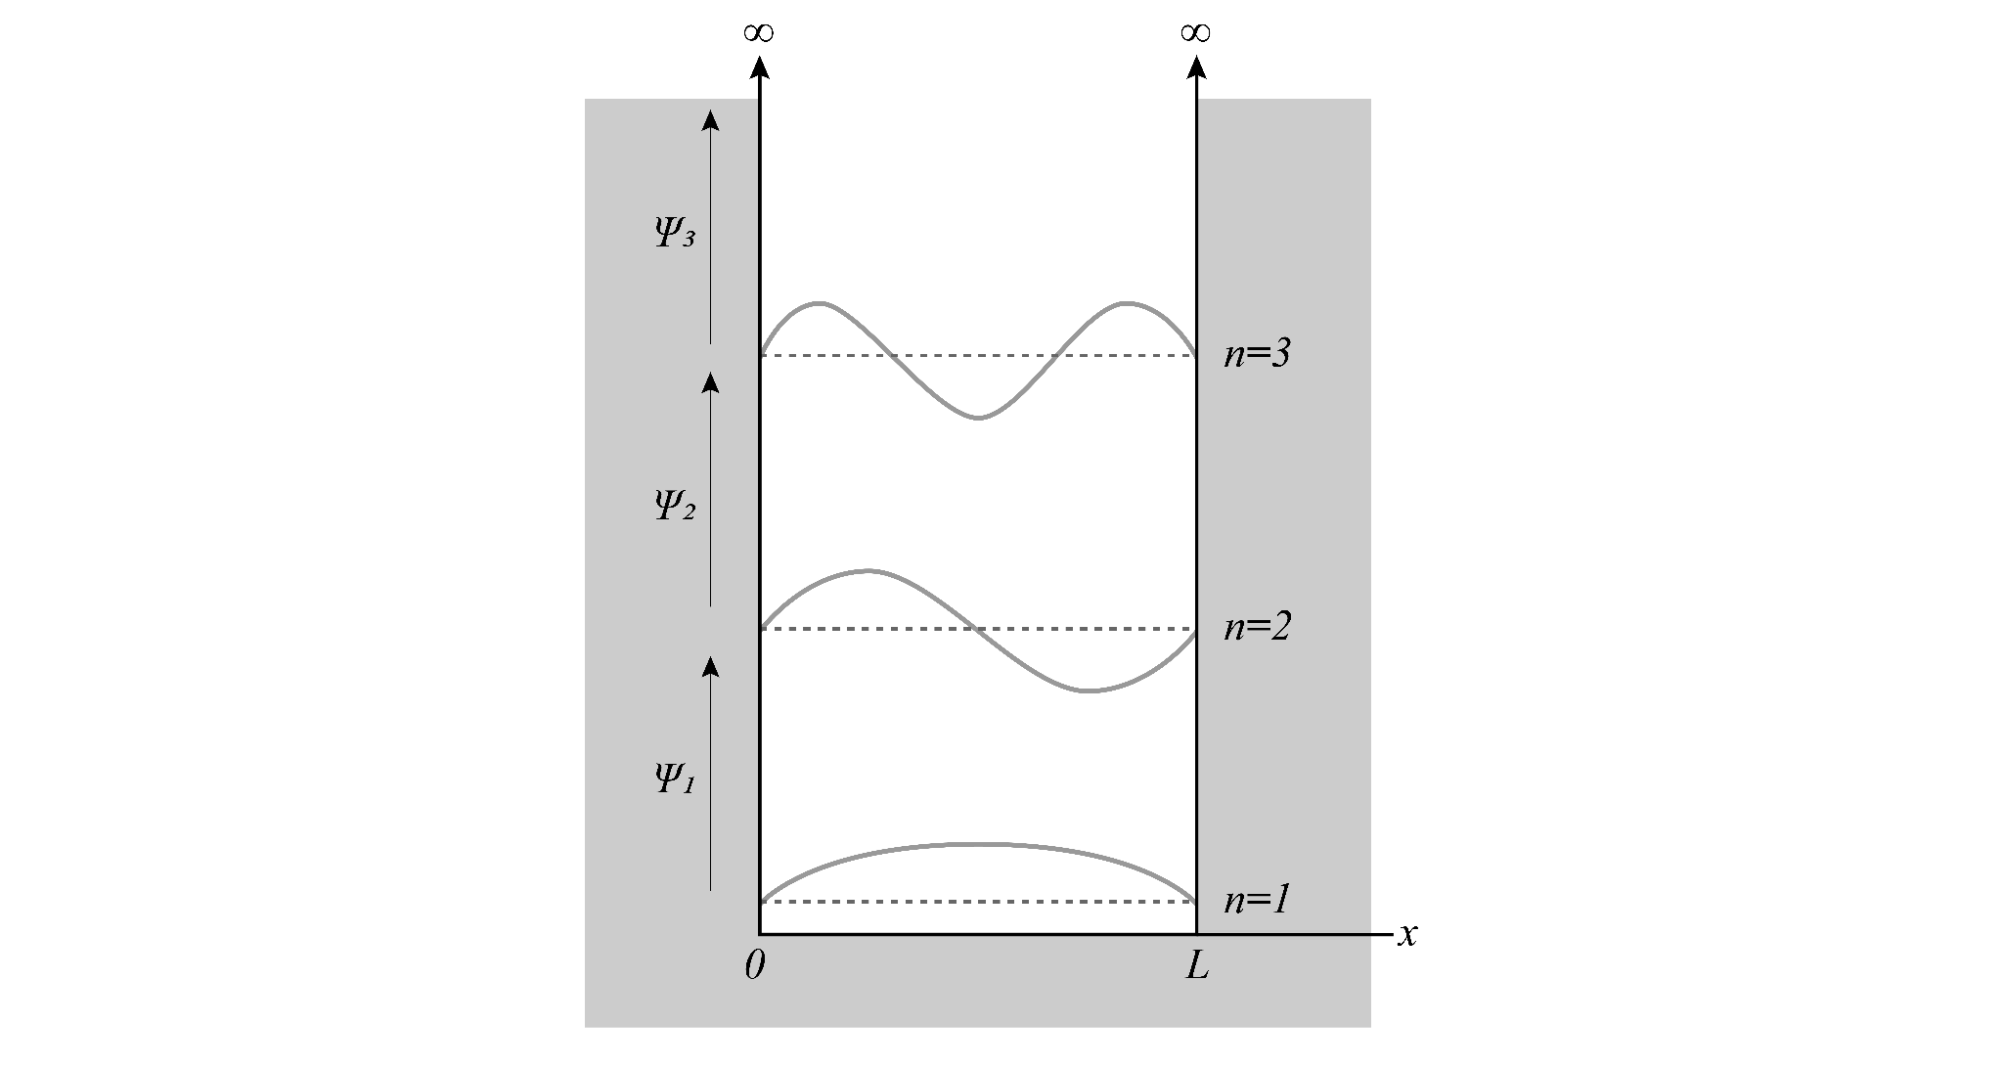
- Record the wavelength. What is the energy?

λ=2L E= 0.78 eV

- Write a statement that describes the relationship between the energy and the wavelength of a wave.

Shorter wavelengths are more energetic

- On the dashed line, U₂, sketch the next wave function that shows the wave contained in the box. Record the energy of the wave function.

See picture above E=3.78 eV

- Write an expression for the wavelength of this wave in terms of L: ______________

λ=L

- Compare the wavelengths and the energies of the first two wave functions for the electron. Which has a greater wavelength? Which has a greater energy?

The second wavelength is shorter and has a greater energetic

- On the dashed line, U₃, sketch the next wave function that shows the wave contained in the box. Record the energy.

See picture above
- Write an expression for the wavelength of this wave in terms of L: ______________

λ=⅔ L

- Compare the wavelengths and energies of the electron with this energy to the electron with the second energy described. Which has a greater wavelength? Which has a greater energy?

The third wavelength is shorter and more energetic

- Predict three different wavelengths that will show the wave contained in the box.

Some possible answers: λ=L/2, L/3, L/4

- Sketch the square of the wave functions you drew in box (a) in box (b). Use a different axis for each sketch.
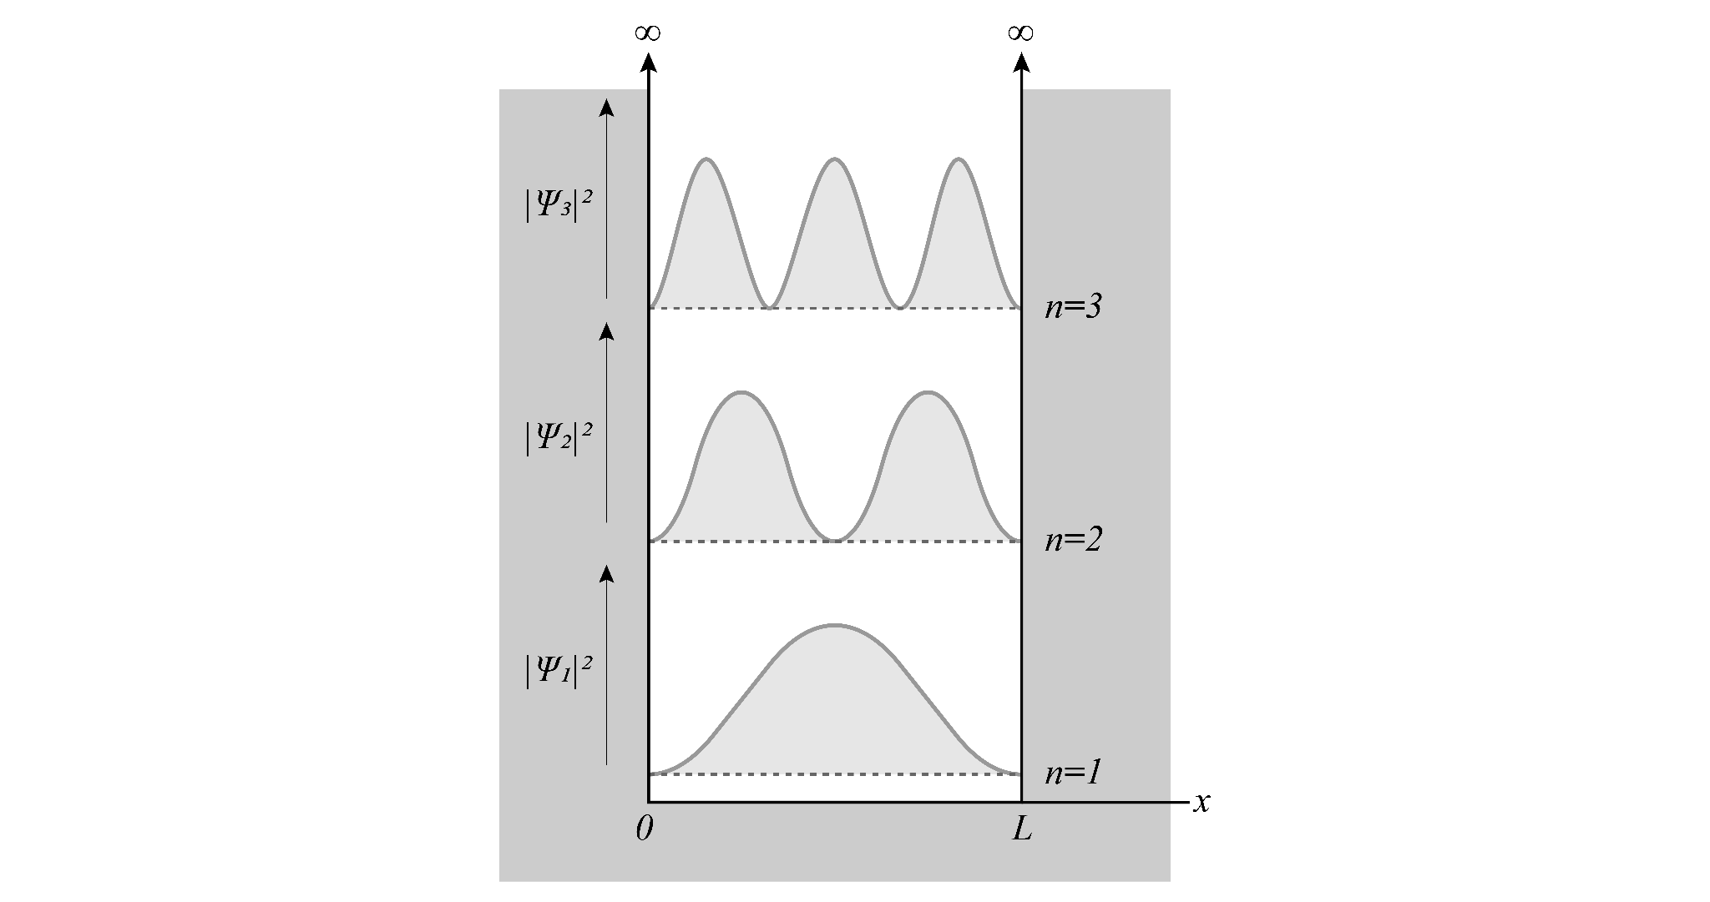
- The square of the first wave function is shown below:

Use your pencil to shade the area representing the probability density of the electron.
Label the following:
The most probable location for the electron.
The place(s) where the electrons cannot be found.
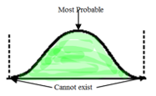
- The square of the second wave function is shown below:
Use your pencil to shade the area representing the probability/probabilities density of the electron.
Label the following:
- The most probable location(s) for the electron.
- The place(s) where the electrons cannot be found.
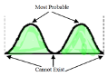
- The square of the third wave function is shown below:

Use your pencil to shade the area representing the probability/probabilities density of the electron.
Label the following:
- The most probable location(s) for the electron.
- The place(s) where the electrons cannot be found.
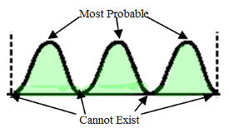
- In the box below, sketch a wave that cannot fit in the box.
One Possible Answer:
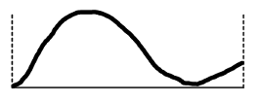
- Estimate the principal quantum number for the wave you sketched.

n=1.75

- Do you agree with the following statement? Explain.
An electron in a 1-D box can have any amount of energy.

No, Electrons can only have an integer value of n for their energies (n=1,2,3,4….)

- How does the particle in a box support the idea of quantized energy?

Quantized energy occurs in fixed amounts. Only standing waves that have nodes at the boundaries of the box fit in the box. The position of these nodes depends on the wavelength and therefore the energy of the particles. Therefore, particles can only have certain allowed amounts of energy.

