TEACHER’S GUIDE: WAVE FUNCTIONS IN ATOMS
What might a standing wave in an atom look like? Let’s look at four situations:

Figure 1: Standing Circular Waves
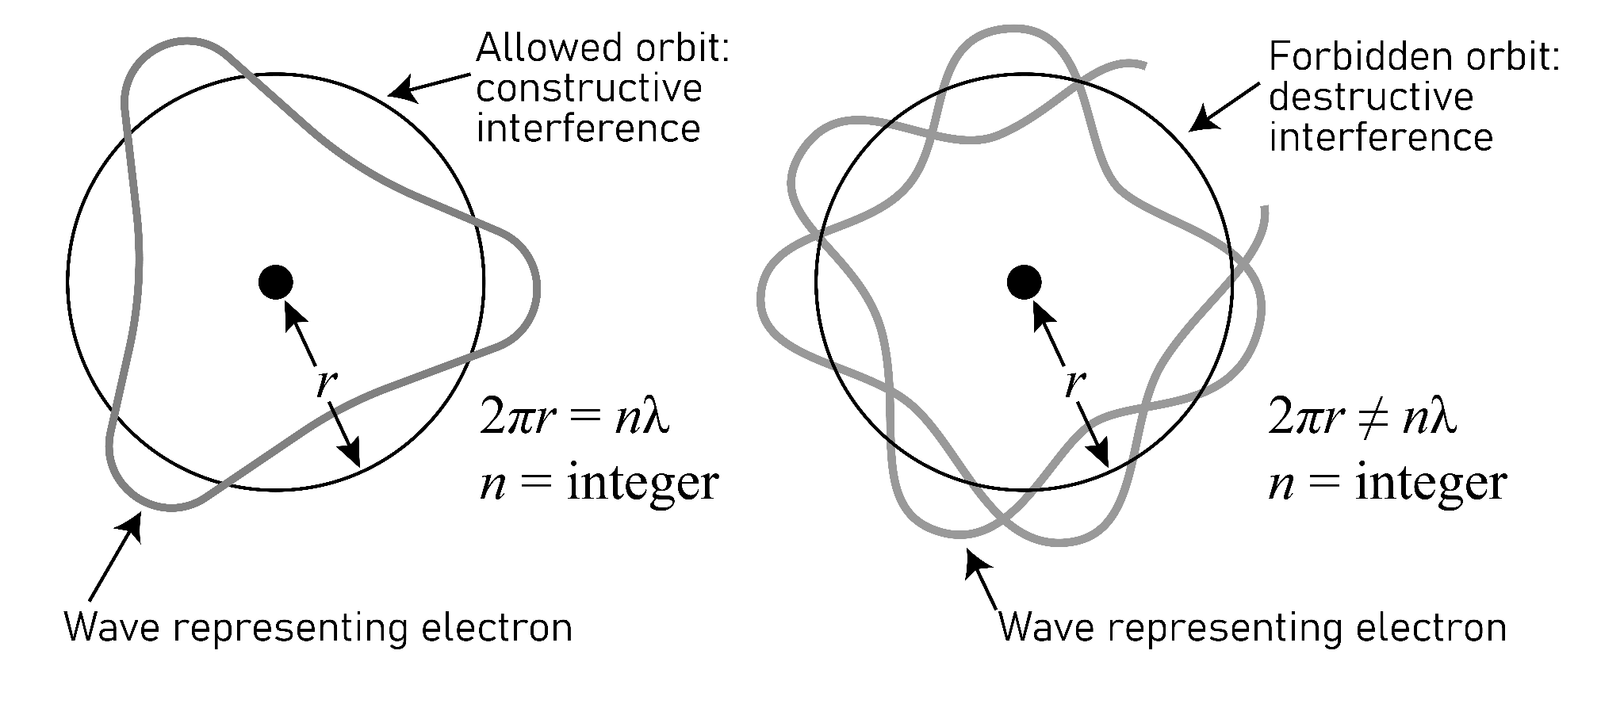
The standing wave in the atom represents an electron. As explained by De Broglie, electron energy is quantized, meaning electrons are only allowed to have certain energies or wavelengths. As a result, the principal quantum number, n, which defines the electron’s energy, must be a positive integer. When an electron has an allowable energy, its standing wave property is in phase with itself (see De Broglie wavelengths in lesson 3). If an electron has an energy value not allowed, the standing wave would be destroyed by destructive interference. Think of the wave as a string and the ends of the string would have to line up perfectly. If the ends don’t line up, destructive interference would occur, as shown below right. (Note the circle in all of these images represents the average distance of the electron from the nucleus.)

Figure 2: Positive wave interference (left) and negative interference (right).
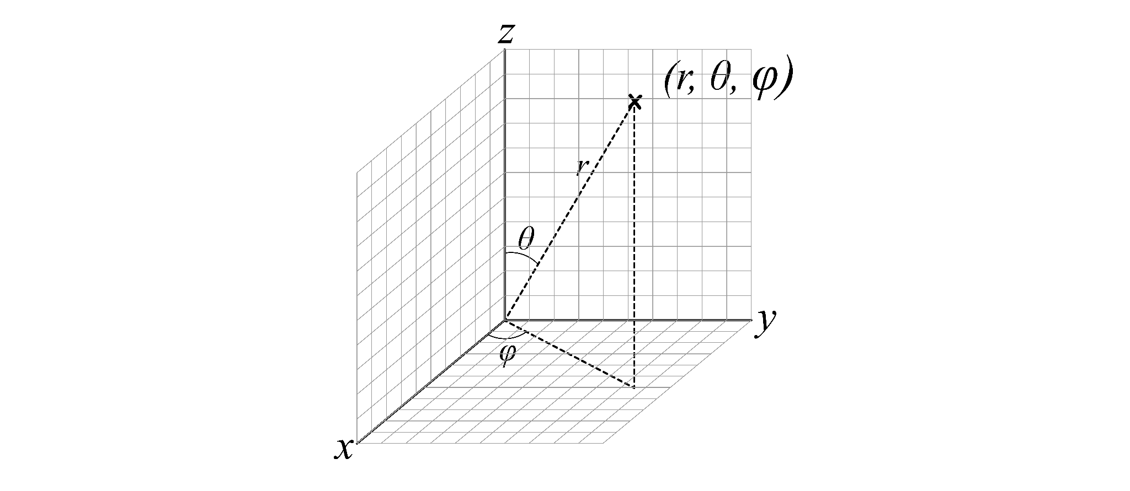
The wave functions in hydrogen atoms (𝛹(r,𝜃,ⲫ)) can produce densities known as atomic orbitals

Figure 3: r,𝜃,ⲫ are known as circular polar coordinates. The distance from the origin (r) to a point away from the origin, the angle (𝜃) between a line connecting the origin and the point and the x-axis, and the angle of projection into the z-axis (ⲫ).
There are three numbers produced by Schrodinger’s equation or the wave function. One number for each dimension in three-dimensional space. An atomic orbital is a three-dimensional probability density, or square of the three dimensional wave function. The three numbers are known as the principal quantum number, n, the angular momentum number, ℓ, and the magnetic number, m_{ℓ}. The principal quantum number describes the energy and the average distance of the electron from the nucleus, and defines what is known as a shell. Both energy and average distance from the nucleus increase as the value of n increases. The angular momentum number describes the shape of the orbital and what is known as a subshell. Subshells are composed of one or more orbitals of the same type. The magnetic number describes the orientation of the orbital in space in an applied magnetic field and defines the numbers of each type of orbital in a subshell.
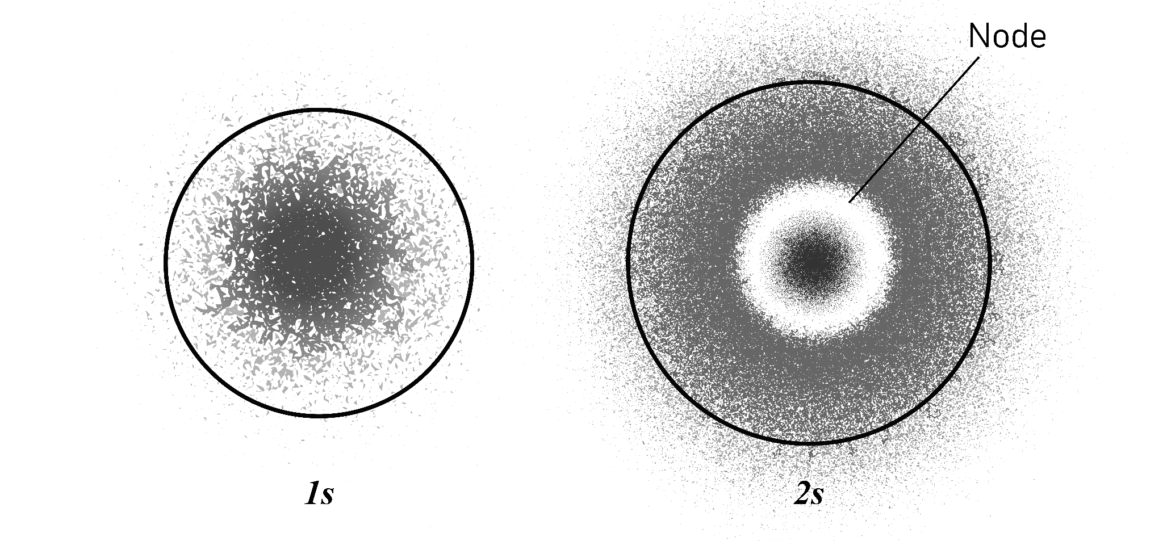

Figure 4: Probability density plots shown where each dot represents a possible electron location. Shown from left to right are the 1s and 2s orbitals. There is a node in the 2s orbital where the density is zero. The circle encompasses 90% of the electron density.

Figure 5: The graphs show the electron probability density from near the nucleus (left) to far from the nucleus (right). Note the node in the 2s and the two nodes in the 3s.

The principal quantum number can only have integer values because electron energy is quantized. The angular momentum number can have integer values from zero to n-1. The orbital described when ℓ=0 is known as the s-orbital. The s-orbital has a spherical shape. There are s-orbitals in each shell (n=1,2,3,...). The s-orbitals are also referred to as s-subshells. In higher energy shells, the s-orbitals are larger. There are nodes within the s-orbitals. The number of nodes can be predicted by n-1. The orbital described when ℓ=1 is known as the p-orbital. There are three p-orbitals with different orientations around the nucleus beginning in the second shell. The three p-orbitals within a shell are collectively known as a p-subshell. P-orbitals have a dumbbell shape and get larger with increasing n values. The orbital described when ℓ=2 is known as the d-orbital. There are five d-orbitals beginning in the third shell. The five d-orbitals within a shell are collectively known as a d-subshell. The orbital described when ℓ=3 is known as the f-orbital. There are seven f-orbitals beginning in the third shell. There are other types of orbitals not shown in Table 1.
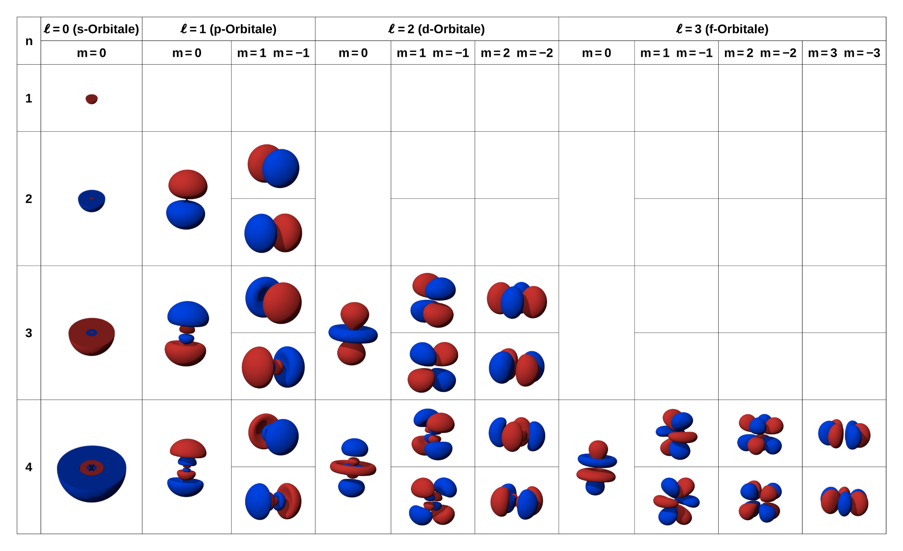

Table 1: Select orbital shapes shown as contour diagrams with defining quantum numbers. The contour shape encompasses 90% of the probability density for electron positions.

Electrons can exist as a single or in pairs in each of the orbitals. In other words, each orbital can hold a maximum number of two electrons. This is known as the Pauli Exclusion Principle. The limit of the number of electrons that may exist in an orbital is defined by a fourth quantum number. The fourth quantum number is known as the spin number, m_{s} and has two possible values, + or -½.
We cannot know the position of an electron or what path it is taking or its momentum. However, we can describe where the electron is based on the orbitals predicted by wave functions. Orbitals are used to describe what is known as electron structure or configuration in atoms. Electron configurations describe where the electrons in atoms are in terms of orbitals. Electron configurations are then used to predict and explain the reactivity and bonding in elements and compounds. For example, the electron configuration of a hydrogen atom in its ground state is 1s¹. The first number is the principal quantum number, the letter is the subshell type, and the superscript number represents the number of electrons in the subshell. The principal quantum number and the letter represent the subshell. The electron configuration for a ground state carbon atom is 1s²2s²2p². This states that a carbon atom has two electrons in the 1s subshell, two electrons in the 2s subshell, and two electrons in the 2p subshell.

Questions:
- How is the idea that electrons behave as waves in atoms consistent with the idea of quantized energy? Only certain discrete wavelengths can exist in atoms. These wavelengths are associated with discrete allowed energies or quantized energy.
- What limits the wavelength of electrons in atoms? Only certain allowed wavelengths produce constructive interference with themselves. Any wavelength that produced destructive interference is not allowed.
- What are the three quantum numbers produced by the wave function in atoms? What do they each represent? The principal quantum number defines the energy or shell and the average distance between the electron and the nucleus. The angular momentum describes the shape of the orbital and the subshell type. The magnetic number describes the orientation of the orbital in space.
- What is an orbital and how is it related to a wave function? An orbital is a three-dimensional probability density plot produced by squaring the wave function.
- Describe a s-orbital. Which shells in atoms contain s-orbitals? How many s-orbitals make up a s-subshell? A s-orbital has a spherical shape. They are present in all shells. S-subshell is made up of one orbital.
- Describe a p-orbital. Which shells in atoms contain p-orbitals? How many p-orbitals make up a p-subshell? A p-orbital has two lobe dumbbell shapes. They are present in all shells beginning with shell n=2. The P-subshell is made up of three orbitals.
- Which shells in atoms contain d-orbitals? How many d-orbitals make up a d-subshell? They are present in all shells beginning with n=3. The d-subshell is made up of five orbitals.
- What is the significance of the Pauli Exclusion Principle? That each orbital in an atom can hold a maximum of two electrons.
- What is an electron configuration? It describes the location of electrons in atoms in terms of which orbitals they occupy.
- The electron configuration for a ground state oxygen atom is 1s²2s²2p⁴. Describe where oxygen’s eight electrons are located in the atom? Two are in the 1s subshell, two are in the 2s subshell, and 4 are in the 2p subshell.

Category: Atomic Orbitals. Wikimedia Commons. (n.d.). https://commons.wikimedia.org/wiki/Category:Atomic_orbitals

