MOLE TO MOLE CONVERSION
In the first set of boxes, indicate what color will represent each element. Balance each equation and tally each element in the boxes below the equation. Finally, convert the moles in the problem that follows (show your work).



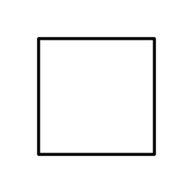
N H O

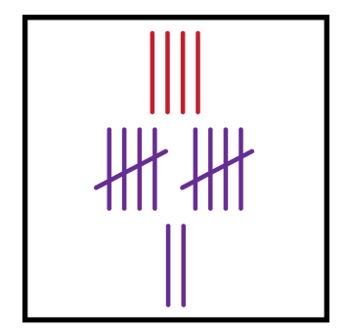
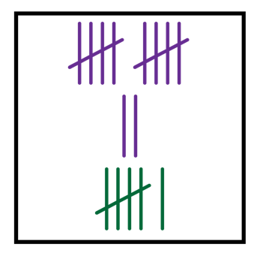
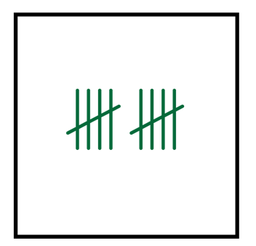
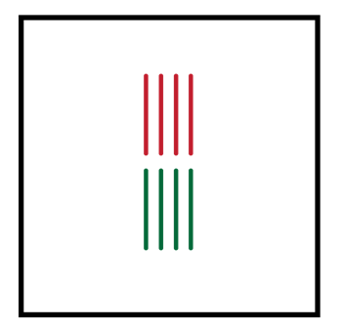
- 4NH₃ + 5O₂ →4NO + 6H₂O

- How many moles of O₂ do you need to make 14 moles of NO? _______

In the first set of boxes, indicate what color will represent each element. Balance each equation and tally each element in the boxes below the equation. Finally, convert the moles in the problem that follows (show your work).

Fe O

- 4Fe + 3O₂ → 2Fe₂O₃
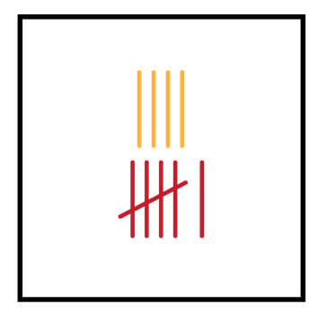
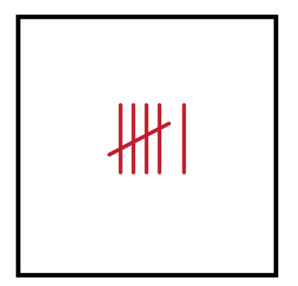


b. How many moles of Fe do you need to make 28 moles of Fe₂O₃? _______

In the first set of boxes, indicate what color will represent each element. Balance each equation and tally each element in the boxes below the equation. Finally, convert the moles in the problem that follows (show your work).




Ca O H P

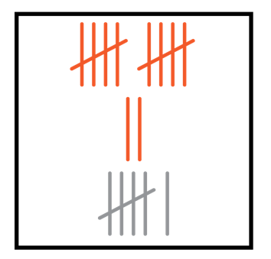
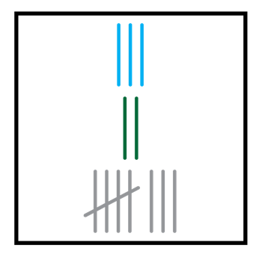
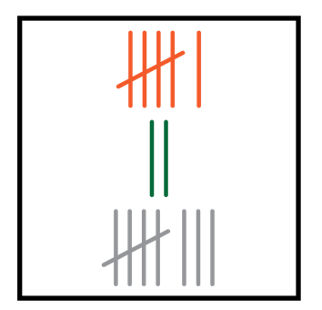
- 3Ca(OH)₂ + 2H₃PO₄ →1Ca₃(PO₄)₂ + 6H₂O
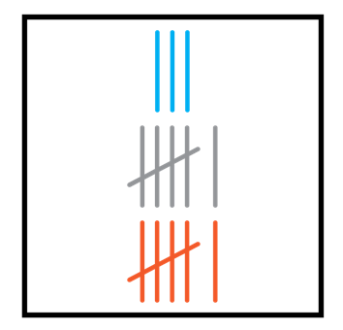
c. How many moles of H₃PO₄ do you need to make 4 moles of H₂O? _______

In the first set of boxes, indicate what color will represent each element. Balance each equation and tally each element in the boxes below the equation. Finally, convert the moles in the problem that follows (show your work).



Al H Cl

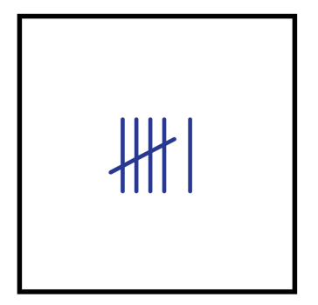
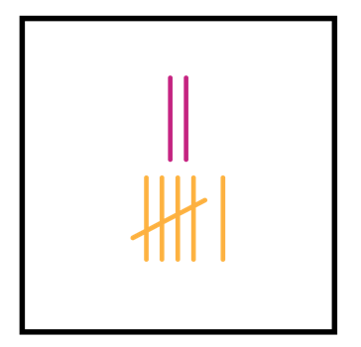
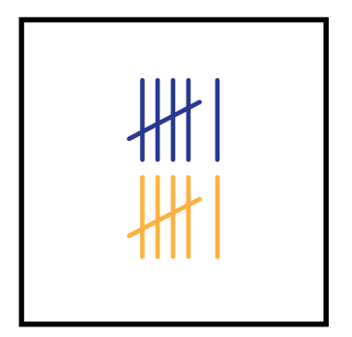
- 2Al + 6HCl →2AlCl₃ + 3H₂

d. How many moles of Al do you need to make 132 moles of AlCl₃?m _______

In the first set of boxes, indicate what color will represent each element. Balance each equation and tally each element in the boxes below the equation. Finally, convert the moles in the problem that follows (show your work).
N H O

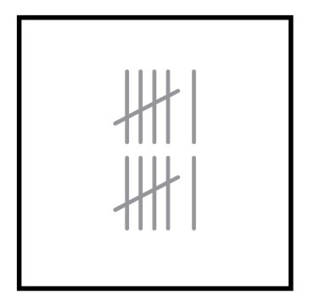
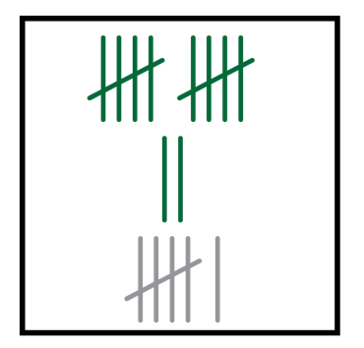
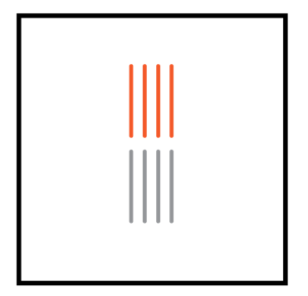
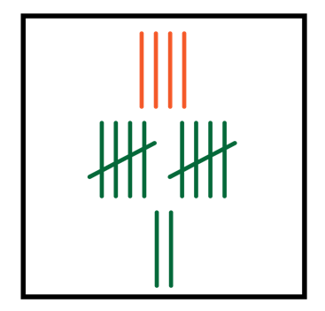
- 4NH₃ + 5O₂ →4NO + 6H₂O

e. If you had 55 moles of O₂ how many moles of NO did you produce? _______

In the first set of boxes, indicate what color will represent each element. Balance each equation and tally each element in the boxes below the equation. Finally, convert the moles in the problem that follows (show your work).
C H O
- 1C₂H₄ + 3O₂ → 2CO₂ + 2H₂O
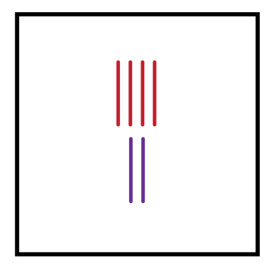
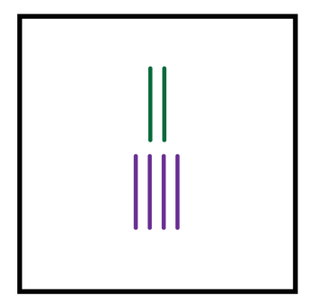
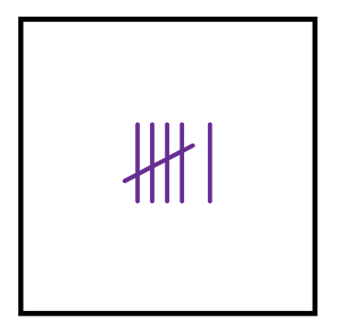
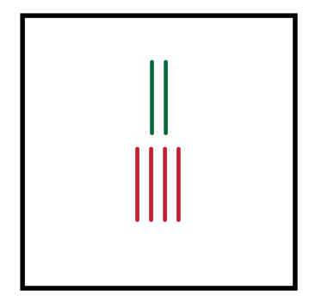
f. How many moles of O₂ do you need to make 77 moles of CO₂? _______

