STOICHIOMETRY: MOLE TO MOLE NOTES
Vocabulary:
Stoichiometry- Greek, “stoiechion” (element) and “metron” (to measure). The calculation of the amount of substances in a chemical reaction from the balanced equation.
Balance the equation and then label the reactants, products, and coefficients in the following chemical equation:
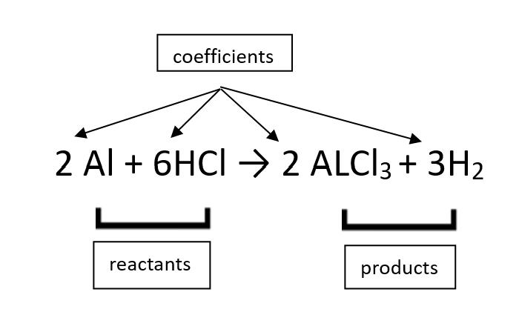
Conversion factor- a numeric ratio of equal measurements used to convert quantities between different units.
Moles (mol)- the quantity of an element or compound containing 6.02 x 10²³ (Avagadro’s number) particles (ex. atoms, ions, etc.) of that element/compound.
Molar (Molecular) Mass- the weight (in grams) of a single mole of particles (atoms, ions, or molecules) of an element/compound.

Steps:
- Balance the equation
- Determine the mole to mole ratio between A and B
- Multiply across, Divide Bottom

General Form for mole to mole conversions:

# mol A | Ratio from coefficient mol B | = moles of B
 | Ratio from coefficient mol A

ketzbook’s Stoichiometry Tricks Video:

Nitrogen reacts with Hydrogen to produce a component of fertilizer called ammonia (NH₃). How many moles of Nitrogen (N₂) do you need to make 10 moles of ammonia (NH₃)?
- Balance the equation:
1 N₂ + 3 H₂ -> 2 NH₃
- Determine the mole-to-mole ratio: 1:3:2
- 10 moles NH₃ require 1 mole N₂
- Using the given information to solve the problem:

10 mol NH₃ | 1 N₂ | = 5 mol N₂
 | 2 mol NH₃

