STOICHIOMETRY: MOLES TO MOLES NOTES
Vocabulary:
Fill in the blank:
Stoichiometry - Greek, “stoiechion” (________) and “metron” (to __________). The calculation of the amount of substances in a chemical reaction from the balanced equation.
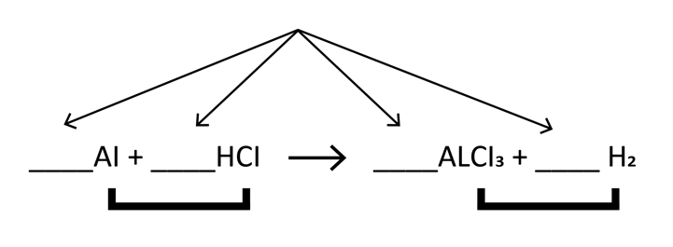
Balance the equation and then label the reactants, products, and coefficients in the following chemical equation:

Conversion factor- a numeric _________ of equal measurements used to convert quantities between different _________.
Moles- the _____________ of an element or compound containing ______________(Avagadro’s number) particles (ex. atoms, ions, etc.) of that element/compound.
Molar(Molecular) Mass- the ___________(in_________) of a single mole of particles (atoms, ions, or molecules) of an element/compound.

Steps:
- _____________ the equation

- Determine the __________ to ___________ ratio between A and B

- ________ across, __________ bottom

General Form for mole to mole conversions:

=

ketzbook’s Stoichiometry Tricks Video:

Nitrogen reacts with Hydrogen to produce a component of fertilizer called ammonia, NH₃. How many moles of Nitrogen, N₂, do you need to make 10 moles of ammonia,NH₃?
- Balance the equation:
___N₂ +____ H₂ ->___ NH₃
- Determine the mole-to-mole ratio:__________
- ___ moles NH₃ require____ moles N₂
- Using the given information to solve the problem:

=

