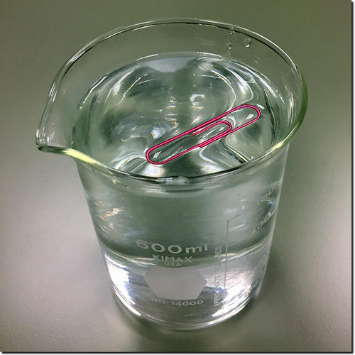
Making the Attraction Real
Overflow My Cup
MATERIALS NEEDED:
- small plastic cup
- water
- hundreds of paper clips
PROCEDURE:
- Fill the cup to the brim with water.
- Make a claim in the table to how many paper clips you believe can fit in the cup before the water spills over.
- Add the paperclips SLOWLY to the water, keeping count of how many you are adding.
- Record in the table how many it took for the water to spill over.
- Explain what you now know about attractions in the table.
- Create a new claim based on your evidence from this activity.

Claim

How many did it take for the water to spill over?

What does this experience tell you about attractions?

Revise your claim to what you experienced:

PROCEDURE:
- Fill the cup to the brim with water.
- Make a claim in the table to how many paper clips you believe can fit in the cup before the water spills over.__________________________
- Add the paperclips SLOWLY to the water, keeping count of how many you are adding.
- Record in the table how many it took for the water to spill over._____________________
- Explain what you now know about attractions in the table.

________________________________________________________________________

________________________________________________________________________

________________________________________________________________________
- Create a new claim based on your evidence from this activity.

________________________________________________________________________

________________________________________________________________________

