H-Chart

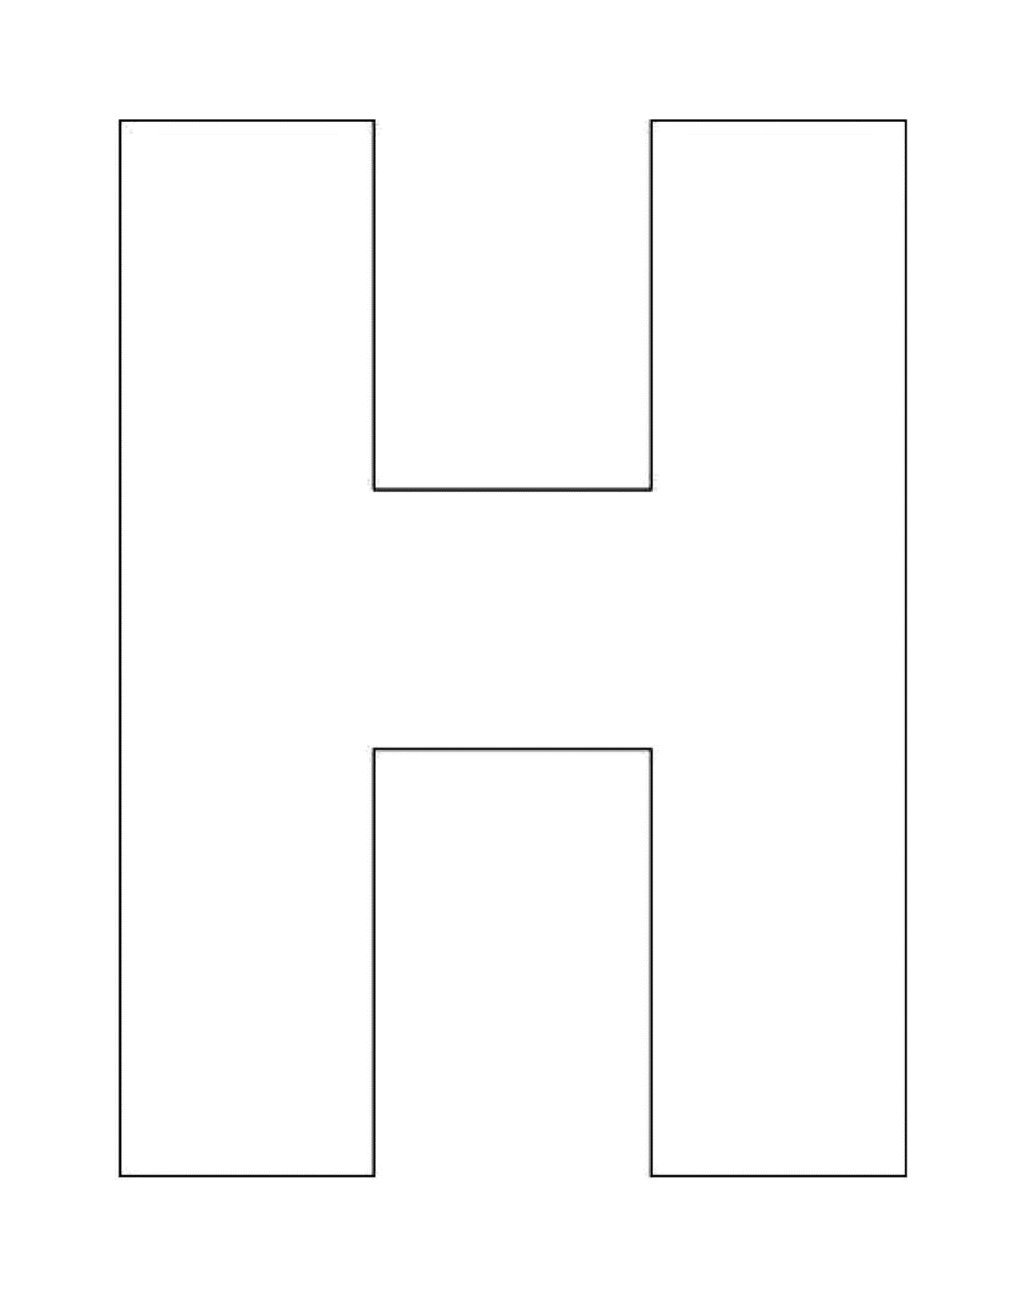

Separate Text

Separate Text

“Third Text” Together