A Picture is Worth a Thousand Words
For each photo, provide a brief caption (or statement) that describes what you think the picture represents. Next, answer the questions under each picture with your honest opinion. There are no right or wrong answers, but please take the time to answer the questions thoughtfully.

Photo 1 Caption:
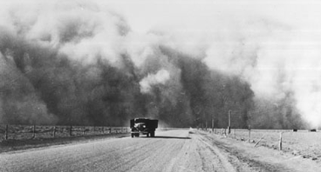
What type of emotions do you think that the passengers of this truck are experiencing in this situation? Write a few sentences describing what it must have been like to be speeding away from such a massive cloud. Be as descriptive as possible.

In what time period do you think this photograph was taken? What clues helped you come to that decision?

Photo 2 Caption:
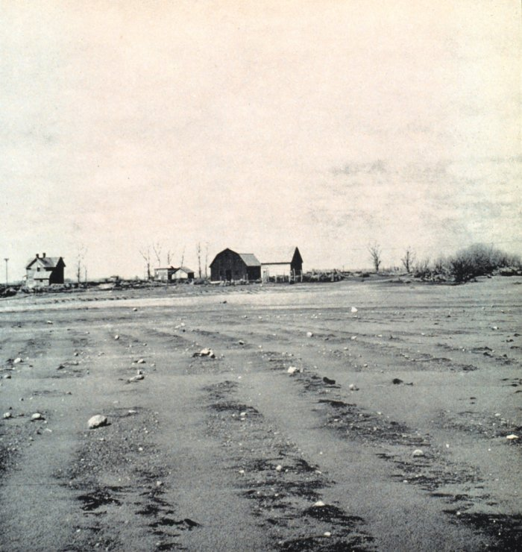
What is life like for the family that lives in this home? What has happened to their crops? Do you think that the family will be able to stay in their home much longer?

Photo 3 Caption:

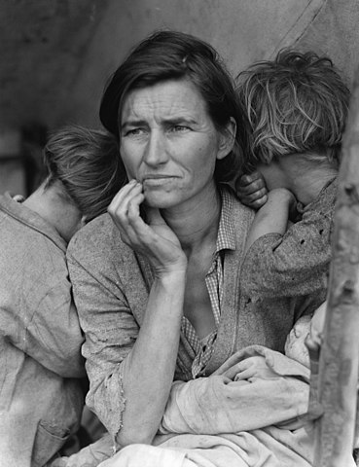
Imagine you are one of the characters in this photo. What are you thinking right now? What emotions fill your heart and mind?

Photo 4 Caption:

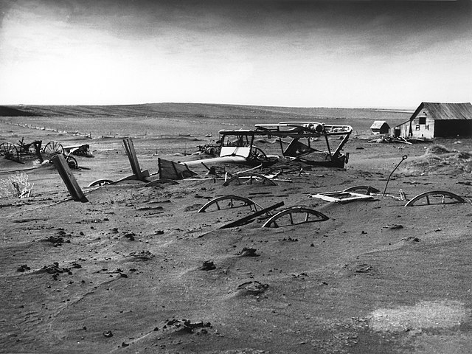
If this photo were not in black and white, what would the dominating colors be in this setting?

Image Credits
Image 1: Mmakki. (2013). The Dust Bowl. Retrieved from https://commons.wikimedia.org/wiki/File:The_Dust_Bowl.gif
Image 2: Lord, R. (1935). A blown-out field in South Dakota. To Hold This Soil, Miscellaneous Publication No. 321, U.S. Department of Agriculture. Retrieved from https://www.photolib.noaa.gov/htmls/wea01404.htm
Image 3: Lange, D. (1936). Destitute pea pickers in California. Mother of seven children. Retrieved from https://commons.wikimedia.org/w/index.php?curid=52734
Image 4: Sloan. (1936). Buried machinery in barn lot in Dallas, South Dakota. U.S. Department of Agriculture image number 00di0971. Retrieved from https://en.wikipedia.org/wiki/File:Dust_Bowl_-_Dallas,_South_Dakota_1936.jpg

