Photo 1
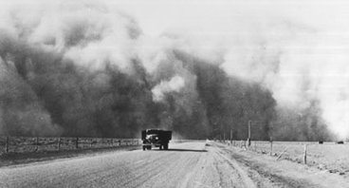
What type of emotions do you think that the passengers of this truck are experiencing in this situation? Write a few sentences describing what it must have been like to be speeding away from such a massive cloud. Be as descriptive as possible.

Photo 2
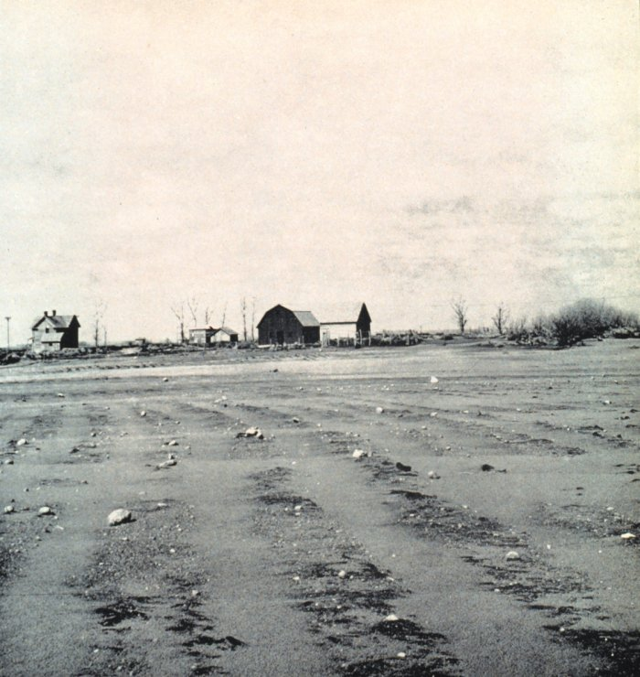
What is life like for the family that lives in this home? What happened to their crops? Do you think the family will be able to stay in their home much longer?

Photo 3
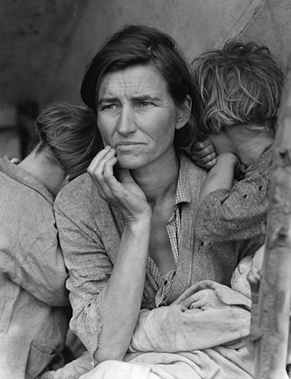
Imagine you are one of the characters in this photo. What are you thinking right now? What emotions fill your heart and mind?

Photo 4
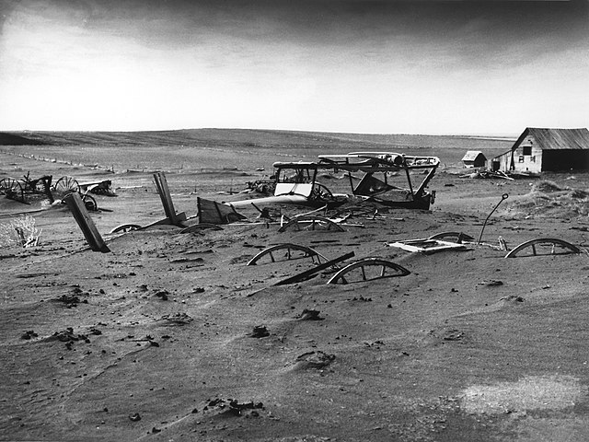
If this photo were not captured in black and white, what colors would dominate the setting?

Sources

Dust cloud [Photograph]. (1936, May). Getty Images. https://www.gettyimages.com/detail/news-photo/south-of-lamar-colorado-a-large-dust-cloud-appears-behind-a-news-photo/108802891?adppopup=true
Lord, R. (1935). A blown-out field in South Dakota [Photograph]. American Institute of Physics. https://history.aip.org/climate/xDust.htm

Lange, D. (1936). Migrant mother [Photograph]. Wikimedia Commons. https://commons.wikimedia.org/w/index.php?curid=52734

Dust bowl – Dallas, South Dakota [Photograph]. (1936). Wikimedia Commons. https://en.wikipedia.org/wiki/File:Dust_Bowl_-_Dallas,_South_Dakota_1936.jpg

