The Dust Bowl From Different Perspectives
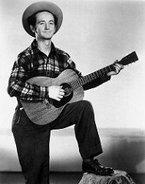
As you read through and listen to this song, use the following questions to help you focus in on specific themes:
- How do the words used by Woody Guthrie fit in with what is happening in the Dust Bowl?
- What kind of emotions does the song describe?
- What do you think is the author’s reason or motive for writing the song?

A Quick Bio:

A native of Okemah, Oklahoma, Woody Guthrie is best known as an American singer, songwriter, and folk musician whose musical legacy includes hundreds of political, traditional, and children’s songs, ballads, and improvised works.

Image source: Galaviz, R. A. (1947). Woody Guthrie. Retrieved from https://www.flickr.com/photos/galaxyfm/2092809274

Dust Bowl Blues: By Woody Guthrie
I just blowed in, and I got them dust bowl blues,
I just blowed in and I got them dust bowl blues,
I just blowed in, and I’ll blow back out again.

I guess you’ve heard about ev’ry kind’ of blues,
I guess you’ve heard about ev’ry kind of blues,
But when the dust gets high,
you can’t even see the sky.

I’ve seen the dust so black that couldn’t see a thing,
I’ve seen the dust so black that I couldn’t see a thing,
And the wind so cold, boy, it nearly cut your water off.

I seen the wind so high that it blowed by fences down,
I’ve seen the wind so high that it blowed my fences down,
Buried my tractor six feet underground.

Well, it turned my farm into a pile of sand,
yes, it turned my farm into a pile of sand,
I had to hit the road with a bottle in my hand.

I spent ten years down in that old dust bowl.
I spend ten years down in that old dust bowl,
When you get that dust pneumony, boy, it’s time to go.

I had a gal, and she was young & sweet,
I had a gal, and she was young & sweet,
But a dust storm buried her sixteen hundred feet.

She was a good gal, long, tall & stout,
Yes, she was a good gal, long, tall & stout,
I had to get a steam shovel just to dig my darlin’ out.

These dusty blues are the dustiest ones I know,
These dusty blues are the dustiest ones I know,
Buried head over heels in the black old dust,
I had to pack up and go.
An’ I just blowed in and I’ll soon blow out again

Out of the Dust
Read the following description of the book by Karen Hesse.

In this powerful historical novel, a young teenager named Billie Jo Kelby describes her life from the winter of 1934 through the autumn of 1935. Through her story readers see what life in the Dust Bowl was like as Oklahoma farmers struggled to raise crops choked by continual dust storms and families struggled to survive.
Billie Jo and her parents face these hard times together and, despite the never-ending dust, Billie Jo is happy. More than anything, Billie Jo loves to play the piano, and she has begun earning money performing. Ma and Pa are happy, too—soon Ma will give birth and at last Billie Jo will have a brother or sister.
Then a terrible accident changes everything. Ma mistakes a pail of kerosene that Pa had left next to the stove for water and begins to use it to cook. Fire erupts. After her mother runs outside, Billie Jo tosses the flaming kerosene out the door, realizing too late that Ma is standing right in the path of the fiery liquid. Billie Jo tries desperately to save Ma, beating out the flames with her own hands. Ma and the baby both die, the town gossips that Billie Jo caused the accident, Pa withdraws into a deep depression, and Billie Jo’s hands are so badly burned that she cannot play the piano and daily chores are agony.
For a long time, she can forgive neither her father nor herself, and even escapes on a freight train. As she leaves the dust of Oklahoma behind, Billie Jo comes to understand herself and her father in a new way. She returns home; the many hardships she has faced—her mother’s tragic death, her father’s retreat into depression, her own need to escape, and the personal journey that finally result in healing and forgiveness—all lead Billie Jo “out of the dust” in a most surprising way.

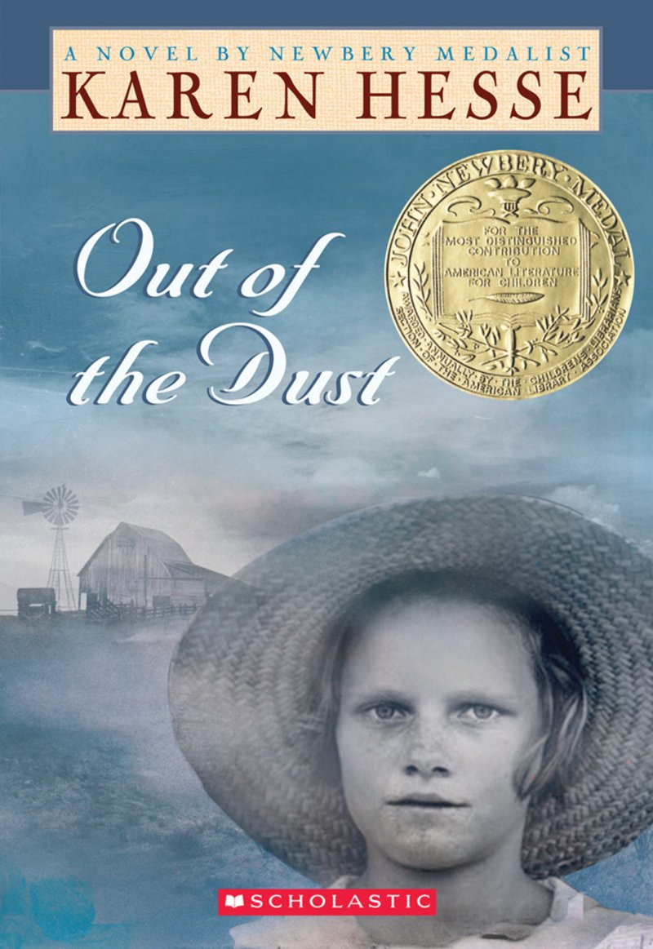
“Daddy came in; he sat across from Ma and blew his nose. He coughed and spit out mud. If he had cried, his tears would have been mud, too. But he didn’t cry. And neither did Ma.”

Image source: Scholastic. (n.d.). Out of the Dust. Retrieved from https://www.scholastic.com/teachers/books/out-of-the-dust-by-karen-hesse/

