Operant Conditioning Theory of Learning
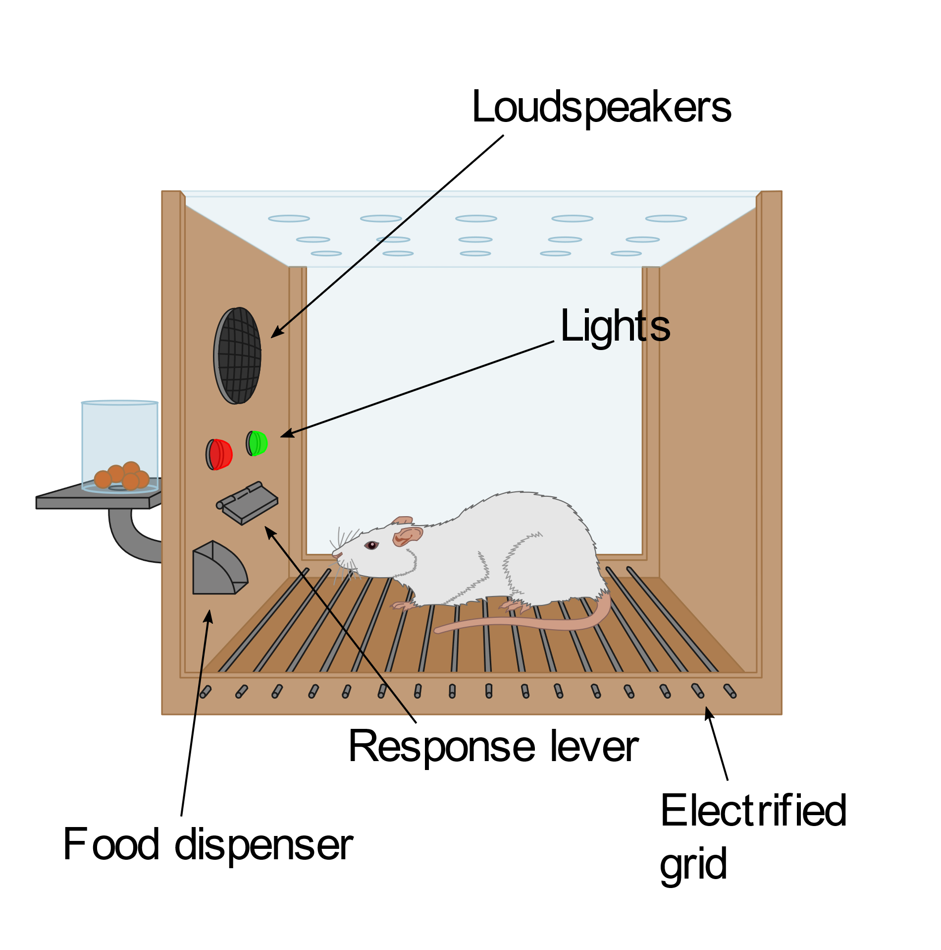
B.F. Skinner was a behavioral psychologist, which means he believed that people’s personality traits formed from their environment instead of genetics. Skinner’s theory of how people’s behavior responds to the consequences they experience is called operant conditioning. The learning theory of operant conditioning was developed by Skinner by conducting experiments on rats in a laboratory. He based his experiments on Edward Thorndike’s law of effect, which says that behavior that is followed up with pleasant consequences will probably be repeated, and behavior that is followed up with unpleasant consequences will not.
To test his new theory, Skinner created an operant conditioning chamber, now known as the Skinner Box, which he used to test animal behavior. He placed a rat inside the box, and if the rat hit a lever, a piece of food would appear. The rat learned to hit the lever for more food. Sometimes, Skinner would electrify the floor of the box so that when a rat was placed inside, it would get shocked. By hitting the lever, the shock would stop. The rat learned to immediately hit the lever if it was getting shocked. From these experiments, Skinner developed four outcomes of behavior (see table below). It is important to remember that positive and negative do not equate to good or bad, and that behavior can be either encouraged or discouraged by experiencing a punishment or having the behavior reinforced.
Outcome | Description | Example
Positive Reinforcement | Adding something to increase a behavior | Parents give verbal praise to son so he continues behaving well
Negative Reinforcement | Subtracting something to increase a behavior | Parents take away daughter’s phone so she’ll finish homework
Positive Punishment | Adding something to decrease a behavior | Parents enforce earlier curfew so son stops coming home late
Negative Punishment | Subtracting something to decrease a behavior | Parents take away daughter’s video games until she stops disrespecting them

