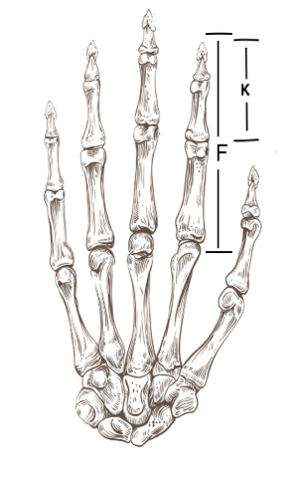
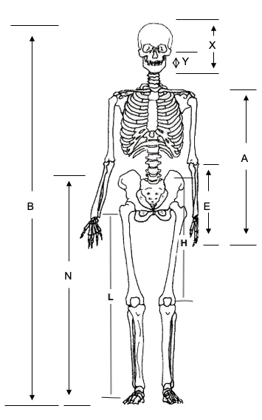
Measure each of the following body dimensions in centimeters.
Measurement Description | Student 1 (cm) | Student 2 (cm)
A (length of arm)
B (height)
E (fingertips to elbow)
F (length of index finger)
H (hip to kneecap)
K (index fingertip to big knuckle)
L (length of leg)
N (height from feet to navel)
X (top of head to chin)
Y (bottom of ear to chin)

