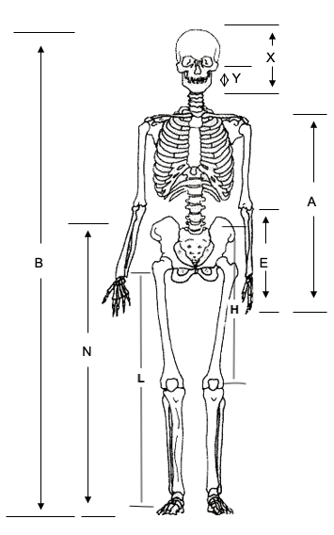
Student data collection sheet
Step one: Measure the following body dimensions in centimeters.
DESCRIPTION | Student 1 | Student 2 | Student 3 | Student 4 | Student 5 | Student 6
A (Length of arm)
B (Height)
E (Finger tips to elbow)
F (Length of index finger)
H (Hip to kneecap)
K (Index finger tip to big knuckle)
L (Length of leg)
N (Height from feet to navel)
Y (Bottom of ear to chin)
X (Top of head to chin)
 |  |  | Note: Record measurements in cm.
Step two: Using your measurements, find the following ratios for each group member, then find the group average for each ratio.
 | Ratios
Student | B/N | F/K | L/H | A/E | X/Y
1
2
3 |  |  |  |  |  |  |  | 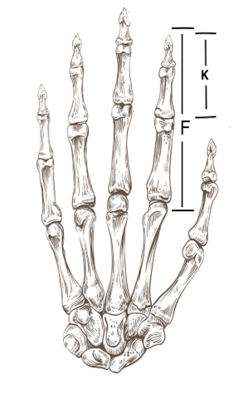
4
5
6
Average
 |  |  | Note: Record ratios as decimals.

