Learning Synths Playground
Navigate to LearningSynths.Ableton.com/en/Playground, which is a simple, digital synthesizer instrument made by Ableton. Each of these controls, representing physical modules, is based on a math equation. (Those equations are shown below.)
Adjust the different sliders and notice how the sound changes. Do some modules work together better than others? If so, why do you think that is the case?

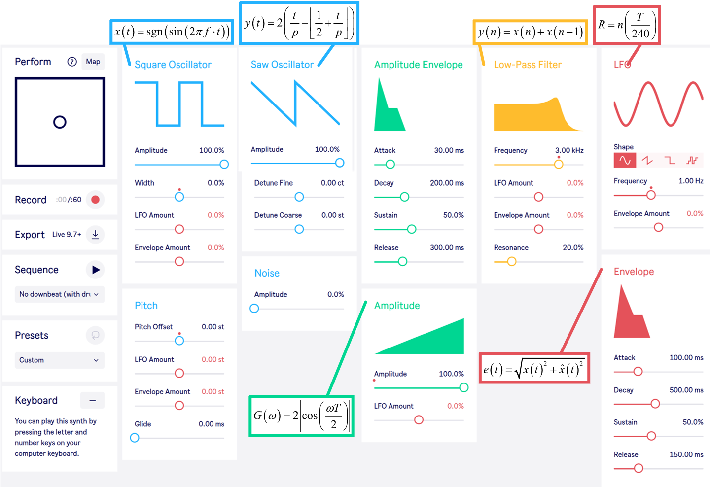
Learning synths. Learning Synths. (n.d.). https://learningsynths.ableton.com/en/playground

