Navigate to the website “Learning Synths Playground” made by Ableton. This website has a simple synthesizer instrument. But each of these modules is based on a math equation. (For fun, those equations are shown on the back of this page). Play with the different sliders and see how the sound changes. Do some modules work together better than others? Why do you think that is the case? Write your answer below.
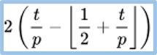
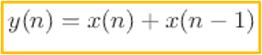
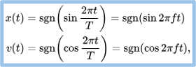
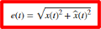
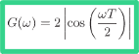
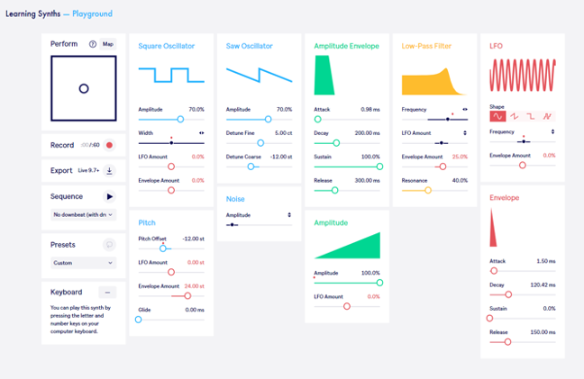
R = n(T/240)
Learning synths. Learning Synths. (n.d.). https://learningsynths.ableton.com/en/playground

