Navigate to the website “[Learning Synths Playground](https://learningsynths.ableton.com/en/playground)” made by Ableton. This website has a simple synthesizer instrument. But each of these modules is based on a math equation. (Those equations are shown below.) Play with the different sliders and see how the sound changes. Do some modules work together better than others? Why do you think that is the case? Write your answer on the back of this page.

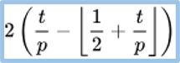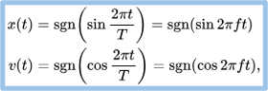

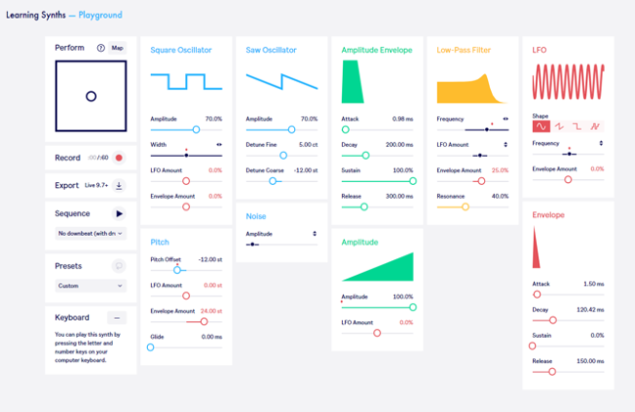

*Learning synths*. Learning Synths. (n.d.). https://learningsynths.ableton.com/en/playground