Polynomials and Sound
Graph | Polynomial | Graph | Polynomial
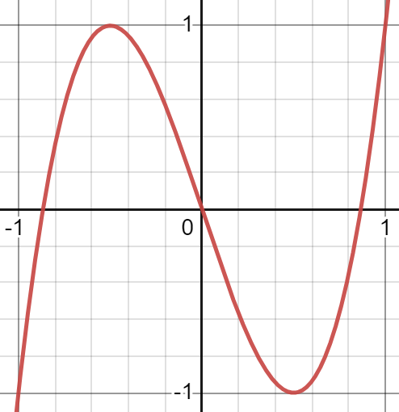 | T₃(x) = 4x³ – 3x | 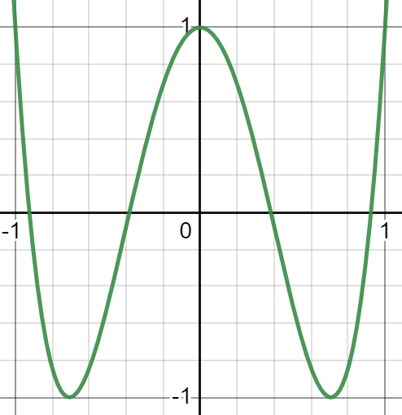 | T₄(x) = 8x⁴ – 8x² + 1
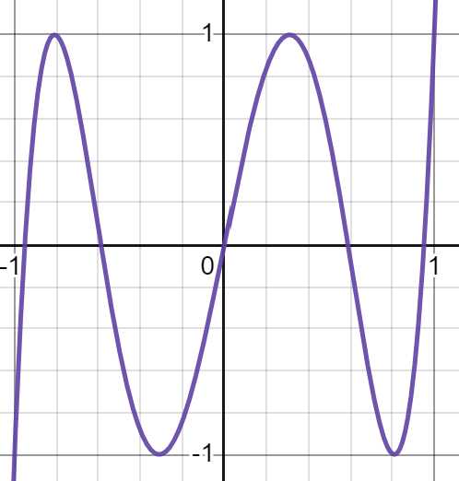 | T₅(x) = 16x⁵ – 20x³ + 5x | 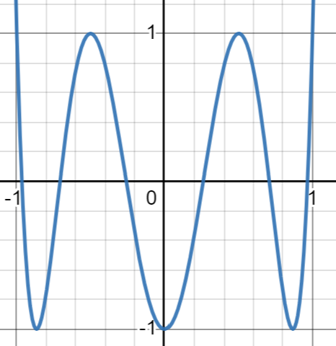 | T₆(x) = 32x⁶ – 48x⁴ + 18x² – 1
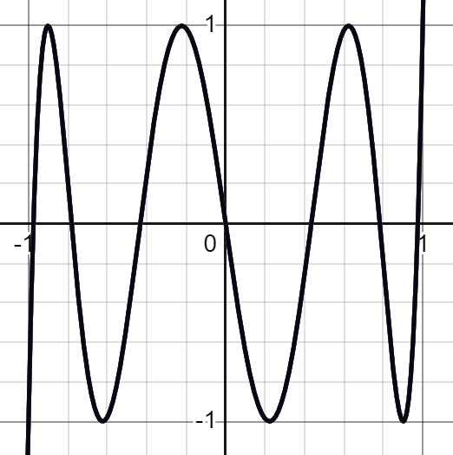 | T₇(x) = 64x⁷ – 112x⁵ + 56x³ – 7x | 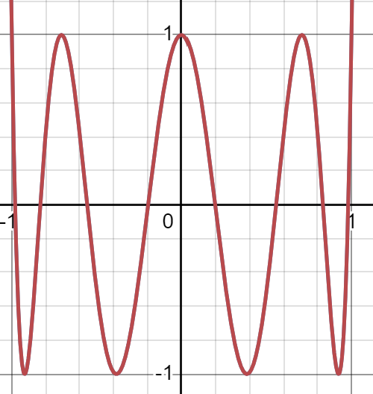 | T₈(x) = 128x⁸ – 256x⁶ + 160x⁴ – 32x² + 1
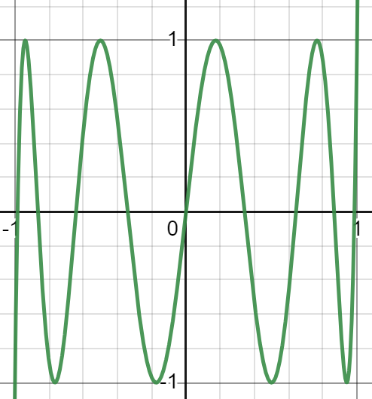 | T₉(x) = 256x⁹ – 576x⁷ + 432x⁵ – 120x³ + 9x
Use the table above to answer the following questions. Show your work on a separate sheet of paper.

1) Find T₃(x) + T₅(x).

3) Find T₈(x) – T₆(x).

2) Find the difference: T₄(x) – T₆(x).

4) Find the sum of T₉(x) + T₇(x).

Web Tool
To use the web tool and hear your polynomial, follow the steps below.

1) Go to k20center.ou.edu/e-learning/polynomials-sound/.
2) Turn down the Effect Volume.
3) Turn up the Noeffect Volume.
4) Select a “Sample #.”
5) Press the “Start” button.
6) Enter the new polynomial.
- Click on each coefficient or exponent to edit its value.
7) Turn down the Noeffect volume.
8) Turn up the Effect volume.

