Below is a list of the Chebyshev Polynomials of the First Kind. On a separate sheet of paper, show your work. In the space provided, write your answer and answer the question: What happens to a sound when we add or subtract the Chebyshev Polynomials? Example: When I added T₃(x) and T₅(x) the sound _______________.

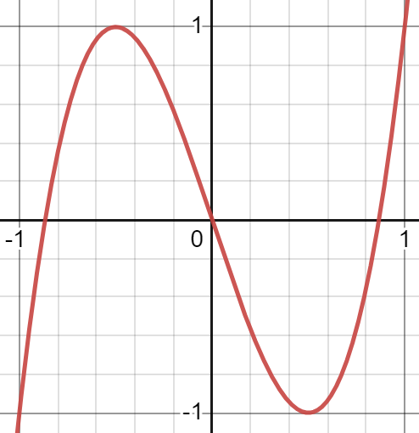 | T₃(x) = 4x³ - 3x
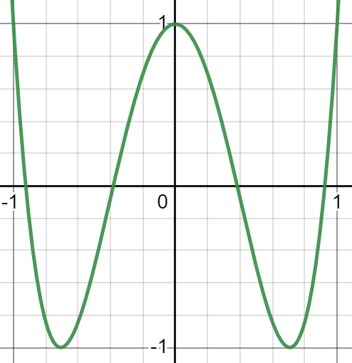 | T₄(x)= 8x⁴ - 8x² +1
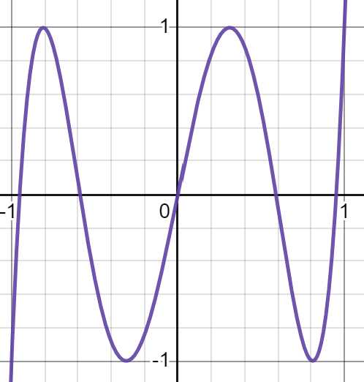 | T₅(x)= 16x⁵ - 20x³ + 5x
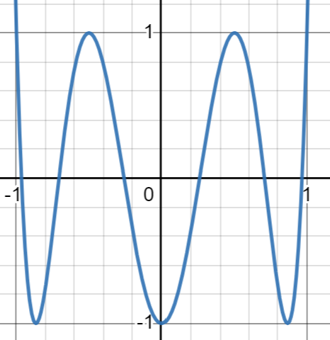 | T₆(x)= 32x⁶ - 48x⁴ + 18x² - 1
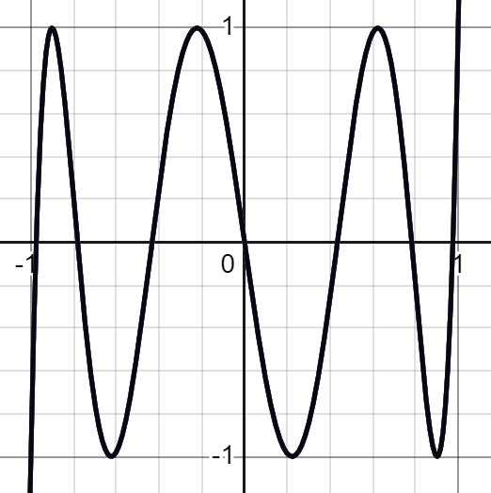 | T₇(x)= 64x⁷ - 112x⁵ + 56x³ - 7x
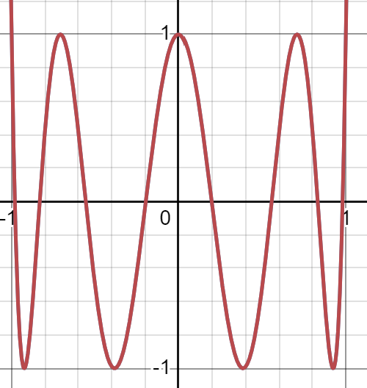 | T₈(x)= 128x⁸ - 256x⁶ + 160x⁴ - 32x² + 1
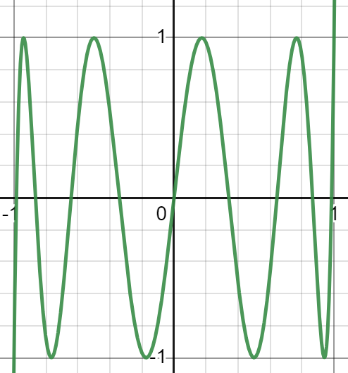 | T₉(x)= 256x⁹ - 576x⁷ + 432x⁵ - 120x³ + 9x

- Find T₃(x) + T₅(x).

- Find the difference of T₄(x) - T₆(x).

- Find T₈(x) - T₆(x).

- Find the sum of T₉(x) + T₇(x).

Part 2: After simplifying each set of polynomials and plugging them into the website, how are the sounds different? What descriptive words would you use for each sound? Examples nasally, cold, scary, happy, etc. Add a descriptive word to each answer you find.

Complete the following steps with your teacher.
- Click the number “49” key at the top of the page. (49 is the MIDI number for the note C#3).
- Turn the effect volume all the way down and slide the noeffect volume all the way up. This is the unfiltered sound.
- Slide the effect volume all the way up. This is the sound being filtered by the T3 Chebyshev polynomial.
- Change the preset to T5, then repeat the process clicking on “49,” turning the effect volume all the way down and sliding the noeffect volume all the way up. Then set the effect volume to “102.” This is the sound being filtered by the T5 Chebyshev polynomial.
- You should notice that the noeffect is the same, but the effect sound is different as the T5 sound is more nasally and lower in pitch than the T3 sound.
- Go to the worksheet and simplify the first set of polynomials.
- After getting the result, leave the sound on while inputting the answers in the boxes. On changing the 3rd coefficient, you should hear the sound change.

