CANAL CHARACTER CARDS
President Theodore Roosevelt
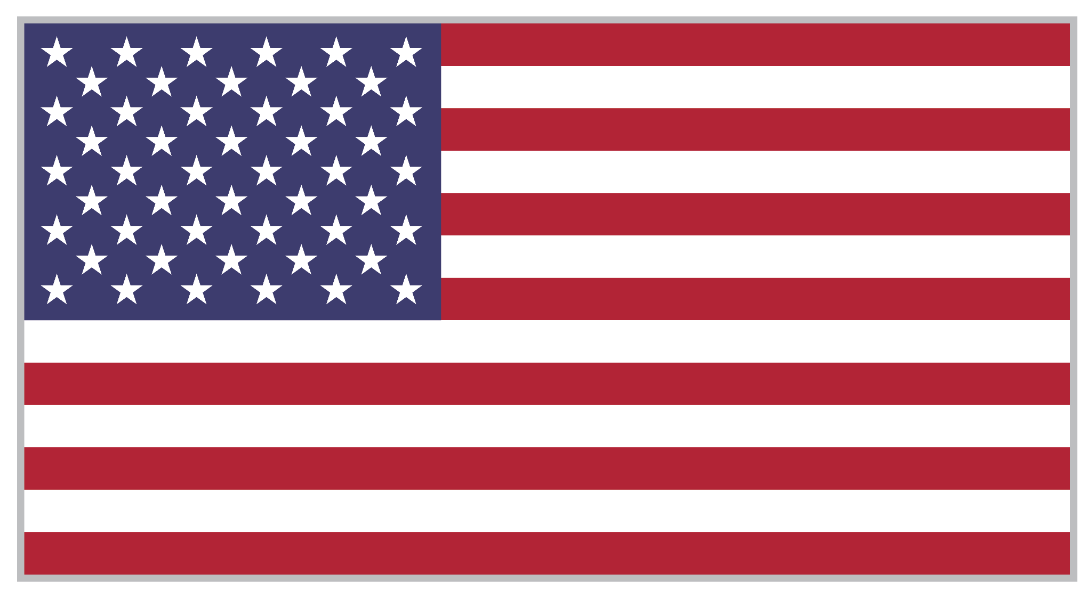 | - I paid France $40 million to buy the rights of the project from a French company that went bankrupt.  - To gain access to the land, I supported a revolution against Colombia so that the country of Panama would be independent.  - Once Panama had independence, I paid the government $10 million to lease the land, plus $250,000 annually until 1999.

President Ulysses S. Grant
- I first proposed a canal project in Panama during an address to Congress.
- I sent seven expeditions to Central America to see if a canal could be built.
- I decided that building a canal was too dangerous and would cost too many lives.

George Washington Goethals
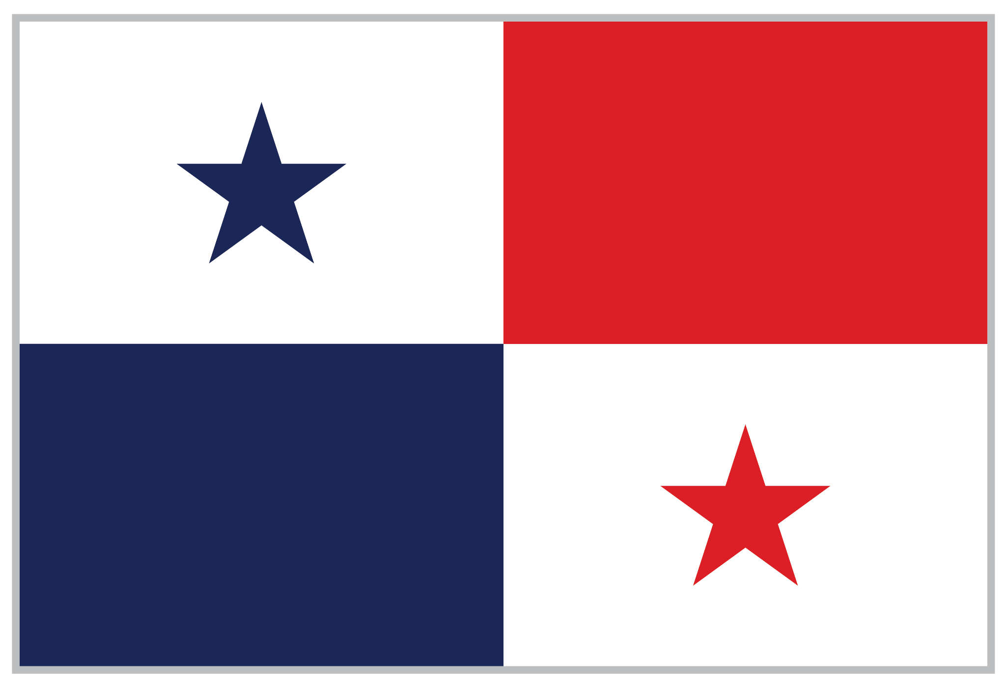 | - I was the 3rd engineer for the canal.  - Although I was a colonel, I never wore a uniform so I could relate more to the workers.  - I took a high interest in the health and sanitation of the canal workers.  - I listened to workers weekly to settle complaints and disputes.  - My strong leadership skills ensured the canal construction was completed.

Engineer John F. Stevens
- I was the second engineer of the canal.
- I improved workers’ happiness by introducing a food car with better food options.
- I gave workers vaccines to protect them from yellow fever.
- I didn’t want special treatment and bunked near the workers.
- I resigned after 2 years due to the difficulty of the job.

John Findley Wallace
- I was the first chief engineer for the construction of the canal but resigned after one year due to the difficulty of the job.
- I did not do a good job organizing the construction site and workers.
- Under my leadership, food was often spoiled and living conditions were unbearable.
- 3 out of 4 American workers left because of poor working conditions and many died due to malaria and yellow fever.

Ferdinand de Lesseps
- I was a French engineer and had experience building canals.
- I started construction of the canal in Panama but made little progress after 8 years.
- A French court found me and my son guilty of mismanagement. I paid a heavy fine and my son went to prison for a year.

Adolphe Godin de Lepinay
- I was a French engineer that studied the Panama isthmus.
- I also had experience with construction in tropical areas.
- I first proposed a canal with locks that led to man-made lakes.
- My idea was rejected by the French, but later it was used by the Americans to successfully build the canal.

Dr. William Crawford Gorgas
- I was the Chief Sanitary Officer for the canal construction zone.
- I directed swamps to be drained so there wouldn’t be as many mosquitos, which spread malaria.
- I led plumbing installation, road paving, and construction of homes, schools, and churches.
- I introduced pesticides to cut down on insects.

Antonio Sanchez
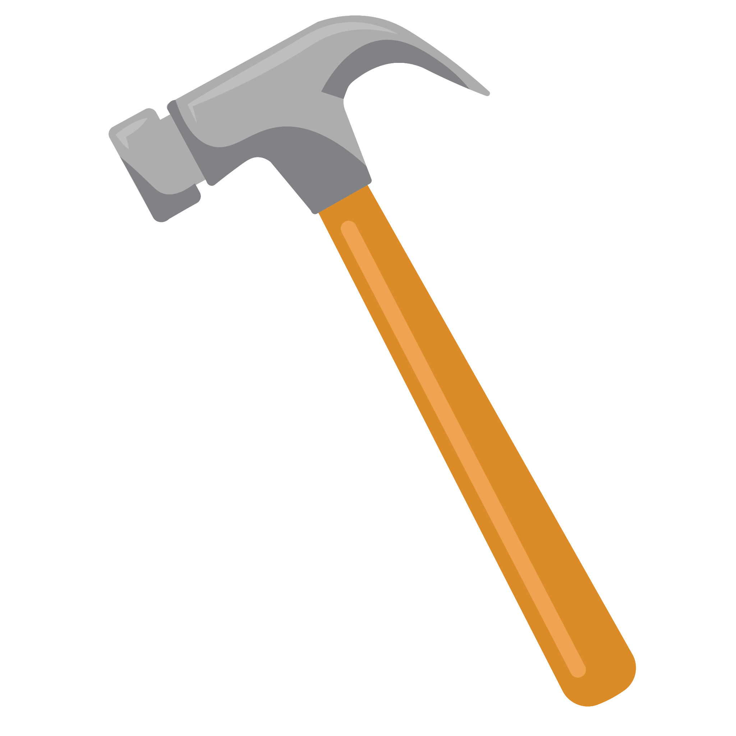 | - I was a construction worker for the canal.  - Because I was considered an unskilled worker, I was paid in silver instead of gold like the skilled workers.  - I once said going to work at the canal was like going to a battlefield.  - I saw many co-workers die from construction injuries and diseases like malaria and yellow fever.

Vasco Nunez de Balboa
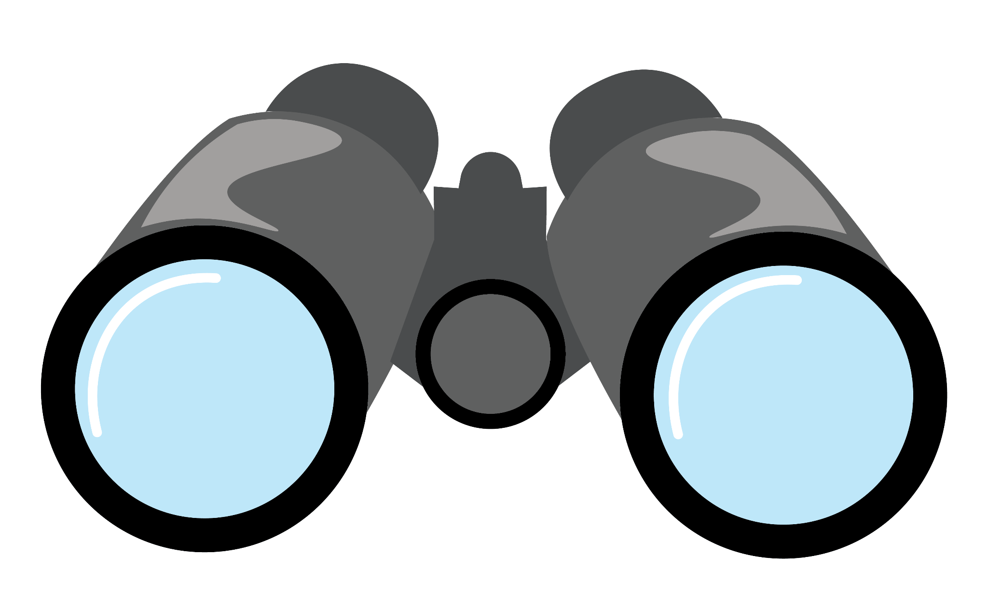 | - I was a Spanish conquistador.  - I crossed the Central American isthmus that would later become Panama in 1513.  - I helped establish a Spanish controlled city in present-day Panama.  - I forced native people into slavery and made them mine gold for Spain.  - The native people would not be independent until 1819.

Constantine Parkinson
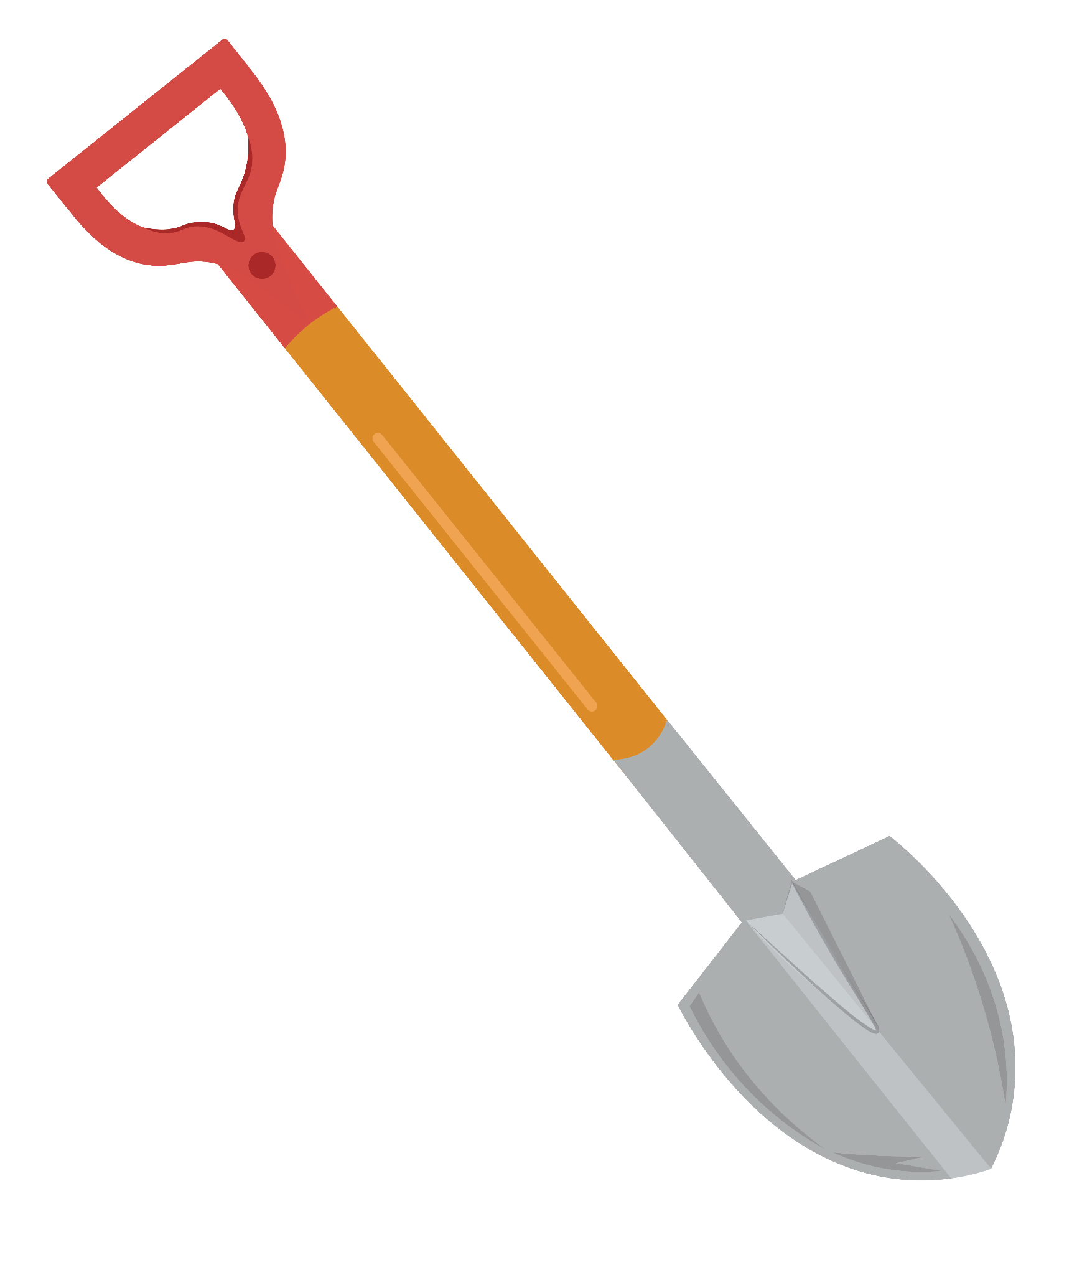 | - I started working on the Panama Canal at 15 years old.  - Because I was considered an unskilled worker, I was paid in silver. Most brown workers were considered unskilled.  - I was injured and lost my right leg; my left heel was crushed.  - The Chief Engineer, George Goethals, told my grandmother there wasn’t any money to help injured workers.

John Korp
- I traveled from New Jersey to work on the canal.
- I was considered a skilled worker so was paid in gold. Most white workers were considered skilled.
- I was given the job of using dynamite to blast apart rocks and clear the land for the canal.
- One day the dynamite exploded before I could leave the area. I died with twenty-six other workers in the explosion.

Louise C. Bidwell
- I lived in Washington, DC and saw an ad for nurses needed at the Panama Canal construction site.
- I was promised good pay, clean living quarters, healthy food, and lots of sunshine. This was not true.
- The hospital I worked in treated men for injuries, yellow fever, and malaria daily.
- I went home after two years due to the difficult work.

Sources:
A&E Television Networks. (n.d.-c). Why the construction of the Panama Canal was so difficult-and deadly. History.com. https://www.history.com/news/panama-canal-construction-dangers
Bemis, E. (n.d.-b). The Digging is the Least Thing of All. Exhibits at the University of Florida Libraries. https://exhibits.domains.uflib.ufl.edu/TheDigging/#:~:text=Over%2060%20million%20pounds%20of,blast%20large%20areas%20of%20rock
Cartwright, M. (2022, July 5). Vasco Núñez de Balboa. World History Encyclopedia. https://www.worldhistory.org/Vasco_Nunez_de_Balboa/
George Washington Goethals. ASCE American Society of Civil Engineers. (n.d.) https://www.asce.org/about-civil-engineering/history-and-heritage/notable-civil-engineers/george-washington-goethals
Magazine, S. (2018, April 18). How the Panama Canal took a huge toll on the contract workers who built it. Smithsonian.com. https://www.smithsonianmag.com/history/how-panama-canal-took-huge-toll-on-contract-workers-who-built-it-180968822/
Public Broadcasting Service. (n.d.). Chief engineers of the Panama Canal. PBS. https://www.pbs.org/wgbh/americanexperience/features/panama-canal-chief-engineers-panama-canal/
Public Broadcasting Service. (n.d.-b). TR and the Panama Canal. PBS. https://www.pbs.org/wgbh/americanexperience/features/tr-panama/
The French plan. Panama Exhibit Site. (2014, October 29). https://panama.lindahall.org/french-plan/
The Gilder Lehrman Institute of American history. Panama Canal proposal, 1881. Gilder Lehrman Institute of American History. https://www.gilderlehrman.org/history-resources/spotlight-primary-source/panama-canal-proposal-1881
McCrea, H. (n.d.). Heroines of the Panama Canal: U.S. nurses in the Panama Canal Zone 1880-1914. pdf.semanticscholar.org. https://pdfs.semanticscholar.org/1775/fd98c12505ed85d282ed2fb776a1e4c0ebb6.pdf

