SAMPLE MORTGAGE STATEMENT
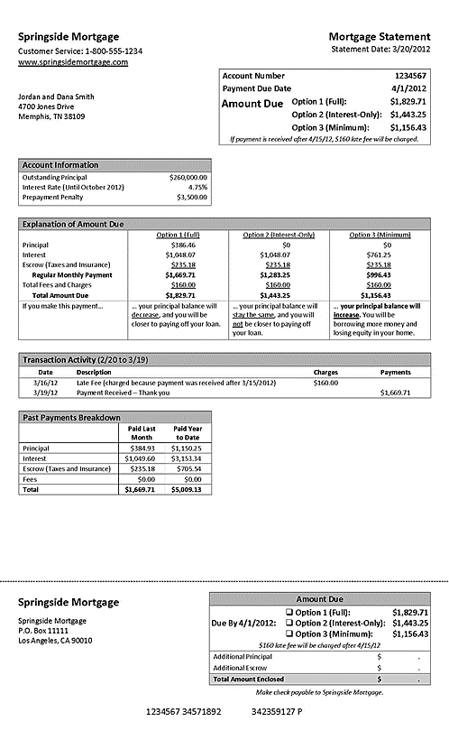

Source: Regulation Room. (n.d.). Periodic statement 3 [Image]. Home Mortgage Consumer Protection. http://archive.regulationroom.org/mortgage-protection/files/2012/08/h28c.png

