FASHION
Fashion Description
What kind of clothes, accessories, jewelry etc. would you normally see at a Diwali celebration? What is the significance behind these fashion choices? How are the materials/fabrics made?
______________________________________________________________________________
______________________________________________________________________________
______________________________________________________________________________
______________________________________________________________________________
______________________________________________________________________________
______________________________________________________________________________
______________________________________________________________________________
______________________________________________________________________________
______________________________________________________________________________
______________________________________________________________________________
______________________________________________________________________________
______________________________________________________________________________
______________________________________________________________________________
______________________________________________________________________________
______________________________________________________________________________
______________________________________________________________________________
______________________________________________________________________________
______________________________________________________________________________
______________________________________________________________________________
______________________________________________________________________________
______________________________________________________________________________
______________________________________________________________________________

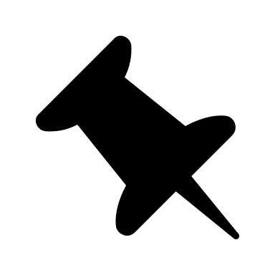
Create your Diwali Fashion vision board.

What are the colors?

What kind of fabric?

