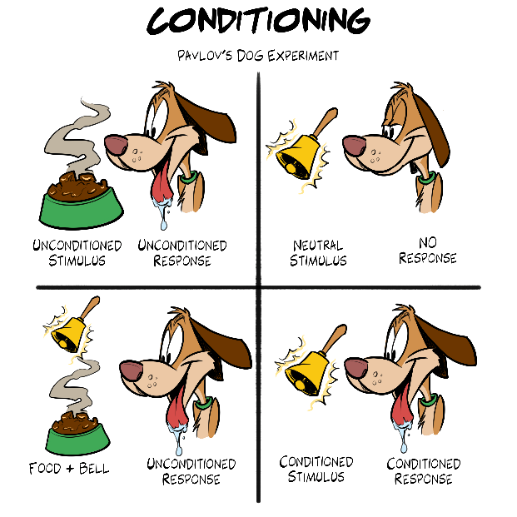
CLASSICAL CONDITIONING THEORY OF LEARNING
Ivan Pavlov was a physiologist who accidentally stumbled upon what is now known as classical conditioning. Pavlov researched how dogs responded to being fed by measuring the amount of saliva they had when given food. He noticed that the dogs would begin to salivate when they heard his assistant walking in with food. He started to play a metronome before he fed the dogs, and they began to automatically salivate when they heard the metronome in anticipation of being fed. Pavlov determined that the two stimuli needed to be given to the dogs close together for the dogs to associate the metronome with food. To stop dogs from associating the metronome with food, he could play the metronome repeatedly but not introduce food to the dogs. This practice is called extinction. Pavlov’s experiment was called classical conditioning because it was the first experiment to determine how people learn. The term “Pavlovian response” was created from Pavlov’s experiments with dogs. Pavlov’s experiment demonstrated how behavior can be changed through the introduction of a stimulus. Other people later expanded on Pavlov's theories and laid the foundation for what is called behaviorism. Behaviorism is a branch of psychology that looks at observable behavior and determines how behavior can be modified. His findings are used to help people overcome phobias, reinforce learning, and in advertising so that people recognize brands.
Neutral Stimulus | A stimulus that does not cause a response or action. It has no effect on behavior.
Unconditioned Stimulus | A stimulus that naturally and automatically causes a response.
Conditioned Stimulus | A previously neutral stimulus that causes a response after being associated with an unconditioned stimulus for a period of time.
Unconditioned Response | An automatic reaction to an unconditioned stimulus and does not require any learning.
Conditioned Response | A response that is learned due to repeated exposure to a stimulus.

Source
Mcleod, S. (2023 July 24). Pavlov’s Dogs Experiment and Pavlovian Conditioning response. Simply Psychology. https://www.simplypsychology.org/pavlov.html

