Bandlab “Add Loops” Instructions – THE KEYS TO SUCCESS

- To add beats, basslines, and loops, in the Mix Editor, select “New Track” from the left-hand side of the screen.

- You’ll see a window that says “New Track” with several options. Select “Browse Loops” in the bottom right-hand corner of that window.

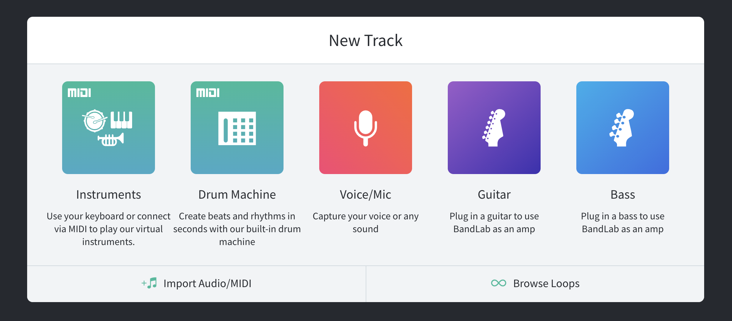

Click “Browse Loops,” and a new options panel will appear on the right- hand side of the screen.

- Click “Loops,” located in the upper right-hand corner of the screen, next to the search bar.

Note: There is an item in the bottom right-hand corner, “∞ Loops.” This is not the item to click in this step.

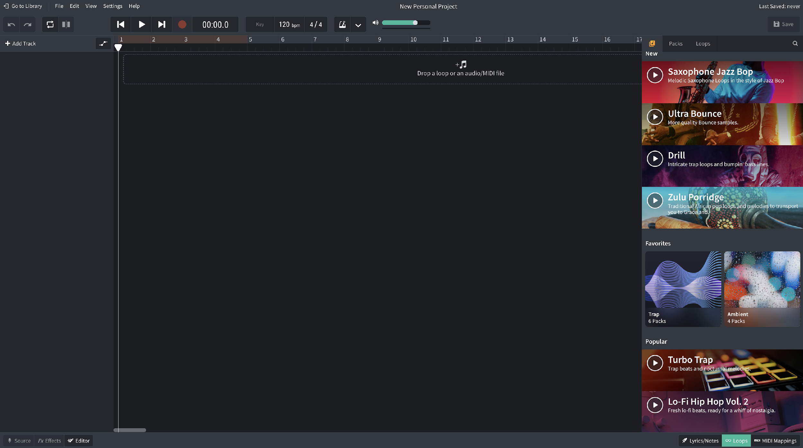
Click “Loops” in the upper-right hand corner of the page.

- Click “Instruments,” located under the search bar and select ‘Beats’.
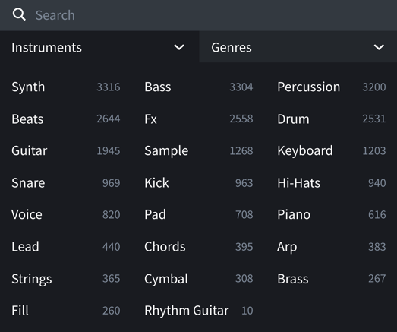

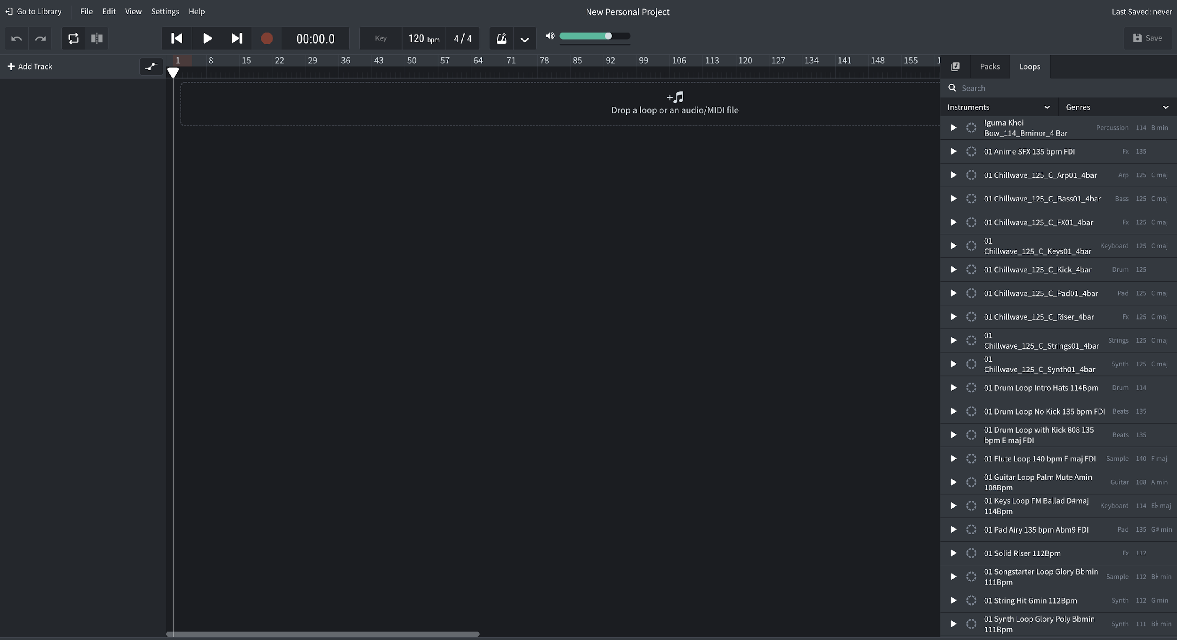
Under instruments, select beats.

- Select two beats and drag them to the area that says, “Drop a loop or an audio midi file.” Place each selection on a different track and align each to the far left of the timeline.
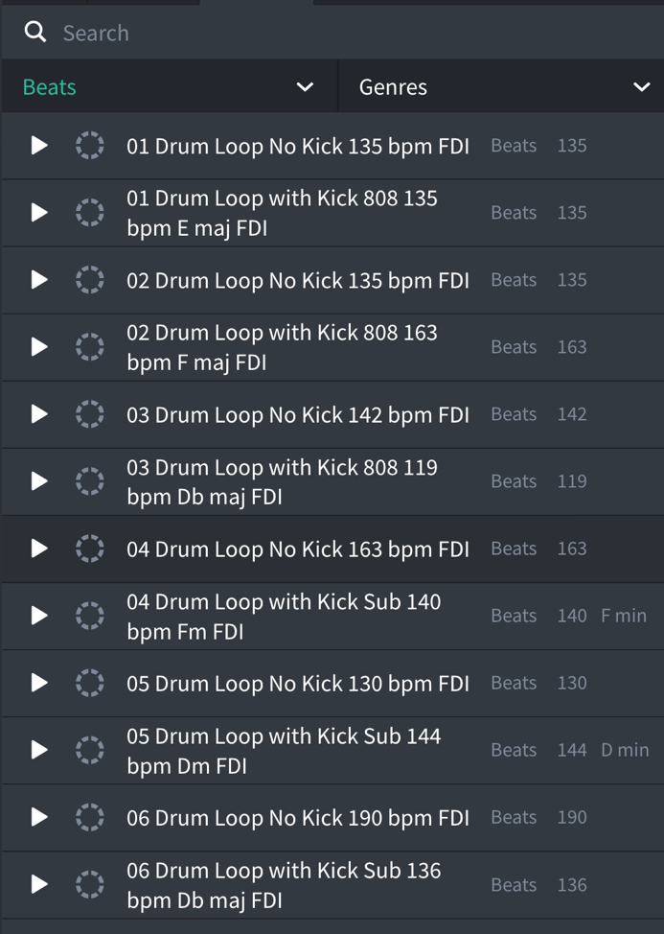

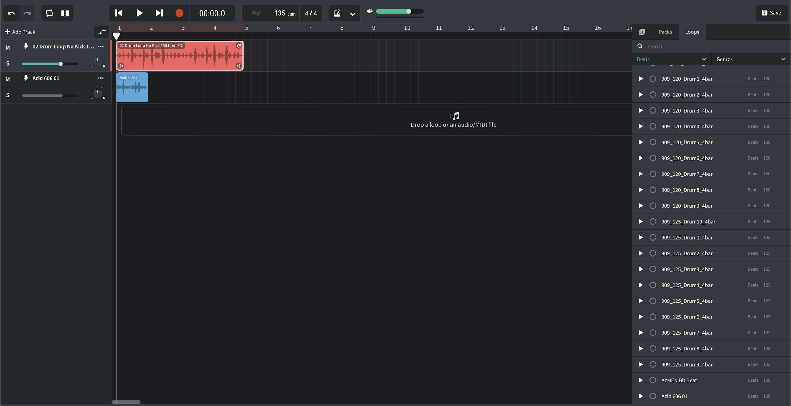
Select a beat from the list on the right and drag it onto a track.

- If one loop is shorter than the other, lengthen it by clicking on the circular arrow in the upper right-hand corner of the loop and dragging it to the right.

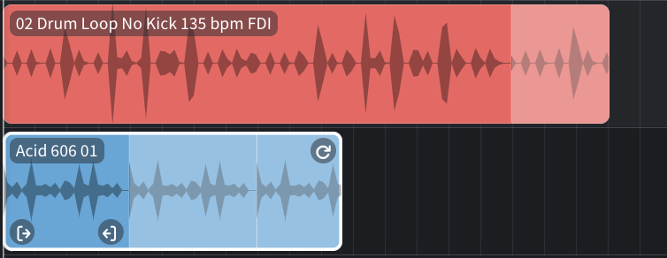

Click the arrow in the top-right corner of the selection to drag and lengthen the loop.

- Click on the word “Beats” that is highlighted in green below the search bar and select “Bass.” Repeat the same process you used when selecting beats to select a Bass loop and any other loops you want to add. When finished, your screen should look something like the one below.

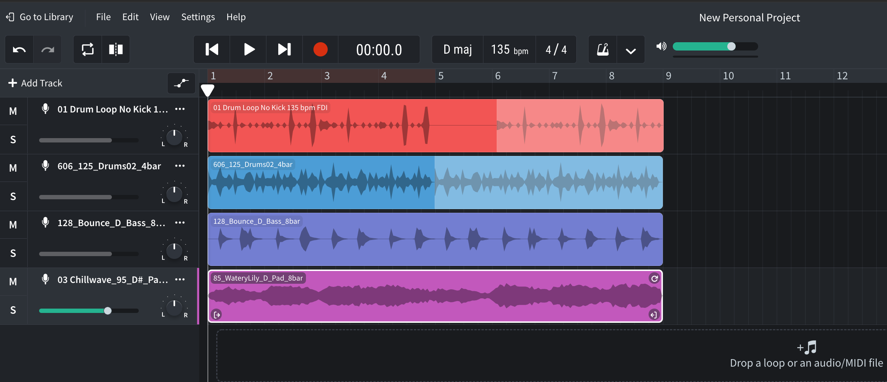
Two beat loops, a bass loop, and a pad loop.

- Now, using both the drag feature to adjust length and by moving entire tracks to different places on the play bar, arrange the tracks however you would like to line up with your scale track. You don’t have to keep any of the tracks you don’t like, so mix and match as desired!

